Contact and Support during Covid 19 for Parents and Carers of Children at Walter Infant School and Nursery.

During this difficult time, you might need some help, or you might know of someone who needs some help: these links might be useful.

Remember you can always phone to school on 01189780825
Or email head@walter.wokingham.sch.uk or admin@walter.wokingham.sch.uk

Who might be able to help?

Daisy’s Dream: https://www.daisysdream.org.uk/
Daisy’s Dream supports children and their families who have been affected by the life threatening illness or bereavement of someone close to them.
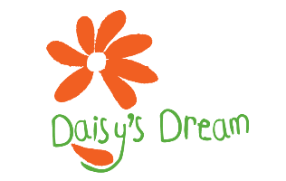

Childline: https://www.childline.org.uk/ Helpline: 0800 1111
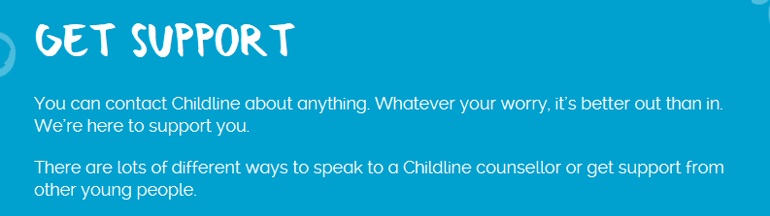

NSPCC: https://www.nspcc.org.uk/ Helpline: 0808 800 5000
https://www.nspcc.org.uk/what-is-child-abuse/

What is child abuse:
Child abuse is when a child is intentionally harmed by an adult or another child – it can be over a period of time but can also be a one-off action. It can be physical, sexual or emotional and it can happen in person or online. It can also be a lack of love, care and attention – this is neglect.

Wokingham Children’s Services: 0118 908 8002 triage@wokingham.gov.uk

Mindfulness: https://www.netmums.com/child/mindfulness-activities-for-kids
Mindfulness can help young children learn to focus, manage their impulses and cope with stress and anxiety. It can be great fun, too!

Yoga for the Family: https://www.cosmickids.com/

