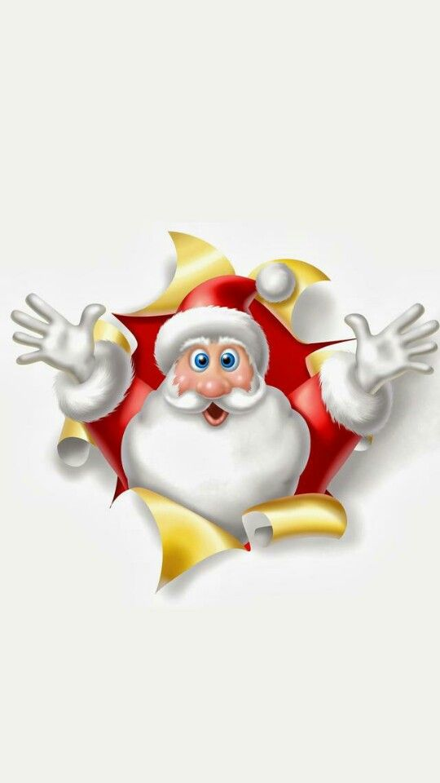

**“Christmas is coming and Father Christmas and his elves are all very excited in the North Pole; the Jingle Bells are ringing and the elves are all singing Christmas Songs. Father Christmas’ favourite is Santa Claus is Coming to Town! They are so busy, but they always have time to read your letters and wrap your presents for delivery on Christmas Eve!**

If you would like to write to Father Christmas; please use the template attached to this letter. Postage to the North Pole is rather expensive as it is so far away; please enclose £3 in the envelope and post it in the post box at school from the Friday 1st December 2023 or at the Christmas Fair. The last day for post is Friday 8th December 2023.

If younger or older siblings would also like to send a letter, please download the template (which you can find on the website) and print off as many copies as you want! Please remember to make sure that you record a first name and surname as well as the class of the child that comes to our school!

Here is a magical bar code and a special key for all those of you who do not have a chimney. Stick the code and the key to the outside of the front door on Christmas Eve. Father Christmas will be able to scan the code to get in to deliver the presents!

Best wishes and Seasons Greetings

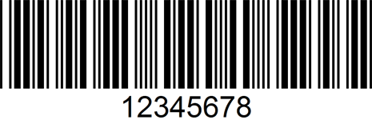

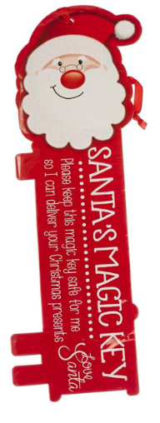

Judy Hargreaves

Headteacher

