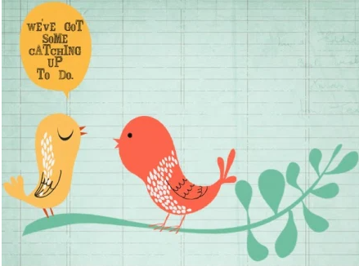
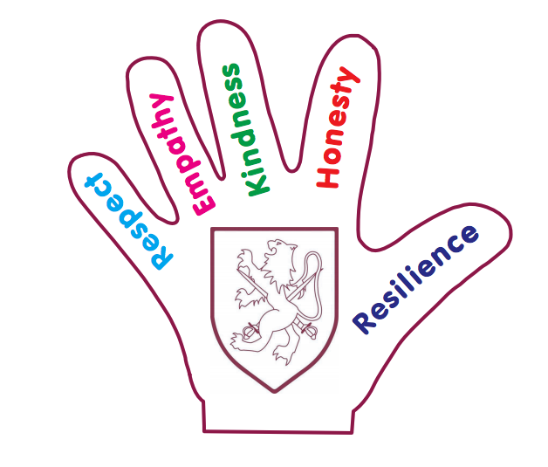
Walter Infant School and Nursery
Catch Up Plan
November 2021 ~ March 2022
School Development Plan 2021 2022
Catch Up: All children have the opportunity to access catch up resources and funding opportunities where identified
We have identified the children in every year group who meet the following criteria:
- Children who are our lowest 20% for attainment
- Children who have moved backwards from our previous assessments (September 2021) from either Greater Depth (GD) to Working AT (WA) or from Working AT (WA) to Working Towards (WT) or from Working Towards (WT) to Emerging (E)
- Children who have not met social and/or emotional milestones (including in some cases self-care)
- Children who have joined our school and are Working Towards the Expected Standard or below without an identified Special Educational Need or Disability
- Children with English as an Additional Language as a new beginner may meet the requirements for Catch Up provision

Every child on our catch-up register has a personalised Catch Up plan; designed by the class teacher based on the teaching and learning needs.

These plans will be visited regularly to monitor progress and to review targets.

Our BIG Curriculum!

Walter Infant School and Nursery is an equitable, safe, secure and happy place to learn; our children grow as individuals in a stimulating and exciting environment which values respect, empathy, kindness, honesty and resilience.

Walter Infant School and Nursery is a larger than average three form entry infant school with a 52 place nursery; we consider ourselves to be a “BIG School for LITTLE PEOPLE”. We have designed a ‘BIG’ curriculum to excite, inspire and foster a desire to learn; we want our children to know more about the world around them and to be happy, confident and successful.

Intent
We want our children to have very positive behaviours for learning and to ask BIG questions and we want our staff team to support our children in finding authentic, age-appropriate answers to questions which stimulate them to want to learn more.

The children will learn through real-life and practical experiences, as well as through wonderful, awe inspiring fiction texts and exciting non-fiction texts. Our children will learn inside and outside the classroom, fulfilling and exceeding the requirements of national age-appropriate curriculums in a stimulating and memorable way.

Therefore, in addition to personalised provision plans (Catch Up Plans) we have invested in new resources, appropriate to the stages of development and the learning needs of all our children who missed out on key learning opportunities in with their previous setting or in their previous year group. We have continued our curriculum offer from the point at which the school was closed to all children. We have adapted our curriculum for Key Stage 1 and Foundation Stage.

In Foundation Stage we follow the: Statutory framework for the Early Years Foundation Stage setting the standards for learning, development and care for children from birth to five.

We are aware from our baseline assessments at the beginning of the autumn term 2021 in Foundation Stage, that some children have gaps in self-regulation and self-care:
ELG: Self-Regulation Children at the expected level of development will:
- Show an understanding of their own feelings and those of others, and begin to regulate their behaviour accordingly;
- Set and work towards simple goals, being able to wait for what they want and control their immediate impulses when appropriate;
- Give focused attention to what the teacher says, responding appropriately even when engaged in activity, and show an ability to follow instructions involving several ideas or actions.
ELG: Managing Self Children at the expected level of development will:
- Be confident to try new activities and show independence, resilience and perseverance in the face of challenge;
- Explain the reasons for rules, know right from wrong and try to behave accordingly;
- Manage their own basic hygiene and personal needs, including dressing, going to the toilet and understanding the importance of healthy food choices.
ELG: Building Relationships Children at the expected level of development will:
- Work and play cooperatively and take turns with others;
- Form positive attachments to adults and friendships with peers;
- Show sensitivity to their own and to others’ needs. (Our Values of Kindness and Empathy)

Development Matters
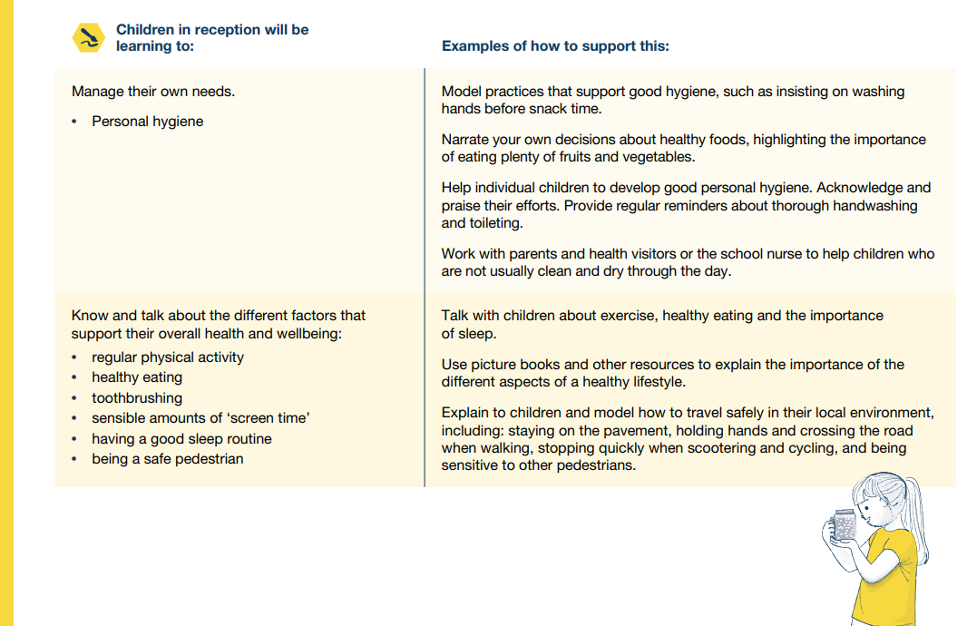

Year Group | Curriculum Starting Point
Foundation Stage 1 | Birth to 3
Foundation Stage 2 | 3 to 4 year olds
Year 1 | Good Level of Development
Year 2 | Year 1 Curriculum Programmes of Study usually covered in the Summer Term and Expected Standards for the end of Year 1

Foundation Stage 1
Provision | Impact | Leader | Cost
Requirement from EYFS for children aged three and over in maintained nursery schools and nursery classes in maintained schools:  • there must be at least one member of staff for every 13 children We have employed an additional FTE staff member (increasing the hours of our dedicated lunch club leaders) to ensure that we have enough support for the children struggling to adapt or in managing their self-care and ablutions.  • at least one member of staff must be a school teacher as defined by section 122 of the Education Act 200241 Miss Potter is an Early Years Teacher with QTS  • at least one other member of staff must hold a full and relevant level 3 qualification Mrs Jo MaCleod has an NVQ Level 3 in Child Care  We have increased the hours of our amazing lunch club facilitators to provide additional support for these most vulnerable children. | January 2022: The children have settled in well and have made progress from their starting points in all areas of development. At the moment only two children (12.5%) out of 16 15 hours children are on track to be WA for word reading). The children are having daily phonics sessions.  8 (44%) out of 18 30 hours children are on track to be WA in word writing.  We have a 30 hours child with an EHCP as well as 2 15 hours children who are working at emerging as well as children who are below the expected cognitive development level to access our learning environment independently. We have increased the hours of our amazing lunch club facilitators to provide additional support for these most vulnerable children. | Jessica Bennette with support from Samantha Potter | 30 hours per week term time only. Grade 3 SCP 6 £300 per week = £12,927
Foundation Stage 2
Provision | Impact | Leader | Cost
Reception classes in maintained schools and academies are subject to infant class size legislation. The School Admissions (Infant Class Size) Regulations 2012 limit the size of infant classes to 30 pupils per school teacher (subject to permitted exceptions) while an ordinary teaching session is conducted.  ‘School teachers’ do not include teaching assistants, higher level teaching assistants or other support staff. Consequently, in an ordinary teaching session, a school must employ sufficient school teachers to enable it to teach its infant classes in groups of no more than 30 per school teacher.  We have 3 FTE teachers and 3 Learning Support Assistants in Foundation Stage.  We have appointed 2 new Learning Support Assistants to work in the Foundation Stage, providing 60 additional hours a week to support vulnerable and SEND children (including our lowest 20%).  Resources  We have created a ‘Thrive Hive’ for our most vulnerable children (especially those joining us from different settings): we have new furniture, cushions, beanbags, a pop-up sensory black space. We have had to buy additional small world play resources as the children are being taught in class bubbles as well as additional literacy and numeracy resources to enhance our curriculum. | January 2022: The children are becoming much more independent and are all making exceptional progress from their starting points.  Our assessments show that less than 50% of children are on track to achieve a Good Level of Development. Pupil Progress Meetings (using our new assessment PITAS) have enabled us to high-light the key areas for development for each child identified.  The children’s behaviours for learning have improved dramatically September. Initially some children were very anxious as they had not been separated from their parents since March. Having an additional adult to support class has made a significant difference to the staff and the children. We will continue this ratio of staffing for this year and then evaluate.  We have 3 children with EHCP plans and other children with significant difficulties undergoing assessments. These children have really benefitted from having a safe haven to go to and the staff have benefitted from having a withdrawal space for when children have become violent. | Jessica Bennette | £31,416  (2 x £15,708 Grade 3 SCP 6 including on costs)
Year 1
Provision | Impact | Leader | Cost
We have 3 FTE teachers and 3 Learning Support Assistants in Year 1. In addition to this we have an NVQ3 member of our team working 0.6 to support our Catch-Up and PPG children and an FTE LSA to support SEND needs in Year 1 and Year 2  These are examples of approaches being undertaken in Key Stage 1 – Year 1  - Quality First Teaching  - Small Group Phonics  - 1:1 reading and small guided reading books with additional sessions  - 1:1 pre-teaching sessions  - Attention Autism Sessions with class teacher  - Dandelion Decodable Books  - Speech and Language programmes  - Social stories  - Now and next boards  - Communication books  - Sensory circuits  - Racing to English  - Colourful Semantics  Every child who is below Age-Related Expectations in Year 1 for reading, writing or mathematics has a Personalised Catch-Up Plan. | January 2020: Pupil progress meetings and PITAS show that all Catch Up children have made progress from their starting points; evidence in books, reading records and staff observations | Stephanie Rees | No additional cost
Year 2
Provision | Impact | Leader | Cost
Reading Catch-up has been our priority this term and we have invested in new reading books so that we can provide a broader offer of texts for the children.  - Quality First Teaching  - Small Group Phonics led by the teachers  - 1:1 reading and small guided reading books with additional sessions  - 1:1 pre-teaching sessions  - Catch-Up Maths sessions with Mrs Walker for groups up to 6  We have maintained the changes to the time tables that we implemented last year as the impact has been extremely positive so we have a curriculum enhancement afternoon in Year 1 and in Year 2. This enables the teachers to work with the children with the greatest needs on specific targets from their catch-up plans.  We are using the Tutoring Funding for 11 children in Year 2 (there are 28 children with Catch Up Plans in Year 2) to pay for 11 hours of support (every afternoon) from a retired teacher until July 2022. This will be small group work and 1:1 in reading, writing, phonics and mathematics. | November 2021: 92% of Year 2 children met the phonics benchmark.  December 2021:  80% of children in Year 2 are at ARE for Reading  78% of children in Year 2 are at ARE for Writing  90% of children in Year 2 are at ARE for Mathematics.  2/28 7% children with Catch-Up plans have not made progress from their September starting points. One child has been in trauma and subject to child protection. One child is a selective mute. Both have specific targets to support them and are making steady progress with initial support (including nurture).  93% of children with Catch Up plans have made good or better progress. Many are now at ARE. | Justin Lee | 11 x £12 x 26 = £3,432
 |  | Total Expenditure | £47,775

Income | Allocated | Received
Autumn 2020 | £5340 | £5340
Spring 2021 | £7240
Summer 2021 | £9020
 | £21600 | £5340
Autumn 2021 | £10,628 | £10,628
Spring 2022
Summer 2022

Our provision for catch-up is £47,775 for the school year 2021 2022.
We have received £10,628 for the year. We will receive £2227.50 (£185:62 per month) for the school year ending July 21st 2022.
This is a total of £12,855.50 leaving £34,919.50 to be met from the school budget.

