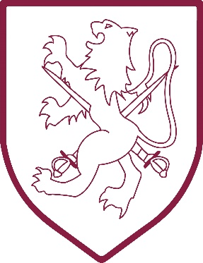 | Walter Infant School  Murray Road Wokingham RG41 2TA  Tel: 0118 978 0825  www.walter.wokingham.sch.uk  admin@walter.wokingham.sch.uk  Headteacher: Mrs Judy Wheeler  Date May 2023

Dear Parents/Carers

Robin Extra Hour & Lunch Club

The 30-hour children who attend Robin are able to stay for an extra hour each day from 2.30pm to 3.30pm, at the cost of £6.00 per session. The places need to be booked for your child to attend the extra hour at least one day prior to them attending.

The 15-hour Children are able to attend our Robin Lunch Club from 11.30am to 12.30pm at the cost of £6.00 per session and also need to be booked one day prior to your child attending. If your child attends lunch club they will need to bring in their own pack lunch to eat.

Bookings are made via the school gateway https://login.schoolgateway.com/0/auth/login using your preferred email address and mobile telephone number. The bookings will open on the 4th September 2023.

There are two ways to pay for the sessions, online payment (Pay as you go), or Childcare Vouchers. Please specify your preference on the form below and return to the office with the other forms in your pack.

Please fill in this form if you think you will use either the Robin extra hour or the Robin Lunch Club, at any time during the time they are in Robin.

Childs Full Name ……………………………………………………………………….

Robin Extra Hour………………………. Robin Lunch Club………………………..

Email …………………………………………………………………………………….

Mobile Number ………………………………………………………………………….

Childcare Vouchers

Pay Online

