Walter Infant School and Nursery

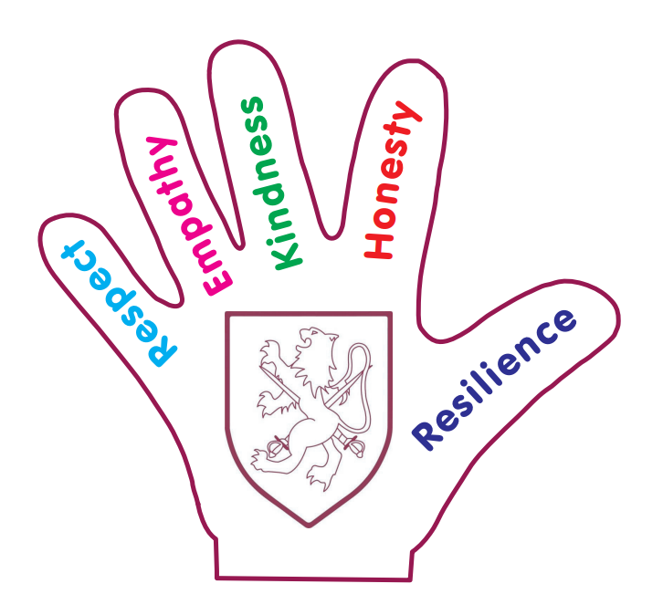

Maths Support Booklet for Parents and Carers

Year 1

National Curriculum Expectations (by the end of year 1):

|  |  |
| --- | --- |
| **Number and Place Value**  Count to and across 100, forwards and backwards, beginning with 0 or 1, or from any given number. Count, read and write numbers to 100 in numerals; count in multiples of twos, fives and tens.  Given a number, identify one more and one less. Identify and represent numbers using objects and pictorial representations including the number line, and use the language of: equal to, more than, less than (fewer), most, least.  Read and write numbers from 1 to 20 in numerals and words. | **Addition and Subtraction**  Read, write and interpret mathematical statements involving addition (+), subtraction (–) and equals (=) signs.  Represent and use number bonds and related subtraction facts within 20.  Add and subtract one-digit and two-digit numbers to 20, including zero.  Solve one-step problems that involve addition and subtraction, using concrete objects and pictorial representations, and missing number problems. |
| **Measurement**  Compare, describe and solve practical problems for: Lengths and heights [for example, long/short, longer/shorter, tall/short, double/half] Mass/weight [for example, heavy/light, heavier than, lighter than] Capacity and volume [for example, full/empty, more than, less than, half, half full, quarter] Time [for example, quicker, slower, earlier, later].  Measure and begin to record the following: Lengths and heights, mass/weight, capacity and volume, time (hours, minutes, seconds). Recognise and know the value of different denominations of coins and notes. Sequence events in chronological order using language [for example, before and after, next, first, today, yesterday, tomorrow, morning, afternoon and evening]. Recognise and use language relating to dates, including days of the week, weeks, months and years.  Tell the time to the hour and half past the hour and draw the hands on a clock face to show these times. | **Multiplication and Division**  Solve one-step problems involving multiplication and division, by calculating the answer using concrete objects, pictorial representations and arrays with the support of the teacher |
| **Fractions**  Recognise, find and name a half as one of two equal parts of an object, shape or quantity.  Recognise, find and name a quarter as one of four equal parts of an object, shape or quantity. |
| **Geometry**  Recognise and name common 2-D and 3-D shapes, including: 2-D shapes [for example, rectangles (including squares), circles and triangles], 3-D shapes [for example, cuboids (including cubes), pyramids and spheres].  Describe position, direction and movement, including whole, half, quarter and three quarter turns. |

|  |  |
| --- | --- |
| 1. **Count to 100 and back** | Practise counting from 0 all the way to 100.  First you can use the hundred square to help you and then you can try to do it from memory. |
| 1. **Count on or back from any given number** | Choose a random number to start on. Can you count to 100 from this number? |
| 1. **Count in 2s** | Count in 2s starting from 0. You only need to know up to 20.  First whisper the odd numbers and say the even numbers (multiples of 2) out loud. Then try just saying the multiples of 2.  Can you do it without looking at the 100 square? |
| 1. **Count in 5s** | Count in 5s starting from 0. You only need to know up to 50  Use your hands to help you – you have 5 fingers!  Can you do it without looking at the 100 square? |
| 1. **Count in 10s** | Count in 10s starting from 0 and going up to 100.  Make sure the words you say end in a ‘ty’ sound not a ‘teen’ sound.  Can you do it without looking at the 100 square? |
| 1. **Find one more and one less than a number** | Choose any number from 0-100. What is one more? What is one less? |
| 1. **Find two more and two less than a number** | Choose any number from 0-100. What is two more? What is two less? |
| 1. **Compare different amounts**   Use the language ‘more than’, ‘less than’, ‘fewer’, ‘equal’, ‘the same as’, ‘most’, ‘least’  COLORED PENCILS - 10-Pack Box of Colored Pencils - C-10 | Coloring Book ...  13  10 | Image result for speech bubblesCompare what you can find in your house.  10 is 3 less than 13. There are 3 more pencils here. |
| 1. **Read and write numbers in numerals and words** | Write numbers in numerals and words using different coloured pens and pencils. |
| 1. **Read and write mathematical statements**   We write this.  We say this.  We write this.  We say this   |  |  |  |  |  | | --- | --- | --- | --- | --- | | 4 | + | 3 | = | 7 | | four | add | three | equals | seven |  |  |  |  |  |  | | --- | --- | --- | --- | --- | | 7 | - | 3 | = | 4 | | seven | subtract | three | equals | four | | Combine two groups of objects e.g. 10 grapes and 2 pears.  Can you say your number sentence? Can you write it?  Ten add two is twelve.  10 + 2 = 12 |
| 1. **Know different words for the same operation**  |  |  | | --- | --- | | + | add, plus, and | | - | subtract, minus, takeaway, | | = | equals, the same as, makes | | Do you know what these words mean? |
| 1. **Number bonds to 10** | Do you know the related subtraction facts?  If you know 7+3=10 then 10-3=7.  Use your knowledge of number bonds to 10 to work out number bonds to 20.  If 4+6=10 then 14+6=20. |
| 1. **Teen numbers**     16  17  14  11    15  We can partition the numbers into 10s and 1s.  10  5 | A teen number is made up of 10 and another number e.g. 16 is 10 and 6 more.  Can you partition teen numbers into tens and ones? |
| 1. **Addition**   Using practical objects    Using a number line  3 Addition Strategies for Mini Mathematicians | Apply this to real life situations.  E.g. normally we have 4 people for dinner, today Gran and Grandad are coming so that’s 2 more. How many people will we have?  Write the number sentence:  4+2=6 |
| 1. **Subtraction**   Using practical objects  Using a number line | Apply this to real life situations.  E.g. We had 12 packets of crisps in the pack. We have eaten 7, how many are left?  Write the number sentence:  12-7=5 |
| 1. **Find a missing number** | Write a number sentence then cover up one number. Use your knowledge to find the answer e.g. 5-3=2 so the missing number is 2.  Check your answers afterwards! |
| 1. **Multiplication using arrays**     2 lots of 5 = 10  5 lots of 2 = 10 | Apply this to real life situations.  E.g. We have 3 packs of apples. Each one has 4 apples in it. How many apples do we have.  Arrange them in an array – 3 rows of 4.  Count how many there are.  3 lots of 4 is 12. |
| 1. **Find half of a number, quantity or shape**     Know that finding half is finding two equal parts.  Know that this is the same as dividing by 2. | Share items equally between two people by saying ‘one for me, one for you’.  Find half a shape by folding it down the middle.  Divide quantities by 2 by sharing ‘one for me, one for you’. |
| 1. **Find a quarter of a number, quantity or shape**   https://www.bing.com/th?id=OIP.WsrqBfjmiJEiSqxN_Ff9agHaFj&w=200&h=149&rs=1&qlt=80&o=6&dpr=1.3&pid=3.1    Know that finding a quarter is finding four equal parts.  Know that this is the same as diving by 4. | Share items equally between four people by saying ‘one for me, one for you, one for you, one for you’.  Find a quarter of a shape by folding it down the middle once and then again.  Divide quantities by 4 by sharing ‘one for me, one for you, one for you, one for you’. |
| 1. **Mass/weight** | Image result for speech bubblesChoose two objects and be a human scale. Put one in each hand and estimate which one is heavier. If you have scales you can weigh them to check.  The potato is the heaviest. |
| 1. **Capacity/volume** | Image result for speech bubblesDescribe the capacity of things in your home. Image result for speech bubbles  My glass is full but yours is only half full. |
| 1. **Length**   Shortest  Longest | Can you order items by length?  What is the longest thing you can find?  What is the shortest thing you can find? |
| 1. **Money**     Image result for new pound notesImage result for new pound notes  Image result for new pound notesEngland 50 Pound Sterling note 2011 Matthew Boulton and James Watt ... | Do you know all the coins and notes?  Can you use the right money to pay for something in a shop?  Can you combine different coins to make the amount you need? |
| 1. **Time** | Can you tell the time?  What does the clock in your house say?  Do you have a watch? Does anyone in your family? |
| 1. **Days Of The Week Printable CardsDates**   Seasons and months wheel | Kindergarten science, Seasons months ... | When is your birthday?  What about your family’s birthdays? What season are they in?  Do you know the date today? |
| 1. **2D shapes**     /Oblong  A side is the edge of a 2D shape.  A corner is where two sides meet. | How many sides does it have?  How many corners does it have?  Can you draw it?  Describe a shape, can someone else guess which one you’re talking about? |
| 1. **3D shapes**       A face is a surface of a 3D shape.  An edge is where two faces meet.  A vertices is where the edges meet.  A cone has a point at the top. | How many faces does it have?  How many edges does it have?  How many vertices does it have?  Does it have a point?  Can you spot any in your home?  Describe a shape, can someone else guess which one you’re talking about? |
| 1. **Use directional language**   Direction:  Movement:    Quarter turn:    Half turn: | Imagine you are a robot. Ask your family to give you instructions to move around your house.  Swap jobs and have a go at giving the instructions. |

And most importantly, help your children learn that…

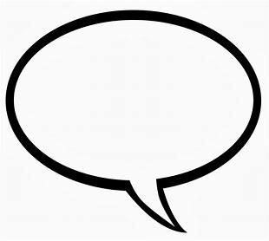

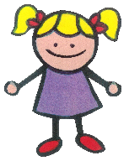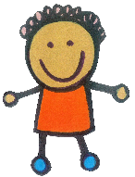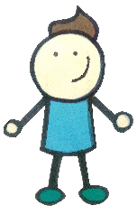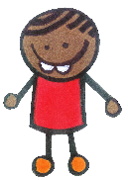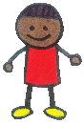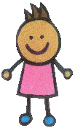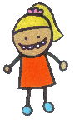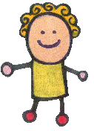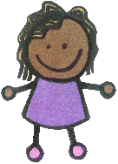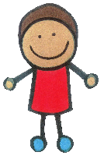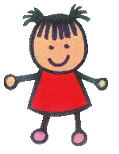

Maths is fun!!