## 



**Walter Infant School and Nursery**

**Pay Policy for Schools– Teaching Staff**

**Model policy for determining pay for teaching staff September 2024**

The Relevant Body of Walter Infant School and Nursery

adopted this policy on …

**Document Control Information**

|  |  |  |
| --- | --- | --- |
| **Version** | **DATE** | **DESCRIPTION** |
| 1 | October 21 | New version separating out Support Staff Pay Policy |
| 2 | October 22 | Updated Policy for 2022 Pay Award |
| 3 | October 2023 | Updated Policy for 2023 Pay Award  Authors: Christine Thresher and Kate Simpson |
| 4 | September 2024 | Awaiting approval FGB |

**Contents**

|  |  |  |
| --- | --- | --- |
|  |  | **Page No.** |
| **1** | **Introduction** | 4 |
| **2** | **Definitions** | 5 |
| **3** | **Equalities Legislation** | 6 |
| **4** | **Access to Records** | 6 |
| **5** | **Delegation** | 6 |
| **6** | **Monitoring & Evaluation** | 6 |
|  |  |  |
| **7** | **September 2023 Pay Award Summary** | 7 |
|  |  |  |
| **8** | **Roles & Responsibilities** | 7 |
| 8.1 | Relevant Body | 7 |
| 8.2 | Pay Committee | 8 |
| 8.3 | Headteacher | 9 |
| 8.4 | Teachers | 10 |
|  |  |  |
| **9** | **Setting and Reviewing Pay** | 10 |
| 9.1 | Job Descriptions | 10 |
| 9.2 | Appraisal | 11 |
|  |  |  |
| **10** | **Leadership Group Pay** | 11 |
| 10.1 | Determination of School’s Headteacher Group | 11 |
| 10.2 | Determination of Leadership Pay Ranges | 12 |
| 10.3 | Annual Pay Reviews | 13 |
| 10.3.1 | Executive Headteachers and Headteachers | 13 |
| 10.3.2 | Associate Headteachers and Heads of School | 14 |
| 10.3.3 | Deputy Headteachers and Assistant Headteachers | 14 |
| 10.4 | Pay progression for Leadership Group Members | 14 |
| 10.5 | Acting Allowances (Leadership) | 15 |
|  |  |  |
| **11** | **Main Pay Range** | 15 |
| 11.1 | Pay on Appointment | 15 |
| 11.2 | Pay Progression for Main Pay Range Teachers | 16 |
|  |  |  |
| **12** | **Upper Pay Range** | 18 |
|  |  |  |
| **13** | **Leading Practitioner Roles** | 20 |
| 13.1 | Pay on Appointment | 20 |
| 13.2 | Pay Determination | 20 |
|  |  |  |
| **14** | **Part-Time Teachers** | 21 |
|  |  |  |
| **15** | **Teachers Employed on a Short Notice Basis** | 22 |
|  |  |  |
| **16** | **Unqualified Teachers** | 22 |
| 16.1 | Pay on Appointment | 23 |
| 16.2 | Unqualified Teachers Allowance | 24 |
| 16.3 | Unqualified Teacher who becomes Qualified | 24 |
|  |  |  |
| **17** | **Discretionary Allowances and Payments** | 24 |
| 17.1 | Teaching and Learning Responsibility Payments (TLRs) | 24 |
| 17.2 | Special Educational Needs (SEN) allowances | 26 |
| 17.3 | Other Additional Payments | 27 |
| 17.4 | Recruitment and Retention Incentives and Benefits | 28 |
| 17.5 | Initial Teacher Training Activities (ITT) | 28 |
| 17.6 | Continuing Professional Development | 29 |
| 17.7 | Out-of-School Learning Activities | 29 |
| 17.8 | Provision of Services | 30 |
| 17.9 | Residential Duties | 30 |
| 17.10 | Honoraria | 30 |
|  |  |  |
| **18** | **Salary Sacrifice Arrangements** | 31 |
|  |  |  |
| **19** | **Safeguarded Payments and Allowances** | 31 |
|  |  |  |
|  | **Appendix 1 – Leadership Pay Ranges** | 33 |
|  |  |  |
|  | **Appendix 2 – Appeals Process** | 35 |
|  | 2.1 Appeal Hearing | 35 |
|  | 2.2 General Principles | 35 |
|  | 2.3 Appeal Procedure | 36 |
|  |  |  |
|  | **Appendix 3 – Application to Move to the Upper Pay Range** | 38 |
|  | 3.1 Process | 38 |
|  | 3.2 Assessment | 39 |

# **1.0 INTRODUCTION**

The [School Teachers’ Pay and Conditions STPCD document](https://www.gov.uk/government/publications/school-teachers-pay-and-conditions) (“the STPCD document”) requires schools and local authorities to have a pay policy which sets out the basis on which they determine teachers’ pay; the date by which they will determine the teachers’ annual pay review; and the procedures for determining appeals. Schools and local authorities must stay within the legal framework set out in the STPCD document and in other relevant legislation that affects all employers (for example, legislation on equality, employment protection and data protection). All procedures for determining pay should be consistent with the principles of public life - objectivity, openness, and accountability.

It is recommended that Academies who have chosen to continue to use the STPCD document, also adopt this model Pay Policy.

Where schools have employees who have transferred in and have protected terms and conditions, relating to pay, under TUPE law, this will continue to apply.

Schools can find additional information on pay matters, published by the Department for Education in: ["Implementing your school’s approach to pay](https://www.gov.uk/government/publications/reviewing-and-revising-school-teachers-pay)".

This model policy has been developed from the model published by the Department for Education taking into account the decisions that relevant bodies will have to make, and it has been revised to include the changes to the 2023 STPCD document. It covers pay arrangements for all teachers, including Headteachers. The policy has been written in the context of schools and academies, but the same principles apply to centrally employed or unattached teachers. This model policy has been drawn up following consultation with all recognised Trade Unions and Associations. A separate pay policy applies to support staff in schools.

If the relevant body wishes to exercise its discretion in any particular area of the pay policy, it should ensure that it consults with staff and recognised Trade Union representatives before adopting any variation to this model policy.

All pay progression for teachers, (movement up a pay range), must be linked to performance. The School’s Appraisal process is the means by which performance is assessed. The Teacher Model Appraisal Policy sets out a process which complies with these requirements.

### 

### **2.0 DEFINITIONS**

### 

The term “relevant body” has been used throughout this policy. In maintained schools the Governing body is the relevant body. The differing structures of academies mean that the Academy Trust will need to define the relevant body for the purposes of pay decisions. For centrally employed or unattached teachers the relevant body is the Local Authority.

**3.0 EQUALITIES LEGISLATION**

The relevant body is committed to ensuring consistency of treatment and fairness and will abide by all relevant equality legislation:

* Employment Relations Act 1999
* Equality Act 2010
* Employment Rights Act 1996
* The Part-time Workers (Prevention of Less Favourable Treatment) Regulations 2000
* The Fixed-term Employees (Prevention of Less Favourable Treatment) Regulations 2002
* The Agency Workers Regulations 2010
* Data Protection Act 2018

In implementing this policy, the relevant body will work within the national and local agreements on pay and conditions of service and the accompanying statutory and non-statutory guidance.

It will be reviewed each year, or when other changes occur to the *School Teachers’ Pay and Conditions (STPCD) document* /Burgundy Book.

**4.0 ACCESS TO RECORDS**

The Headteacher will ensure reasonable access for individual members of staff to their own employment records.

### 

### **5.0 DELEGATION**

Normal rules apply in respect of the delegation of functions by relevant bodies, Headteachers and local authorities.

**6.0 MONITORING AND EVALUATION**

The relevant body and Headteacher will monitor the operation and effectiveness of the school’s pay policy. Advice and guidance on this policy can be obtained from your school's HR provider.

## **7.0 SEPTEMBER 2024 PAY AWARD SUMMARY**

The pay award should be implemented for all teachers with effect from 1 September 2024.

In this policy the pay award is seen as distinct from a decision on pay progression, i.e., movement up the pay range, which can only be made following assessment of a teacher’s performance through the appraisal process.

**8.0 ROLES & RESPONSIBILITIES**

**8.1 Relevant Body**

The relevant body will fulfil its obligations to:

* **Teachers**: as set out in the School Teachers’ Pay and Conditions (STPCD) document and the Conditions of Service for School Teachers in England and Wales (commonly known as the ‘Burgundy Book’).
* **Support staff**: the National Joint Council for Local Government Services National Agreement on Pay and Conditions of Service (Green Book) or any LA pay/grading system – as covered in the Support Staff Pay Policy.

The relevant body will need to consider any updated pay policy and assure themselves that appropriate arrangements for linking appraisal to pay are in place, can be applied consistently and that their pay decisions can be objectively justified.

The relevant body will form a Pay Committee, which has delegated responsibilities and decision-making powers in relation to pay. The Pay Committee has full authority to take pay decisions on behalf of the relevant body in accordance with this policy.

The relevant body will establish an Appeals Committee to take decisions on appeals against the decisions of the Pay Committee in accordance with the terms of the appeals procedure as outlined in this policy.

The relevant body will ensure that it makes funds available to support pay decisions, in accordance with this pay policy and the school’s spending plan.

The relevant body will monitor the outcomes of pay decisions and the impact of this policy on an annual basis, including the extent to which different groups of teachers may progress at different rates, ensuring the school’s continued compliance with equalities legislation.

**8.2 Pay Committee**

The Pay Committee will comprise of at least three governors. No member of the relevant body who is employed to work in the school shall be eligible for membership of this committee.

The pay committee will be attended by the Headteacher in an advisory capacity. Where the pay committee has invited either a representative of the LA or an external adviser to attend and offer advice on the determination of the Headteacher’s pay, that person will withdraw at the same time as the Headteacher while the committee reaches its decision. Any member of the committee required to withdraw will do so.

Any person employed to work at the school, other than the Headteacher, must withdraw from a meeting at which the pay or appraisal of any other employee of the school, is under consideration. The Headteacher must withdraw from that part of the meeting where the subject of consideration is their own pay. A relevant person must withdraw where there is a conflict of interest or any doubt about their ability to act impartially.

The Pay Committee Terms of Reference:

* To implement the Pay Policy with reference to staffing and financial budget plans.
* To achieve the aims of the Pay Policy in a fair and equitable manner and within statutory and contractual obligations.
* To apply the criteria of the Pay Policy consistently in determining the pay for each member of staff in the annual review.
* To determine the size of the leadership group; and set a Pay Range for the Headteacher Leadership Pay and for other staff on the Leadership Pay Spine and decide where leadership group members should be placed on these, in line with the STPCD 2023 and the Burgundy Book.
* To consider difficult and discretionary pay issues, such as the use of recruitment and retention incentives.
* Minute all decisions taken and submit these minutes to the relevant body as required.
* Keep abreast of any relevant developments and advise the relevant body when the Pay Policy needs updating.
* Observe all statutory, non-statutory and contractual conditions in respect of pay matters.
* Maintain the strictest confidentiality.
* Recommend to the Finance Committee any budget adjustments needed for annual pay reviews.
* Work with the Headteacher to ensure that the Relevant Body complies with The Education (School Teachers’ Appraisal) (England) Regulations 2012.

The report of the pay committee will be placed in the confidential section of the relevant body’s agenda and will either be received or referred back. Reference back may occur only if the pay committee has exceeded its powers under the policy.

**8.3 Headteacher**

Although the relevant Pay Committee has overall responsibility for the management of the Pay Policy, it is not always practical for every single pay decision to be referred to it. Therefore, the Headteacher has delegated responsibility for the following:

* Submit any updated appraisal and pay policies to the relevant body for approval
* Setting performance objectives and carrying out performance development reviews as required, including a formal annual review of performance
* Ensuring effective appraisal arrangements are in place and that appraisers have the knowledge and skills to apply procedures fairly and clear arrangements for linking appraisal to pay progression are in place.
* Submit pay recommendations to the Pay Committee and ensure they have sufficient and appropriate evidence and information upon which to make pay decisions.
* Applying pay discretions where these are clear and non-contentious within the scope of the policy, e.g., use of TLRs
* Reviewing, drafting, and finalising job descriptions for all staff.
* Ensuring teachers are informed about pay decisions reached, and that records are kept of recommendations and decisions made.

**8.4 Teachers**

A teacher will:

* engage with appraisal (Performance Management); this includes working with their appraiser to ensure that there is a secure evidence base for an annual pay determination to be made
* keep records of their objectives and review them throughout the appraisal process with their appraiser
* share any additional evidence they consider relevant, and which they choose to share, with their appraiser (this is not an essential requirement)
* ensure they have an annual review of their performance

**9.0 SETTING AND REVIEWING PAY**

The relevant body will ensure that all teaching staff salaries, including those of the Headteacher, Deputy Headteacher(s) and Assistant Headteacher(s) will be reviewed annually to take effect from 1 September and that all teachers are given a written statement setting out their salary and any other financial benefits to which they are entitled.

The relevant body should complete teachers’ annual pay reviews by 31 October and the Headteacher’s annual pay review by 31 December, however the value of any new pay point may not be confirmed until pay information is released by the government each year. The School will, however, complete the process without undue delay.

A year for the purposes of pay progression permits certain periods of absence to be counted towards the period of a year. The relevant body will consider whether performance objectives have been met, taking account of whether unforeseen circumstances may have led to a particular objective not being achieved, such as pregnancy and maternity absence or long-term sickness absence. Objectives should have been revised to take account of such absence.

The relevant body has an appeals procedure in relation to pay in accordance with the provisions of the relevant paragraph of the STPCD document. It is set out as an appendix to this pay policy – see appendix 2.

**9.1 Job Descriptions**

The Headteacher will ensure that each member of staff is provided with a job description in accordance with the staffing structure agreed by the relevant body. Job descriptions may be reviewed from time to time, in consultation with the individual employee concerned, in order to make reasonable changes in the light of the changing needs of the school. Job descriptions will identify key areas of responsibility. All job descriptions will be reviewed annually as part of the appraisal process.

**9.2 Appraisal (Performance Management)**

The relevant body will comply with The Education (School Teachers’ Appraisal) (England) Regulations 2012concerning the appraisal of teachers. Assessment will be based on evidence from a range of sources (see the school’s appraisal policy). Although the school will establish a firm evidence base in relation to the performance of all teachers, there is a responsibility on individual teachers and appraisers to work together. Teachers should also gather any evidence that they deem is appropriate in relation to meeting their objectives, the Teachers’ Standards, and any other criteria (i.e., application to be paid on Upper Pay Range) so that such evidence can be taken into account at the review.

**10 LEADERSHIP GROUP PAY**

The STPCD document determines that Leadership Group Pay includes Headteacher, Deputy Headteacher and Assistant Headteacher pay. Posts paid on the Leadership Pay Range must be identified in the school’s staffing structure.

**10.1 Determination of the school’s Headteacher group**

The Headteacher group is divided into 8 groups with associated pay ranges (as per section 5.3 of the STPCD 2023). The Relevant Pay Committee must assign its school to a Headteacher group in accordance with paragraphs 5, 6, 7, 8 and 9 of the STPCD 2023.

Schools must adhere to the minima and maxima for their school group size as follows:

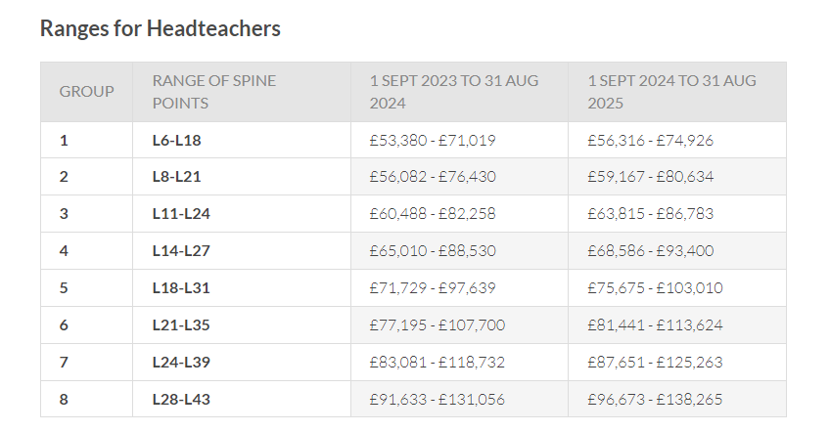

Schools will need to determine locally their own Headteacher Pay range and points, ensuring the minimum point is no lower than stated for their group in the table above and the maximum point is no higher than stated, unless in accordance with the details in STPCD paragraphs 9.1 – 9.4 (although it does **not** have to reflect the maximum listed).

The Headteacher group for permanent Executive Headteachers is determined by calculating the total unit score for all the pupils across all schools.

**10.2 Determination of leadership pay ranges**

Once the relevant Pay Committee has assigned the Headteacher group for the school, it can determine the leadership pay ranges for the Headteacher, Deputy Headteacher and Assistant Headteacher post in accordance with paragraphs 9.2 to 9.4 of the STPCD 2023. In summary the relevant body must consider:

* The permanent responsibilities of the role, any challenges that are specific to the role, and all other relevant considerations. In the case of a new appointment, the relevant body will consider the extent to which the leadership pay range reflects how closely their preferred candidate meets the requirements of the post. The relevant body will ensure that there is appropriate scope within the range to allow for performance related progress over time.
* Pay ranges for Headteachers should not normally exceed the maximum of the Headteacher group, unless there are circumstances specific to the role or the candidate which warrant a higher than normal payment. The relevant body must ensure that the maximum of the Headteacher’s pay range and any temporary payments (see section 10 of the STPCD) does not exceed the maximum of the Headteacher group by more than 25% other than in exceptional circumstances; in such circumstances, the relevant body must seek external independent advice before providing such agreement and support its decision with a business case.
* The maximum of the Deputy or Assistant Headteacher’s pay range must not exceed the maximum of the Headteacher group for the school, calculated in accordance with STPCD sections 6 to 8. The pay range for a Deputy or Assistant Headteacher should only overlap the Headteacher’s pay range in exceptional circumstances.
* In setting the Headteacher’s pay range the relevant body is advised to have regard to the highest point on the range for a Deputy or Assistant Headteacher and the salary of the highest paid classroom teacher, to ensure that appropriate differentials are created and maintained between posts of differing responsibility and accountability.

**10.3 Annual Pay Reviews**

**10.3.1 Executive Headteachers and Headteachers**

A panel of three Governors (or Trustees or equivalent) will undertake annual performance reviews for an Executive Headteacher or Headteacher and make recommendations to the relevant Pay Committee. This panel must not include any Staff Governors. The School Improvement Partner (SIP) or an external advisor will assist with the process.

The Headteacher must demonstrate sustained high quality of performance, with particular regard to leadership, management and pupil progress at the school and will be subject to a review of performance against objectives before any performance points will be awarded.

The Headteacher’s pay range should only be reviewed if it is necessary to take account of a change to the size or group of the school, or if there is a significant change to the responsibilities of the post or if a review is necessary to maintain consistency with pay arrangements for new appointments to the leadership team. The Pay Committee should formally record the school’s Headteacher pay range and the reasoning for their decision. The relevant body should not take account of the salary of the serving Headteacher if they re-determine the Headteacher’s pay range.

Where the Headteacher takes on permanent accountability for one or more additional schools, the pay committee will set a pay range in accordance with paragraphs 5, 6, 7, 8 and 9 of the STPCD 2024.

Where in accordance with the provisions of an earlier STPCD document the relevant body has determined a pay range the maximum of which exceeds the highest salary payable under the relevant paragraph of the 2024 Pay STPCD document it will continue to pay any salary determined by reference to that pay range until such time as it reassesses the pay range for its leadership posts under the provisions of the current STPCD document.

The relevant body may determine that additional discretionary payments be made to a Headteacher for clearly temporary responsibilities or duties that are in addition to the post for which their salary has been determined. In each case the relevant body must not have previously taken such reason or circumstance into account when determining the Headteacher’s pay range. The total sum of payments made to a Headteacher in any school year must not exceed 25% of the annual salary, which is otherwise payable to the Headteacher, and the total sum of salary and other payments made to a Headteacher must not exceed 25% above the maximum of the Headteacher group unless in wholly exceptional circumstances and where supported by a business case.

**10.3.2 Associate Headteachers and Heads of School**

The Executive Headteacher will undertake delegated annual performance management reviews for Associate Headteacher and Head of School roles in a Federation arrangement. The Executive Headteacher, Associate Headteacher and Head of School must respectively demonstrate sustained high quality of performance, with particular regard to leadership, management and pupil progress at the school and will be subject to an individual review of performance against performance objectives before any performance points will be awarded.

**10.3.3 Deputy Headteachers and Assistant Headteachers**

The Headteacher is responsible for undertaking annual performance reviews for other leadership group members.

Deputy Headteachers and Assistant Headteachers must demonstrate sustained high quality of performance, in respect of school leadership and management and pupil progress and will be subject to a review of performance against their performance objectives before any performance points will be awarded.

The relevant Pay Committee will be advised by the Headteacher of the agreed performance objectives and the outcome of the review of these.

**10.4 Pay progression for leadership group members**

The relevant body will consider annually whether to increase the salary of members of the leadership group (namely Headteachers, Deputy Headteachers and Assistant Headteachers) who have completed a year of employment since the previous pay determination and to what salary within the relevant pay range.

The decision whether to award pay progression will be related to the individual’s performance, as assessed through the school’s appraisal arrangements.

Decisions regarding pay progression will be made with reference to the teachers’ appraisal reports and the pay recommendations they contain.

Sustained high quality of performance and having met performance objectives, with regard to the results of the most recent appraisal, will give the individual an expectation of progression on the pay range. The award may be one point or a maximum of two for exceptional performance. The value of the pay points will include any uplift to the national pay framework for September 2023.

It will be possible for a ‘no progression’ determination to be made without recourse to the capability procedure. However, any lack of pay progression should not be a surprise and teachers should already be aware of any targets not being achieved or met.

Teachers who have been placed on an improvement action plan, mid-year, who have successfully achieved all elements of the plan, may still be awarded pay progression, subject to a successful end of year appraisal.

All teachers can expect progression to the top of their pay range as a result of successful appraisal reviews

**10.5 Acting Allowances (Leadership)**

The relevant body will consider paying a teacher who is temporarily carrying out the full duties of an absent Headteacher, Deputy Headteacher or Assistant Headteacher at an appropriate point within the Headteacher or Deputy/Assistant Headteacher’s pay ranges. The relevant body must, within the period of four weeks beginning on the day on which such duties are first assigned and carried out, determine whether an allowance (“acting allowance”) must be paid. The increase in salary will be backdated to the first day of absence. The level of allowance must be at least at the minimum leadership spine point payable in the school for the post in which the teacher is acting.

In the case of planned prolonged absence, an acting pay point within the applicable pay range should be established in advance and payment made as soon as the duties are taken up.

Except in the case of the Deputy Headteacher, who is contractually obliged to act as the Headteacher in their absence, any member of staff acting up to a higher position should have first agreed to take on the acting duties in question.

Acting up allowances for any position other than a leadership group member (including support staff posts) will be determined by the Headteacher, taking into account the responsibilities of the post, the salary of the person acting up and the post holder’s salary.

**11.0 MAIN PAY RANGE**

**11.1 Pay on appointment**

The relevant body will determine the pay range for a vacancy prior to advertising it. On appointment it will determine the starting salary within that range to be offered to the successful candidate.

In making such determinations, the relevant body may take into account a range of factors, including:

* the requirements of the post
* any specialist knowledge required for the post
* the experience required to undertake the specific duties of the post
* the wider school context
* market conditions

There is no assumption that a teacher will be paid at the same rate as they were being paid in a previous school.

The relevant body may consider awarding one or more additional points for relevant experience on the following basis (the maximum number of additional points awarded will normally be two):

* One point for each year of employment as a qualified teacher in higher or further education, including sixth form colleges or in independent schools.
* One point for each year of employment as a qualified teacher within state sector schools outside England and Wales.
* One point for each three years’ experience outside teaching which the relevant body considers to be of value to the performance of the teacher’s duties, e.g., industrial, or commercial training, work in an occupation relevant to the teacher’s work at the school, and experience with children/young people.

The relevant body will, if necessary, use its discretion to award a recruitment and incentive benefit (more detail contained within the allowances section of this policy) to secure the candidate of its choice (this must be time framed). Very clear and specific criteria should be adopted if doing so and STPCD documented evidence may be required to verify any experience claimed.

**11.2 Pay progression for Main Pay Range Teachers**

The September 2023 pay award provides the following statutory minimum and maximum points of the main pay range:

Minimum: £31,650

Maximum: £43,607

Any pay uplifts will be back dated to 1 September 2024.

The Pay Committee must determine, in accordance with their own pay policy and funding, how to implement pay awards within the main pay range for teachers, taking into account the Government’s expectation that good classroom teachers should expect to reach the maximum of the main pay range within five years.

From 1st September 2024, the School Teachers Review Body has recommended the following advisory pay points within the main pay range.

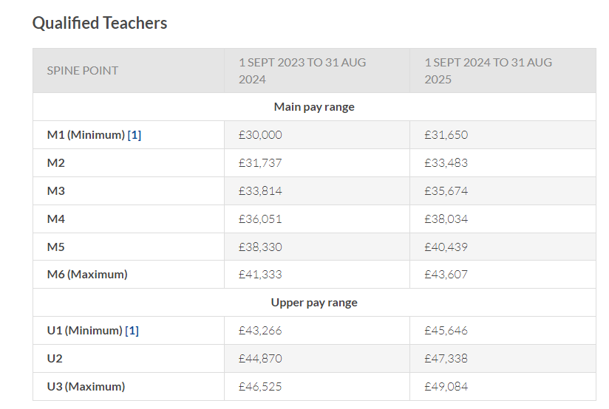These advisory points are not mandatory, and schools can choose a different approach. **However, they would need to consult individually with Unions if not following the recommended pay ranges.**

Further guidance can be found in the Department for Education’s STPCD document: Implementing your school’s approach to pay.

To move up the main pay range, one annual point at a time, teachers will need to have made good progress towards their objectives and have shown that they are competent in all elements of the Teachers’ Standards. The Government’s expectation is that good classroom teachers should expect to reach the maximum of the main pay range within five years.

Please see the Teacher Standards: Guidance for school leaders, school staff and Relevant Bodies – https://www.gov.uk/government/publications/teachers-standards

Judgments will be properly rooted in evidence. Teachers on the main pay range will have challenging objectives and evidence should show:

* A positive impact on pupil progress
* An impact on wider outcomes for pupils
* Improvements in specific elements of practice identified to the teacher, e.g., behaviour management or lesson planning
* A contribution to the work of the school
* An impact on the effectiveness of staff and colleagues

Further information, including sources of evidence is contained in the school’s appraisal policy.

A teacher whose performance does not meet the Teachers’ Standards (and/or other relevant standards) and / or their appraisal objectives may be considered not to be eligible for pay progression. While it is possible for a ‘no progression’ determination to be made without recourse to the capability procedure, there is an expectation that concerns about a teacher’s performance will have been made clear in writing through the appraisal process and that these have not been sufficiently addressed through support provided by the school.

The pay committee will be advised by the Headteacher in making all such decisions. Any increase (i.e., no movement, one point, more than one point) will be clearly attributable to the performance of the teacher in question. The pay committee will be able to justify its decisions.

In the case of ECT Teachers, whose appraisal arrangements are different, pay decisions will be made by means of the statutory induction process. The relevant body must ensure that ECTs are not negatively affected by the extension of the induction period from one to two years. Therefore, schools are able to award pay progression to ECTs at the end of the first year.

**12 UPPER PAY RANGE (see table above)**

The process for applying to move to the Upper Pay Range is covered in Appendix 3.

Progression through the Upper Pay Scale is not automatic. Teachers can only progress if their performance has been reviewed and they are **highly competent** and have made a **substantial** and **sustained** contribution to the school.

All teachers on the Upper Pay Range (UPR) will have their pay reviewed annually in accordance with the Appraisal Policy.

The pay committee will determine whether there should be any movement on the Upper Pay Range. In making such a determination, it will consider:

* pay progression on the Upper Pay Range will be clearly attributable to the performance of the individual teacher
* the evidence base, which should show that the teacher has had a successful appraisal and has made good progress towards objectives
* evidence that the teacher has maintained the criteria set out in the relevant paragraph of the STPCD document, namely that the teacher is highly competent in all elements of the relevant standards; and that the teacher’s achievements and contribution to the school are substantial and sustained. The meaning of these criteria is set out in Appendix 3 of this policy entitled, “Application to Move to the Upper Pay Range”.

The pay committee will be able to objectively justify its decisions.

Where it is clear that the evidence shows the teacher has made good progress, i.e., they continue to maintain the criteria set out above (see ‘Applications to be Paid on the Upper Pay Range’), and have made good progress towards their objectives, the teacher will move to a mid-point on the Upper Pay Range; or if already on the mid-point, will move to the top of the Upper Pay Range.

Further information, including sources of evidence is contained within the school’s appraisal policy.

The pay committee will be advised by the Headteacher in making all such decisions.

**13 LEADING PRACTITIONER ROLES**

The Leading Practitioner range is for teachers who support the modelling and improvement of teaching skills, where those duties fall outside the criteria for the TLR payment structure. Schools can create posts whose primary purpose is the modelling and leading improvement of teaching skills and that are paid above the maximum of the Upper Pay Range.

For teachers working in this capacity, additional duties will be set out in the job description which link to developing, implementing, and improving school effectiveness and performance of staff, colleagues, and pupils.

Pay determination has a minimum and maximum range, and the Pay Committee will be responsible for determining where within that range a post will be placed. The Pay Committee shall also ensure that there is scope for performance related progress over time within the pay range they set.

If the relevant body has determined that Leading Practitioner teacher posts are required, they must be identified in the school’s staffing structure.

**13.1 Pay on appointment**

The pay committee will determine a pay range from minimum of L1 £50,025 to maximum £76,050 for each leading practitioner post in accordance with section 16 of the STPCD document; under the paragraph 16.3 guidance.

**13.2 Pay determinations**

The Headteacher will agree appraisal objectives for the leading practitioner.   
  
The pay committee shall have regard to the results of the leading practitioner’s appraisal, including the pay recommendation, when exercising any discretion in relation to their pay, in accordance with the relevant paragraph of the STPCD document.

The pay committee will take account of other evidence. The evidence should show the leading practitioner:

* has made good progress towards their objectives
* is an exemplar of teaching skills, which should impact significantly on pupil progress, within school and within the wider school community, where relevant
* has made a substantial impact on the effectiveness of staff and colleagues, including any specific elements of practice that have been highlighted as in need of improvement
* is highly competent in all aspects of the Teachers’ Standards
* has shown strong leadership in developing, implementing, and evaluating policies and practice in their workplace that contribute to school improvement.

“Highly competent” and “substantial” are defined in Appendix 3 entitled, “Application to Move to the Upper Pay Range”.

The pay committee will be advised by the Headteacher in making all such decisions.

The pay committee will determine pay progression such that the amount is clearly attributable to the performance of the leading practitioner. The pay committee will be able to objectively justify its decision.

Where it is clear from the evidence that the teacher’s performance is exceptional, the pay committee will award enhanced pay progression.

Further information, including sources of evidence is contained within the school’s appraisal policy.

**14 PART-TIME TEACHERS**

Teachers employed on an ongoing basis at the school but who work less than a full working day or week are deemed to be part time. For the purposes of calculating pay for a part time teacher:

a) “pro rata principle” means that proportion of total remuneration which corresponds to the number of hours that the teacher is employed in that capacity during the course of the school’s timetabled teaching week as a proportion of the total number of hours in the school’s timetabled teaching week; (and for this purpose “total remuneration” means the remuneration that would be payable to that person if employed in the same post on a full-time basis); and

b) “the school’s timetabled teaching week” means the aggregate period in the school timetable during which pupils are normally taught.

The relevant body will give them a written statement detailing their working time obligations and the mechanism used to determine their pay subject to the provisions of the statutory pay arrangements and in comparison, with the school’s timetabled teaching week for a full-time teacher in an equivalent post.

Part-time teachers are entitled to planning, preparation, and assessment time pro-rata to full-time teachers. Part-time teachers must be paid in accordance with the pro rata principle. The same principle must be applied to any allowances awarded to the part-time teacher.

Any additional hours such a teacher may agree to work from time to time at the request of the Headteacher should also be paid at the same rate.

**15 TEACHERS EMPLOYED ON A SHORT NOTICE BASIS**

Teachers employed on a day-to-day or other short notice basis will be paid on a daily basis calculated on the assumption that a full working year consists of 195 days, periods of employment for less than a day being calculated pro-rata.

Teachers should be paid for all the hours they are required to be on the school premises. Allowance should be made for non-contact time.

Teachers who are employed to teach for the full pupil day will be paid at a daily rate of 1/195th; of the annual pay they would receive if engaged on a regular contract.

Teachers who work less than a full day will be hourly paid and will also have their salary calculated as an annual amount which will then be divided by 195 then divided again by the proportion of the full pupil day which they teach.

Rates for supply teachers should be established through the normal process of assessing their appropriate point on the main or upper pay range unless the teacher has agreed a different rate in advance, in accordance with Agency Worker Regulations 2010.

**16 UNQUALIFIED TEACHERS**

There are different types of 'unqualified teacher' such as:

* trainees working towards qualified teacher status (QTS),
* overseas trained teachers, and
* instructors who are people with a particular skill, special qualifications and or experience.

From 1st September 2024, the STPCD document stated the following minimum, maximum and advisory pay points, within the unqualified pay range. The pay committee will use reference points. Therefore, the pay scale for the unqualified pay range in this school is:

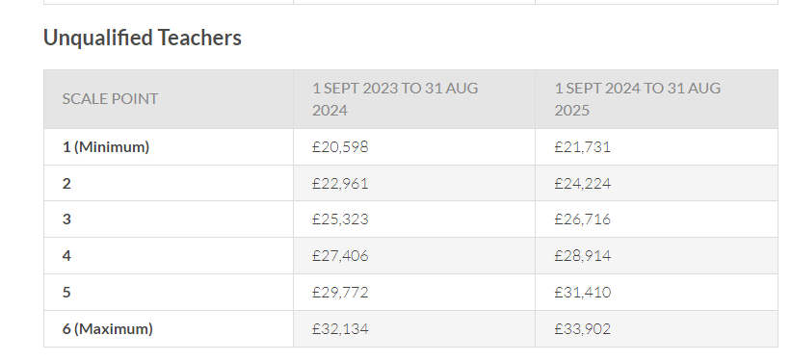

**16.1 Pay on appointment**

The relevant body will determine the starting pay of an unqualified teacher.

An unqualified teacher who becomes qualified must be moved to the main pay range for classroom teachers according to the rules set out in the STPCD document, section 3 paragraph 18 and section 16.3 of this policy.

The relevant body will pay an unqualified teacher enrolled on one of the salaried employment based routes into teaching on the unqualified teachers’ range.

To progress up the unqualified teacher range, unqualified teachers will need to show that they have made good progress towards their objectives. Judgments will be properly rooted in evidence. As unqualified teachers move up the scale, this evidence should show:

* an improvement in teaching skills
* an increasing positive impact on pupil progress
* an increasing impact on wider outcomes for pupils
* improvements in specific elements of practice identified to the teacher
* an increasing contribution to the work of the school
* an increasing impact on the effectiveness of staff and colleagues

Information on sources of evidence is contained within the school’s appraisal policy.

The pay committee will be advised by the Headteacher in making all such decisions. Pay progression on the unqualified teacher range will be clearly attributable to the performance of the individual teacher. The pay committee will be able to objectively justify its decisions.

**16.2 Unqualified Teachers’ Allowance**

The relevant body may pay an unqualified teachers’ allowance to unqualified teachers when they consider in the context of its staffing structure and pay policy that the teacher has:

1. taken on a sustained additional responsibility which:

i. is focused on teaching and learning; and

ii. requires the exercise of a teacher’s professional skills and judgment; or

b) qualifications or experience which bring added value to the role being undertaken.

The value of the allowance will be determined by the post held in the school’s structure and also the ability to recruit and retain in that post.

Unqualified teachers may not hold TLR payments or SEN allowances.

**16.3 An unqualified teacher who becomes qualified**

Upon obtaining qualified teacher status (QTS), an unqualified teacher must be transferred to a salary within the main pay range for teachers.

Where the teacher continues to be employed by the same school within which they were employed before they obtained QTS the teacher must be paid a salary which is the same as, or higher than, the sum of their unqualified teacher salary payable and any allowances payable (including any safeguarded sum), as the relevant body considers to be appropriate.

Further guidance on payments for teachers who achieve QTS retrospectively can be found in the STPCD document, part 1, section 18.

**17 DISCRETIONARY ALLOWANCES AND PAYMENTS**

**17.1 Teaching and Learning Responsibility Payments (TLRs)**

The Relevant Body may award TLR payments to teachers who occupy posts of additional responsibility. There are three levels of TLR with criteria for payment fully set out in the STPCD document.

A TLR 2 or TLR 1 is awarded to a classroom teacher who holds a permanent TLR post identified in the school’s staffing structure which requires the teacher to undertake a clearly defined and sustained additional responsibility in the context of the schools staffing structure for the purpose of ensuring the continued delivery of high-quality teaching and learning.

Before awarding a TLR 1, the relevant body must be satisfied that the sustained, additional responsibility referred to in the previous paragraph includes line management responsibility for a significant number of people.

A TLR 3 is fixed-term and may be awarded to a classroom teacher for a specific time-limited school improvement project or one-off externally driven responsibility. The relevant body must ensure that the reason for the award of a TLR 3 and its duration is established at the outset, in writing. Recruitment to a TLR 3 will normally be through an open recruitment process. No safeguarding will apply in relation to an award of a TLR3.

With the exception of sub paragraphs (c) and (e) below which do not have to apply to the award of a TLR 3, before awarding any TLR, the relevant body must be satisfied that the teacher’s duties include a significant responsibility that is not required of all classroom teachers, and that:

1. is focused on teaching and learning;
2. requires the exercise of a teacher’s professional skills and judgement;
3. requires the teacher to lead, manage and develop a subject or curriculum area; or to lead and manage pupil development across the curriculum;
4. has an impact on the educational progress of pupils other than the teacher’s assigned classes or groups of pupils; and
5. involves leading, developing and enhancing the teaching practice of other staff.

All job descriptions will be regularly reviewed and will make clear, if applicable, the responsibility or package of responsibilities for which a TLR is awarded.

The values of TLRs must fall within the following ranges. The annual value of a:

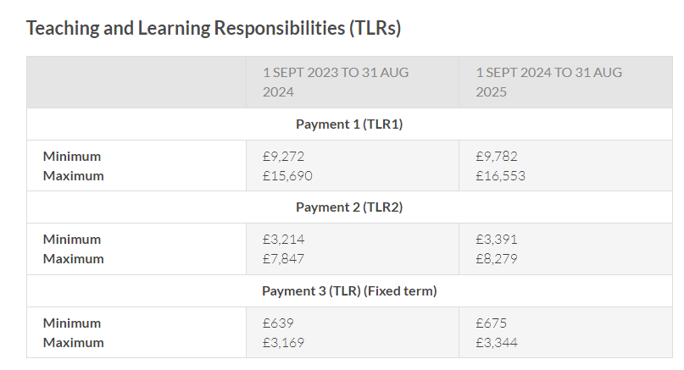

A teacher may not hold a TLR1 or TLR2 concurrently; however, a teacher in receipt of either allowance may also hold a TLR3 for specific time limited school improvement projects outside of remit of their current allowance or for a one off external driven responsibility (by monthly payment).

A TLR is a payment integral to a post in the schools staffing structure and therefore may only be held by two or more people when job sharing that post.

A TLR1 or TLR2 awarded to part-time teachers must be paid pro-rata at the same proportion as the teacher’s part-time contract and a full TLR cannot be paid to a part time teacher. The pro-rata principle does not apply to a TLR3 awarded to a part-time teacher.

TLR 1s and TLR 2s cannot be paid on a temporary or fixed-term basis except where a teacher is occupying another post in the temporary absence of the post holder. The award may be while the teacher remains in the same post or occupies another post in the temporary absence of the post holder.

TLRs awarded to teachers employed under a fixed term contract or whilst they occupy another post in the temporary absence of the post holder will not be safeguarded after the fixed term contract expires or after the date (or circumstance if occurring earlier than that date) as notified to the teacher, which will bring the fixed period or fixed term contract to an end.

TLR payments will cease when teachers move to different schools. They can also cease where responsibilities are restructured. In the case of a restructure the sum of the TLR (TLR 1s + 2s only) may be subject to safeguarding.

**17.2 Special Educational Needs (SEN) allowances**

A SEN allowance is payable to a classroom teacher:

* in any SEN post that requires a mandatory SEN qualification and involves teaching pupils with SEN;
* in a special school;
* who teaches pupils in one or more designated special classes or units in a school or, in the case of an unattached teacher, in a local authority unit or service;
* in any non-designated setting (including any PRU) that is analogous to a designated special class or unit, where the post -

1. involves a substantial element of working directly with children with special educational needs;
2. requires the exercise of a teacher’s professional skills and judgement in the teaching of children with special educational needs; and
3. has a greater level of involvement in the teaching of children with special educational needs than is the normal requirement of teachers throughout the school or unit within the school or, in the case of an unattached teacher, the unit or service.

Where a SEN allowance is to be paid, the relevant body must determine the spot value of the allowance, taking into account the structure of the school’s SEN provision and the following factors-

* whether any mandatory qualifications are required for the post;
* the qualifications or expertise of the teacher relevant to the post; and
* the relative demands of the post.

The relevant body will also establish differential values in relation to SEN roles in the school in order to reflect significant differences in the nature and challenge of the work entailed so that the different payment levels can be objectively justified.

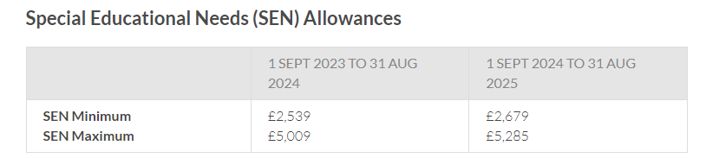SEN allowances may be held at the same time as TLRs. However, the relevant body should ensure that holders of SEN allowances are not carrying out tasks that would be more appropriately undertaken by support staff. The relevant body should also consider whether, if teachers have responsibilities that meet the criteria for the award of a TLR payment, it would be more appropriate to award a TLR payment.

**17.3 Other Additional Payments**

The relevant body may make additional payments as they see fit to a teacher, other than a Headteacher in respect of:

* continuing professional development undertaken outside the school day;
* activities relating to the provision of initial teacher training as part of the ordinary conduct of the school;
* participation in out-of-school hours learning activity agreed between the teacher and the Headteacher or, in the case of the Headteacher, between the Headteacher and the relevant body;
* additional responsibilities and activities due to, or in respect of, the provisions of services by the Headteacher relating to the raising of educational standards to one or more additional schools.

Payment will be calculated on a daily basis at 1/195th of the teacher’s actual salary.

**17.4 Recruitment and Retention Incentives and Benefits**

The relevant body may consider paying recruitment or retention awards in circumstances where they anticipate or encounter recruitment and/or retention difficulties. They may award an annual allowance, lump sum payment, periodic payment or provide other financial assistance, support or benefits to a teacher as they consider necessary as an incentive for the recruitment of new teachers and the retention of existing teachers.

In particular the relevant body will determine:

* Whether the award is for recruitment or retention.
* The nature of the award.
* When/how the award will be paid.
* The start date and duration of the award.
* The basis for any uplift that may be applied.

The Relevant Pay Committee will award such allowances where, in their view:

* The post is considered to be difficult to fill.
* The post holder teaches a subject in which there is a shortage of teachers.

and will ensure that these criteria are consistently applied.

If the Pay Committee thinks it is relevant to apply an incentive, they will clearly state in writing to the employee the amount, the expected duration of any recruitment or retention benefits and the review date that the incentive may be withdrawn.

The relevant body will conduct an annual formal review of all such awards. A review of rates will be necessary if the Relevant Body intends to increase the level of these awards in line with general increases to salaries, or in other circumstances which the Relevant Body may determine.

**17.5 Initial Teacher Training Activities (ITT)**

The relevant body has discretion to make additional payments to all teachers (including Headteacher) for activities related to providing ITT. They will consider payments to teachers where it is demonstrated that they are currently engaged in such activities and where it is financially practicable for the school to do so.

This may be determined as a daily or hourly rate calculated with reference to the teacher’s actual pay or where appropriate at a higher level to reflect the responsibility and size of the commitment; e.g. A higher rate may be determined by multiplying the daily or hourly rate by a factor, e.g., x1.5, x2

Suggested areas include supervising and observing teaching practice, giving feedback to trainee teachers on their performance, acting as a professional mentor, running seminars or tutorials on aspects of the course, and formally assessing students’ competence.

Other aspects of ITT activities cannot be regarded as part of the ordinary conduct of the school. Such activities include the additional requirements of School Centred ITT (SCITT), where schools take the lead in providing ITT courses. They may include planning and preparing materials for an ITT course and taking responsibility for the well-being and tuition of ITT students.

Teachers who undertake ITT activities which are not seen as part of the ordinary running of the school will be issued with separate contracts of employment which are not on teachers’ terms and conditions, to cover those areas of work that are not part of their substantive teaching job or contract of employment.

### **17.6 Continuing Professional Development**

Teachers who undertake voluntary continuing professional development outside the school day may be entitled to an additional payment if this is agreed in advance. Relevant bodies should decide which CPD activities teachers may be paid for and set an appropriate level of payment. This may be determined as a daily or hourly rate calculated with reference to the teacher’s actual pay or where appropriate at a higher level to reflect the responsibility and size of the commitment.

Payments to classroom teachers should only be made in respect of those activities undertaken outside of either the 1265 hours (1258.5 hours for the school year beginning in 2023) of directed time for full-time teachers; or the appropriate proportion of the 1265 hours (1258.5 hours for the school year beginning in 2023) of directed time for part-time teachers. Participation in CPD outside of directed time is voluntary and cannot be directed.

### **17.7 Out-of-school learning activities**

Teachers who agree to provide learning activities outside of the normal school hours may be entitled to a payment if this is agreed in advance. This may be determined as a daily or hourly rate calculated with reference to the teacher’s actual pay or where appropriate at a higher level to reflect the responsibility and size of the commitment. Payments to classroom teachers should only be made in respect of activities undertaken outside of directed time.

Activities that may attract payment include breakfast clubs, homework clubs; summer schools, outdoor activities and clubs linked to the curriculum and one to one tuition taking place outside the school day where the activities require the exercise of the teacher’s professional skills or judgement.

With the remodelling of the school workforce and the need to ensure downward pressure on teachers’ working hours many schools are using support staff and other adults to undertake these activities.

### 

### **17.8 Provision of services**

The relevant body has discretion to make payments to a Headteacher who provides an external service to one or more additional schools, for example as a National Leader of Education (NLE) and also to any of the school’s teachers whose post acquires additional responsibility as a result of the Headteacher’s activities. Payments are not automatic. Detailed guidance on the operating principles and requirements which apply to the provision of services to other schools is set out in the STPCD document, section 3 – paras. 65-68. Any decision should be appropriately recorded.

**17.9 Residential Duties**

The pay committee will take account of agreements reached in the National Joint Council for Teachers in Residential Establishments in determining payments for residential duties.

**17.10 Honoraria**

The relevant body will not pay any honoraria to any member of the teaching staff for carrying out their professional duties as a teacher. There is no provision within the School Teachers’ Pay and Conditions STPCD document for the payment of any bonuses or honoraria in any circumstances.

**18 SALARY SACRIFICE ARRANGEMENTS**

Where the employer operates a salary sacrifice arrangement, a teacher may participate in any arrangement and their gross salary shall be reduced accordingly.

The term “salary sacrifice arrangement” means any arrangement under which the teacher gives up the right to receive part of the teacher’s gross salary in return for the employer’s agreement to provide a benefit-in-kind under any of the following schemes:

a) a childcare voucher or other childcare benefit scheme;

b) a cycle or cyclist’s safety equipment scheme; or

Where the employer operates a salary sacrifice arrangement, the teacher may participate in any such arrangement and the teacher’s gross salary may be reduced accordingly for the duration of such participation.

Participation in any salary sacrifice arrangement has no effect upon the determination of any safeguarded sum to which the teacher may be entitled under any provision of this STPCD document.

The relevant body should ensure that any relevant information about such arrangements is passed on to teachers at their school, to enable the teachers freely to decide whether or not salary sacrifice is an appropriate option. Participation in salary sacrifice is voluntary on the part of current employees. Employers may not withhold access from those wishing to participate.

**19 SAFEGUARDED PAYMENTS AND ALLOWANCES**

Safeguarding arrangements will apply according to the provisions of the STPCD document, part 5, paras. 29 - 37

Where pay decisions are taken which lead to a teacher receiving safeguarding, they will be given written notification as soon as possible and no later than one month after the decision.

A safeguarded sum will not be increased during the safeguarding period. The safeguarded sum will be payable for a maximum period of three years.

Teachers entitled to safeguarding in excess of £500 may be required to undertake additional responsibilities commensurate with the safeguarded sum for the period of safeguarding.

There is provision for teachers who occupy another post on a temporary basis to have their safeguarding restored on return to their original post (unless it would otherwise have ceased).

General safeguarding applied on or before 31 December 2005 is not subject to the three-year limit.

**APPENDIX 1 – LEADERSHIP PAY RANGE**

#### Leadership Group

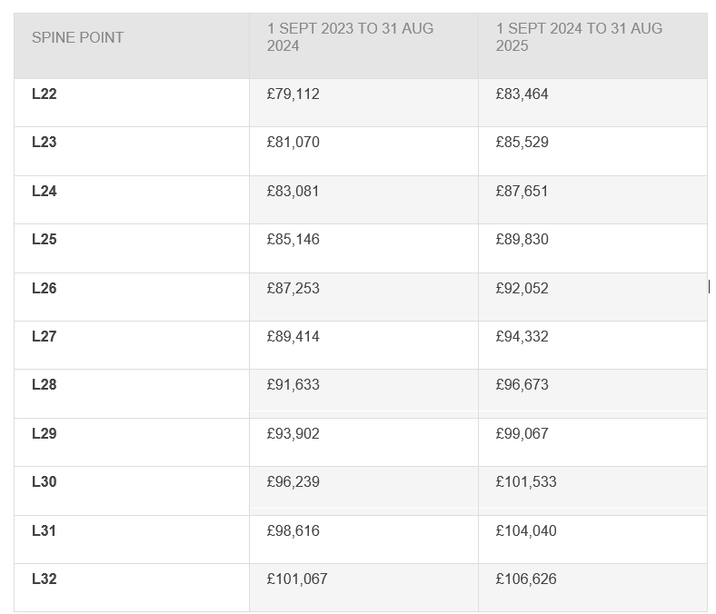

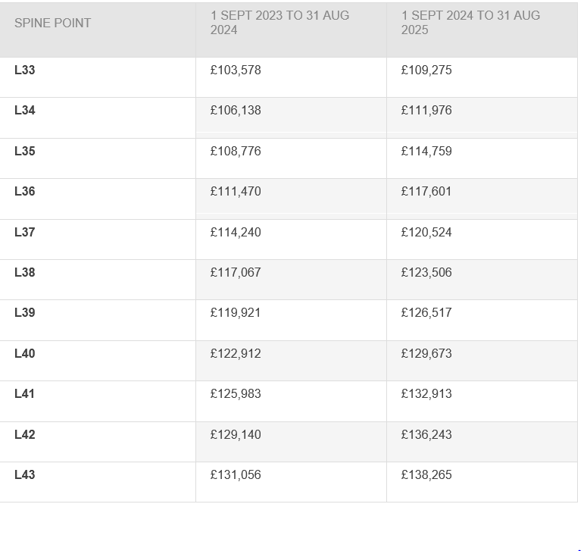

**APPENDIX 2 – APPEALS PROCEDURE**

The School Teachers’ Pay and Conditions Document (“the STPCD document”) requires schools and local authorities to have a pay policy in place that sets out the basis on which teachers’ pay is determined and the procedures for handling appeals.

As part of the overall appraisal process, a pay recommendation is made by the appraiser/reviewer (normally the line manager) and discussed with the teacher at their review meeting prior to being submitted to the school’s Pay Committee or relevant decision-making body. Written details of and the reasons for the pay recommendation will be given to the teacher.

At this particular stage of the pay determination process, if the teacher wishes to better understand the rationale for the pay recommendation or bring any further evidence to the attention of the appraiser/reviewer, they should be given the opportunity to do so before the final pay recommendation is drafted in the appraisal report. The nature of any subsequent appraisal and pay discussion will be informal and therefore representation (on either side) is not necessary, nor would it be appropriate. At the conclusion of any further discussion, the pay recommendation may be adjusted, or it may remain the same; the appraisal report will be updated to reflect the discussion.

If a teacher believes that the final pay recommendation falls short of their expectations and they wish to seek a further review of the information that affects their pay, they may wish to formally appeal against the decision, utilising the formal Appeal Hearing Procedure. Appeal Hearings against pay decisions must satisfy the dispute resolution requirements of employment law (i.e., Part 4 of the Trade Union and Labour Relations (Consolidation) Act, 1992) and the ACAS Code of Practice.

**2.1 Appeal Hearing Procedure**

If, after notification, a teacher does not consider that the school’s Pay Committee/relevant decision-making body has taken all the relevant information into account they have the right to appeal against the decision.

**2.2 General principles**:

A teacher may seek a review of any determination in relation to their pay or any other decision taken by the relevant body (or a committee or individual acting with delegated authority) that affects their pay.

The decision of the appeal panel is final. There is no further internal process available once the appeal stage has been completed.

**2.3 Appeal Procedure**

The following list, which is not exhaustive, includes the usual reasons for seeking a review of a pay determination:

That the person or committee by whom the decision was made –

a) incorrectly applied any provision of the school’s pay policy or

incorrectly applied any provision of the Statutory pay document

b) failed to have proper regard for statutory guidance

c) failed to take proper account of relevant evidence

d) took account of irrelevant or inaccurate evidence

e) was biased, or

f) otherwise unlawfully discriminated against the teacher.

The order of proceedings is as follows:

1. The teacher receives written confirmation of the pay determination and where applicable the basis on which the decision was made.
2. If the teacher is not satisfied, they should seek to resolve this by discussing the matter informally with the decision-maker within ten working days of the decision.
3. Where this is not possible, or where the teacher continues to be dissatisfied, they may follow a formal appeal process.
4. The teacher should set down in writing the grounds for questioning the pay decision and send it to the person (or committee) who made the determination, within ten working days of the notification of the decision being appealed against or of the outcome of the discussion referred to above.
5. Any appeal should be heard by a panel of at least three governors (or Trustees or equivalent) who were not involved in the original determination normally within 20 working days of the receipt of the written appeal notification and giving the employee at least 10 working days’ notice of the date of the appeal hearing.
6. For any hearing the employee is entitled to be accompanied by a colleague or union representative. Each step and action of this process must be taken without unreasonable delay. The timing and location of the formal meeting must be reasonable and must allow both parties to attend and explain their case.
7. At the appeal hearing, the appellant will set out the reasons why they consider the salary assessment to be inappropriate and provide evidence to support their case. The Headteacher will be called to give evidence as to the information that was provided to the initial salary review committee that will have guided their considerations. The Chairman or another member of the initial salary review committee will then explain the reasons for the decision that was taken.
8. This procedure performs the function of the grievance procedure and therefore pay decisions cannot be reopened under the general grievance procedures.
9. In the event of a complaint by the Headteacher, the Chair of Governors will act as the Review Officer, unless the Chair has been previously involved in the performance review proceedings. In this case another non-staff Governor should act as the Review Officer.
10. The appeal committee will retire to consider any new evidence that has been presented and may either:

* Uphold the appeal and award additional salary spinal point(s).
* reject the appeal.

1. The decision of the appeal panel will be given in writing within 5 calendar days, and where the appeal is rejected will include a note of the evidence considered and the reasons for the decision.

**APPENDIX 3 - APPLICATIONS TO MOVE TO THE UPPER PAY RANGE**

Any qualified teacher can apply to be paid on the Upper Pay Range and any such application must be assessed in line with this policy. It is the responsibility of the teacher to decide whether or not they wish to apply to be paid on the upper pay range.

Applications may be made once a year.

Applications to move to the Upper Pay Range must be made by 31st of October

An application made between 1 September and up to 31st October for consideration, if successful will be backdated to 1 September.

All applications should include the results of the two most recent appraisals. Where such information is not applicable or available, e.g., those returning from maternity or sickness absence, a written statement and summary of evidence designed to demonstrate that the applicant has met the assessment criteria must be submitted by the applicant.

For the assessment to be robust and transparent, it will be an evidence-based process only. Teachers therefore should ensure that they build a mainly paper evidence base to support their application. Those teachers who are not subject to the Appraisal Regulations 2012, or who have been absent, through sickness, disability, or maternity, may cite written evidence from a 3-year period before the date of application in support of their application.

If a teacher is simultaneously employed at another school(s), they may submit separate applications if they wish to apply to be paid on the UPR in that school(s). This school will not be bound by any pay decision made by another school.

**3.1 Process**:

One application may be submitted annually. The closing date for applications is normally 31st Octobereach year; however, exceptions will be made in particular circumstances, e.g., those teachers who are on maternity leave or who are currently on sick leave. The process for applications is:

* Submit previous two appraisals and supporting evidence to the Headteacher during the Performance Management window (pre 31st October each year)
* You will receive notification of the name of the assessor of your application within 5 working days
* The assessor will assess the application, which will include a recommendation to the pay committee of the relevant body
* The application, evidence and recommendation will be passed to the Headteacher for moderation purposes, if the Headteacher is not the assessor
* The pay committee will make the final decision, advised by the Headteacher
* Teachers will receive written notification of the outcome of their application after it has been approved by the Pay Committee.
* Successful applicants will move to the minimum of the UPR on 1 September of the relevant year.
* Where the application is unsuccessful, the written notification will include the areas where it was felt that the teacher’s performance did not satisfy the relevant criteria set out in this policy (see ‘Assessment’ below)
* If requested, oral feedback which will be provided by the assessor. Oral feedback will be given as soon as possible within 10 school working days of the date of notification of the outcome of the application. Feedback will be given in a positive and encouraging environment and will include advice and support on areas for improvement in order to meet the relevant criteria
* Unsuccessful applicants can appeal the decision. The appeals process is set out at the back of this pay policy

Successful applicants will be placed on point 1 of the Upper Pay Range.

**3.2 Assessment**

An application from a qualified teacher will be successful where the relevant body is satisfied:

* the teacher is **highly competent** in all elements of the teacher standards (and/or other relevant standards); and
* the teacher’s achievements and contribution to the school are **substantial** and **sustained**.

In this school, this means:

“**highly competent**”: the teacher’s performance is assessed as having excellent depth and breadth of knowledge, skill and understanding of the Teachers’ Standards in the particular role they are fulfilling and the context in which they are working. To a level which is good enough to provide coaching and mentoring to other teachers, give advice to them and demonstrate to them effective teaching practice and how to make a wider contribution to the work of the school, in order to help them meet the relevant standards and develop their teaching practice.

“**substantial**”: the teacher’s achievements and contribution to the school are significant and add value, not just in making a distinctive contribution to raising standards of teaching and learning in their own classroom, or with their own groups of children, but also in making a significant wider contribution to school improvement, which impacts on pupil progress and the effectiveness of staff and colleagues. Includes taking advantage of professional development and using the outcomes effectively to improve pupils learning.

“**sustained**”: Maintained continuously over a significant period. The teacher must have had two consecutive successful appraisal reports in this school and have made good progress towards their objectives during this period (see exceptions, e.g., maternity/sick leave, in the introduction to this section). They will have been expected to have shown that their teaching expertise has grown over the relevant period and is consistently good to outstanding.

For the purposes of this pay policy, the relevant body will be satisfied that the teacher has met the expectations for progression to the upper pay range where the Upper Pay Range Criteria have been satisfied as evidenced by two successful and consecutive performance management/appraisal reviews.

Further information, including information on sources of evidence is contained within the school’s appraisal policy.