
SMSC Year 1 Provision
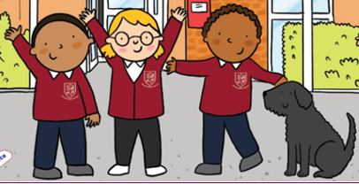
Spiritual  - Discussing the different cultures and religions in our school  - Celebrating Festivals: Diwali, Eid, Lunar New Year, Christmas, Easter, saying how they are different  - Listening to spiritual Stories: Rama and Sita, The Big Race, The Nativity, The story of Easter  - Judaism: Shabbat, Yom Kippur  - Islam: Why do Muslims celebrate Eid?  - Hinduism: Diwali, The Festival of Lights  - Christianity: Jesus as a Friend  - Whole school and Class assemblies, sharing ideas  - Mindfulness: Jigsaw and PSHRE  - Singing, including Harvest and Christmas | Moral  - Reading and sharing Moral Stories from Different Countries and Religions: learning the names of the characters from the story of Diwali  - Discussing good and bad characters and behaviours from stories, and re-enacting the events e.g. The Little Red Hen  - Identifying anti-social and bullying behaviour (Anti-bullying  - Explaining the meaning of truth through our value of honesty  - Knowing how others feel through our value of empathy  - Demonstrating Kindness independently  - Modelling good behaviour for others  - Donating toys and other items for our school fair  - Helping to organise our donations for the Food Bank
Social  - Role Play: Goldilocks and The Three Bears, The Tiger who came to Tea  - Home Corners and Book Corners  - School Trip to Beale Park  - Christmas Nativity Plays  - Presenting in Class Assemblies  - Participating in Sports Day at St Pauls.  - Visitors to School: Louis Taylor Road Show, Scooter Training  - Sharing and taking turs in PE | Cultural  - Performing an Indian Dance to help celebrate Diwali  - Choreographing a Dragon Dance during Lunar New Year  - Maypole Dancing  - African drumming  - The UK: England, Scotland, Wales and Northern Ireland  - Respect and Tolerance: how are we different?  - ROBOTS: How to keep safe on the internet?  - Guided Reading; books from other cultures  - School lunches from other cultures, trying different foods

