BONJOUR! YOUR FRENCH CLUB AT WALTER INFANT SCHOOL IS WAITING FOR YOU THIS SUMMER TERM 2023!

BONJOUR! My name is Madame Thonon and I run the French club at Walter Infant School. We have a fantastic programme to help children learning French through fun and educational activities. My goal is to make learning French fun through games, loads of songs, stories and role-plays – with our programme designed specifically for Y1 and Y2 pupils. I want all my pupils to have the opportunity to excel at French and I offer the children a solid grounding of basic grammar and vocabulary, a specialist experience in French language and a native speaker accent, in a COVID19 compliant environment. Learning French with us will set your child in good stead when they join St Paul’s School and start learning French in the curriculum, they will shine with all the knowledge they will gain from attending our classes!

SO, PLEASE JOIN US AND HAVE LOADS OF FUN WHILST LEARNING FRENCH !

The benefits of learning a language in early years are numerous. Here is a brief summary:
- Do better at school, in all areas of the curriculum  - Show superior problem-solving skills  - Increased self-esteem and confidence  - It gives your brain a good workout and keeps it younger for longer! | - Develop easily a native-like accent when young  - Better chances at college applications and bigger career choices  - Greater understanding of the world  - Understand your mother language better

Classes are small (maximum of 12 children per class) and will run for Y1 and Y2 children on Thursdays afterschool for 30 mins. Classes are offered at £6.00 per lesson and fees are payable before the start of the term. Children additionally purchase a book, CD and app package at a one-off cost of £20.00 which lasts at least one academic year.

If you are interested in your child joining our French club, please email me your child’s details (see at the bottom of this letter) promptly to book your place. I will then contact you personally to arrange for registration. All places will be allocated on a first-come basis, with confirmations sent out as soon as possible on receipt of your payment and registration forms.

If you have any queries about the classes, please do not hesitate to contact me directly.
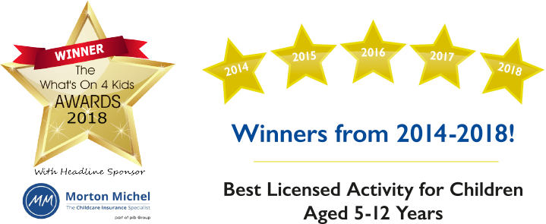
Kind regards,

Laurence Thonon
La Jolie Ronde Licensee
Phone: 0777 265 83 87
Email: laurencethonon@yahoo.com

------------------PLEASE SEND THE FOLLOWING DETAILS BY EMAIL TO REGISTER------------------

I would like to register my child/ren for the La Jolie Ronde French club at Walter Infant School

Name of child/ren.....................................................................................................DOB......................................................................
School Yr (in sept).......................................................... Class name in September …………………………………….....................
Tel. No:....................................................................................Mobile:...................................................................................................
Name of parent/guardian: .......................................................................................................................................................................
Email :.....................................................................................................................................................................................................
Address......................................................................................................................................................................................................................................................................................................................................................................................................................................................................................................................................................................................................................................

