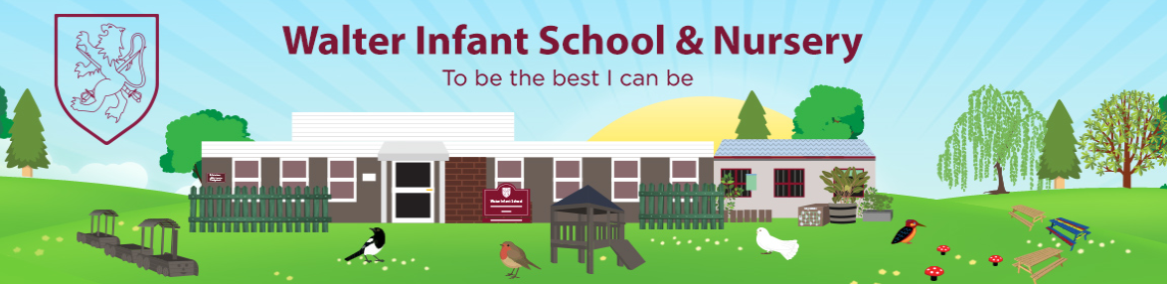
SMSC Foundation Stage Provision
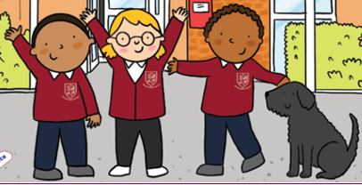
Spiritual  - Learning about the different cultures and religions in our school  - Celebrating Festivals: Diwali, Eid, Lunar New Year, Christmas, Easter  - Listening to spiritual Stories: Rama and Sita, The Big Race, The Nativity, The story of Easter  - Recognising some religious symbols, Easter Eggs, Diwas, Rangoli Patterns, Lanterns, Candles, Crosses, Stars etc  - Awe and Wonder of the Natural World; exploring nature, noticing change, including seasonal change  - Look Out Station and Bug Hunts  - Naming our school Values and recognising our animals.  - Mindfulness and ‘Paws’ for thought | Moral  - Moral Stories from Different Countries and Religions: learning the names of the characters from the story of Diwali  - Identifying good and bad characters and behaviours from stories, and re-enacting the events e.g. The Little Red Hen  - Wearing and colouring Odd Socks during Anti-bullying Week  - Learning about the truth through our value of honesty  - Supporting our friends through our value of empathy  - Kindness leaves and describing kind behaviour  - Following our class expectations for behaviour  - Helping to raise awareness of national charities, e.g. Red Nose Day, Jeans for Genes Day  - Sharing food from home for the food bank.
Social  - Role Play: TheLittle Red Hen, The Gingerbread Man  - Home Corners and Book Corners  - School Trip to Wellington Country park  - Stay and Play  - Class Assemblies  - Christmas Songs for families to share  - Sports Day  - Visitors to School: People who help Us!  - Birthday Celebrations in Class | Cultural  - Indian Dance Day to help celebrate Diwali  - The Dragon Dance during Lunar New Year  - Tasting food from other cultures, e.g. The Runaway Chapati alongside The Gingerbread Man  - Our home corners have food and clothes from other cultures  - Sharing home languages with classmates  - Self-portraits and Family Trees  - Sharing Traditional Stories and Rhymes at home and school  - Toys and dolls from other cultures

