Walter Infant School and Nursery
School Development Targets 2022 2023

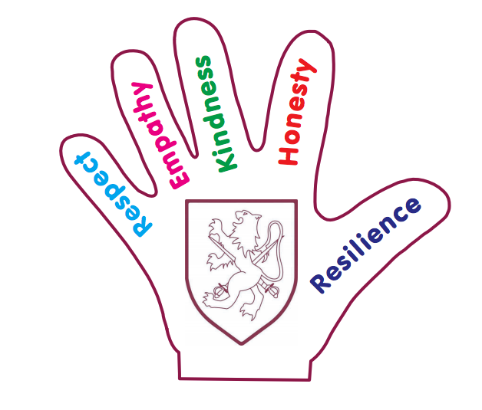
Quality of Education

To account for delays and gaps in learning that have arisen and continue to arise as a result of the pandemic (OFSTED 2022)

To research and invest in an SSP that closely matches our resources and our Ethos!
To close the vocabulary gap between disadvantaged children and all children!
Behaviours and Attitudes
To develop our Behaviour Curriculum; imbedding our new Behaviour Policy built on our Therapeutic Thinking approach
To complete 2022 Anti-Bullying Behaviour Training for all staff from the Anti-Bullying Alliance
Personal Development
To embed our goals for Cultural Capital for all our children focussing on our most disadvantaged children from lower socio-economic groups and vulnerable groups
To develop Mental Health Plans for children experiencing anxiety or attachment disorders
Leadership and Management
To support our new Senior Leadership Team as we move forward after the significant changes to leadership in 2022 2023
To ensure that Safeguarding is a priority for all members of our school community, including concerned neighbours and families.

To document that all staff, governors, volunteers, and club providers have a working knowledge of Keeping Children Safe in Education 2022 and the legal responsibilities when working with children

