Pupil Premium Strategy Statement for Walter Infant School and Nursery 2021-2022
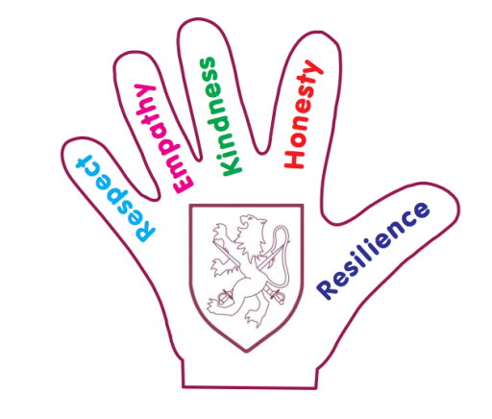
School Overview
Metric | Data
School name | Walter Infant School and Nursery
Pupils in school | 303
Proportion of disadvantaged pupils | 11%
Pupil premium allocation this academic year | £38,625
Academic year or years covered by statement | 2021-2022
Publish date | May 31st 2021
Review date | March 31st 2022
Statement authorised by | Judy Wheeler & Karen Day
Pupil premium lead | Judy Wheeler
Governor lead | To be agreed

Walter Infant school and Nursery: Curriculum Services PUPIL PREMIUM
Income for 2021/22 | £38,625
Salary Costs | £10,147
Balance to be allocated | £28,478

PPG Expenditure
Training | Mental wellbeing training and resources, Therapy Dog Training for dog and staff, Speech and Language training and resources  Therapeutic Thinking Training | £4,500
Clubs for PPG Children | All extra-curricular clubs (1club per child per year) and Robin Lunch Club for EYPPG | £4,000
Cool Milk | For PPG who choose to have milk | £675
Canine Assisted Learning | 6 sessions (for 5 children) per half term | £4,500
School Trips | Financial support for PPG children for trips and visitors | £770
Family Support | Sessions for families in receipt of PPG | £100
Resources | Reading Books, Classroom Resources, toys for inside and outside play to fill the Cultural Capital Gaps | £5,000
 | Wiggle Waggle Sessions for all Foundation Children | £1500
Uniform/Clothing | PPG children and disadvantaged children | £800
Additional Support (salaries) | For children with Special Educational Needs and other disadvantages (Double and Triple Deficit) | £6,000
 | Total Allocated Spend | £27,845  Var. £633

Disadvantaged pupil outcomes for the end of FS1 last academic year (2020 Teacher Assessment re: COVID 19)
Measure end of Year FS1 | Score 2020 All | Score 2020 EYPPG  (2 children)
Age Related Expectations in Writing | 70% | 50%
Age Related Expectations in Reading | 70% | 100%
Age Related Expectations in Mathematics | 70% | 100%

FS1 30 hours 2020 ARE
 | EYPPG  0 | All children | Gap
Writing | 0 | 100% | N/A
Reading | 0 | 94% | N/A
Maths | 0 | 94% | N/A
FS1 15 hours 2020 ARE
 | EYPPG  2 | All children | Gap
Writing | 50% | 70% | 20%
Reading | 100% | 70% | 30%+
Maths | 100% | 70% | 30%+

Disadvantaged pupil progress outcomes for the end of FS2 last academic year (2019 data and 2020 Teacher Assessment re: COVID 19)

End of Year EYFS FS2 Data

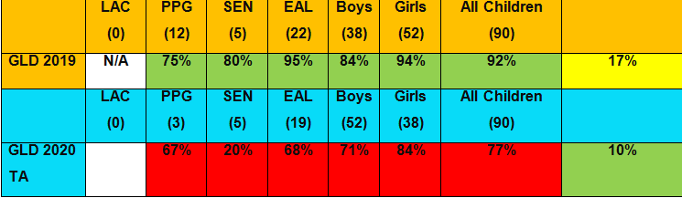
PPG SEN EAL Boys Girls All
Measure end of Year FS2 GLD | Score 2019 data | Score 2020 TA
Good Level of Development | 75% | 67%

Disadvantaged pupil attainment for end of year 2 last academic year (2019 data and 2020 Teacher Assessment re: COVID 19))
Year 2 cohort 2020
All | PPG | SEN | EAL | Boys | Girls
90 | 16 | 9 | 22 | 52 | 38

Year Two end of year results 2019 for ARE +
 | PPG | SEN | EAL | Boys | Girls | All children
Writing | 74% | 33% | 87% | 82% | 86% | 84%
Reading | 75% | 50% | 87% | 83% | 86% | 85%
Maths | 93% | 67% | 96% | 88% | 94% | 91%
Science | 100% | 100% | 100% | 100% | 100% | 100%
Year Two end of year results 2020 for ARE + Teacher Ass
 | PPG | SEN | EAL | Boys | Girls | All children
Writing | 75% | 87% | 95% | 90% | 94% | 91%
Reading | 75% | 87% | 95% | 88% | 94% | 91%
Maths | 75% | 87% | 95% | 95% | 90% | 92%
Science | 100% | 100% | 100% | 100% | 100% | 100%

Measure end of Year 2 for PPG | Score 2019 data | Score 2020 TA
Reading | 75% | 75%
Writing | 74% | 75%
Maths | 93% | 75%

Targets for Disadvantaged Children
Measure @ end of KS1 | Score
Meeting expected standard at KS1 | 85%
Achieving high standard at KS1 | 25%
Measure @ end of FS2 | Score
Meeting expected standard at FS2 | 85%
Achieving high standard at FS2 | 25%
Measure @ end of FS1 | Score
Meeting expected standard at FS1 | 85%

Teaching and Learning Aims for All Children

Measure | Activity
Priority 1  Our children know how to learn  100% of all PPG children make good or better progress from their starting points | Metacognition: our focus will continue to be ensuring the children know how to learn: EEF Metacognition and Self-Regulated Learning.  “Self-regulated learners are aware of their strengths and weaknesses, and can motivate themselves to engage in, and improve their learning” EEF  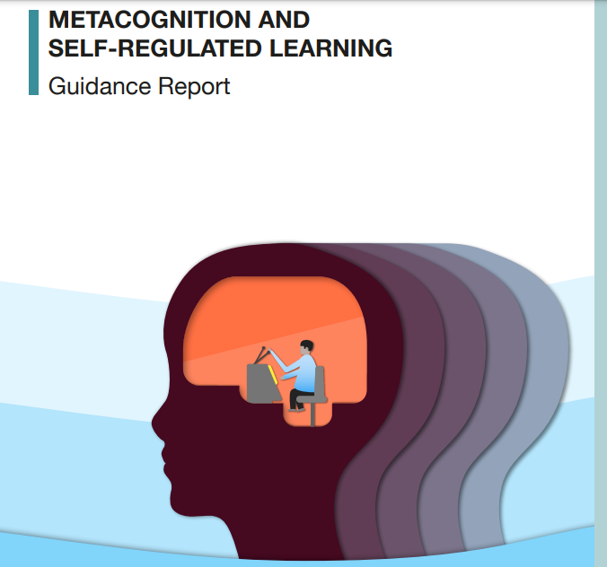  CPD for all classroom staff delivered in the summer term 2021 Cost £585  https://cpd.thekeysupport.com/teaching-and-learning/metacognition-learning-to-learn/
Barriers to learning these priorities address: | Poor behaviours for learning can prevent the children from making expected or better progress.
Projected spending | Staffing - £10147  Reading Books and other resources - £3000  Total: £13147

Teaching priorities for current academic year
Aim | Target | Target date
Progress in Reading | 100% good or better progress  85% at ARE | July 2021  March 2022
Progress in Writing | 100% good or better progress  85% at ARE | July 2021  March 2022
Progress in Mathematics | 100% good or better progress  85% at ARE | July 2021  March 2022
Phonics | 100% good or better progress  85% at ARE | July 2021  March 2022
Other | 100% good or better progress  85% at ARE | July 2021  March 2022

Remember to focus support on disadvantaged pupils reaching the expected standard in phonics check at end of year 1.

Targeted academic support for current academic year
Measure | Activity
All children including PPG and the most disadvantaged make good or better progress from starting points in reading, writing and mathematics | All children with identified mental health issues are receiving the support they need to be well and to make progress  School Therapy Dog in school each day  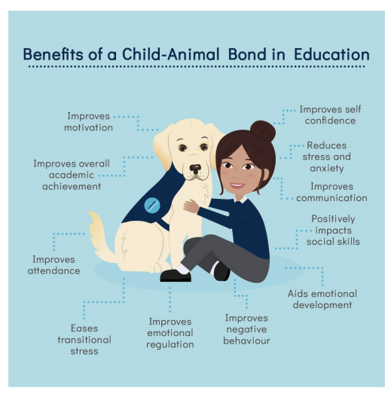  https://theconversation.com/dogs-in-the-classroom-coming-to-a-school-near-you-soon-114392  “University of Buckingham, Sir Anthony Seldon, who made a speech at the university’s “Ultimate Wellbeing” conference promoting school dogs as “a powerfully cost-effective way … to improve mental health in our schools”. Also in attendance at the conference was Damian Hinds, UK education secretary, who spoke in support of bringing dogs into schools to enhance well-being and claimed every school should adopt one.”  £4250 dog and training  £4500 Canine Assisted Learning
Staff are able to identify and support children with poor behaviours for learning due to metacognition deficiency | Training for all staff to identify current mental health issues presenting in school including anxiety, OCD, Attachment and separation  CPD on Metacognition for all classroom based staff  £250 OLT Training
Barriers to learning these priorities address | Lack of knowledge/understanding about different Mental Health Issues which impact on the well-being of children  We have a Mental Health Lead and Two mental Health Champions in school. All staff have received Mental Health First Aid Training.  The Mental Health Leader and Mental Health Champion will attend further training in September 2021  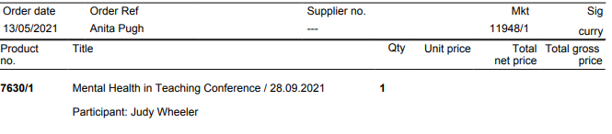  £120 Mental Health Training JW and SR
Projected spending | School Dog and Staff Training - £4250  Canine Assisted Learning - £4500  Staff Training - £370  Total: £9120

Wider strategies for current academic year
Measure | Activity
Priority 1  All children are ready and able to start learning  The gap between PPG children and all children diminishes throughout the year (based on ARE ~ 10% at the moment) | The children arrive at school calm and ready to learn OR we ensure that after arriving at school we can make provisions so that they are calm and readier to learn e.g. breakfast, home work, reading , clothing etc Maslow’s Hierarchy of Need  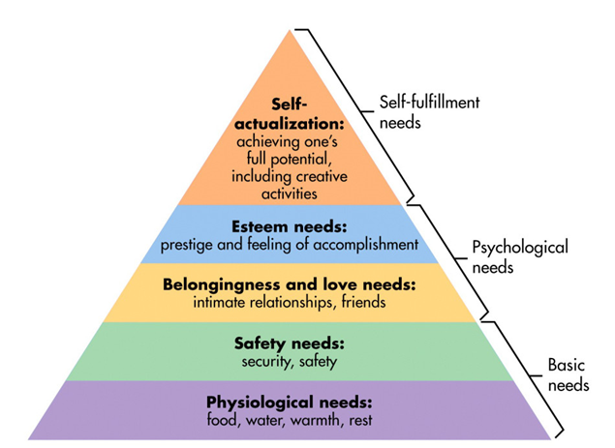  https://www.simplypsychology.org/maslow.html#gsc.tab=0  “Maslow's hierarchy of needs is a motivational theory in psychology comprising a five-tier model of human needs, often depicted as hierarchical levels within a pyramid. From the bottom of the hierarchy upwards, the needs are: physiological (food and clothing), safety (job security), love and belonging needs (friendship), esteem, and self-actualization.  Needs lower down in the hierarchy must be satisfied before individuals can attend to needs higher up.”
Priority 2  For all children to have extensive access to Character Education at Walter, including extra-curricular activities (including representation of 10% on the School Council), school visitors and school trips | - An Extra-Curricular Club for each child in School in receipt of PPG Funding, now also extended to I-Rock £2000  - Key Rhymes and Resources SEN £2000  - Wiggle Waggle: Music and Movement to develop gross Motor Skills and short term memory £1500  - Miller’s Ark visiting with animals for KS1~ many of our children have never been to a farm or a zoo and we have been unable to have a school trip this year  - Maypole Dancing (Cultural Capital) – why do we have May Day and May Bank Holidays?  - Olympic Dance Troupe –Tokyo 2021 for all children in FS2, Y1 and Y2
Priority 3  All children will have devices to access blended learning opportunities from home (Kindle Fire with home internet access). | Kindle Fire Tablets:  - 7" IPS display 16 or 32 GB of internal storage (up to 512 GB of expandable storage with microSD).  - Faster 1.3 GHz quad-core processor and 1 GB of RAM.  - Up to 7 hours of reading, surfing the web, watching video and listening to music.  - Enjoy your favourite apps like BBC iPlayer, Netflix, Disney+, Facebook, Instagram, TikTok, YouTube and more through the Amazon Appstore (Google Play Store not supported). Subscription fees may apply.  - Now hands free with Alexa.  - 2 MP rear-facing camera and HD 720p front-facing camera.  £49.99 each- we will budget for 11% of our new cohort of 116 children £1276
Barriers to learning these priorities address | Attendance of identified children (some of our most disadvantaged children have poor attendance and poor parental engagement) no cost  Lack of devices and internet to work from home  Reduced access to learning and support from home for identified PPG children (Personalised Plans in place and 1:1 support for reading) ~ closing the ‘Cultural Capital’ gap (including Wiggle Waggle)  “Cultural Capital is the essential knowledge that children need to prepare them for their future success. It is about giving children the best possible start to their early education.”  https://www.early-education.org.uk/cultural-capital#:~:text=Cultural%20capital%20is%20the%20essential,start%20to%20their%20early%20education.  https://eyfs.info/articles.html/leadership-and-management/the-theories-behind-cultural-capital-r253/  As a school, we will address the needs and disadvantaged of all our vulnerable children through a Personalised Pupil Premium Plan (these are viewed as a rucksack which contains the individual provision requirements of each child! For example:  Contents  1:1 reading, football club and football kit, milk, school uniform, school trip fund, Canine Assisted Learning once a week, collect child and bring to school
Projected spending | Wiggle Waggle - £1500  Clubs - £4000  School Trips - £770  SEN - £2000  Devices - £1276  Uniform and clothing - £800  Cool Milk - £675  Resources - £2000  Additional Staffing hours - £4000  Total: £17201

Total Projected Spend based on Priorities £39,468 (overspend £843 this includes estimated number of devices and Family Worker costs)

Monitoring and Implementation
Area | Challenge | Mitigating action
Teaching | To provide enough time and opportunity for good quality CPD to develop nurturing and therapy skills of staff | INSET days and Staff meeting time allocated to training for all staff
Targeted support | To close the gaps in reading between all children and disadvantaged children; particularly double deficit white-British boys due to lack of engagement from home | PPG Champions working with all children below ARE in Reading at least twice a week to develop understanding (inference and deduction)  New reading books (Dandelion) to support decoding and word recognition  Regular tracking, by classroom teacher, to monitor progress
Wider strategies | To close the Cultural Capital Gap between disadvantaged and all children | To provide personalised opportunities for children to learn more about the world around them e.g. pond dipping, bug hunts, school trips, visitors to school including a farm.

Review: last year’s aims and outcomes
Aim | Outcome
All our children will make good or better progress from their individual starting points. Measured by Point in Time assessments (PITAs), information from pupil performance meetings and end of year attainment. | See data above  The children did not have access to their full curriculum entitlement due to the Pandemic and Lockdown
Children eligible for the PP Grant with additional needs will make the same progress and attain at the same level as all children. Measured by book reviews, point in assessments and information from pupil performance meetings. | Double and triple deficit children in Year 2 made good progress in Reading, 3% went backwards in writing and 2 % went backwards in mathematics from September 2020 to the end of April 2021.
Children eligible for the PP Grant will make as much progress as all children. Measured by point in assessments (PITAs), information from pupil performance meetings and end of year attainment. | 67% FS2 PPG children achieved GLD compared with 77% but all made progress from their starting points by the end of July 2020, 6% of PPG children had not made good progress by the end of April 2021 (the school was closed from 1st January 2021 to 8th March 2021)  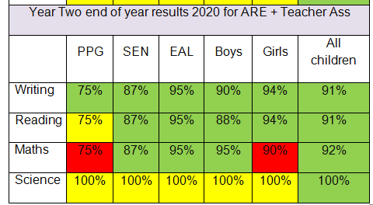
Communication and Language difficulties diminished for all children. Measured by review of speech and language programs, information from point in assessments and information from pupil performance meetings. | 87% of SEN children including SALT made good progress compared with 91% of all children in Reading and Writing and 92% of all children in mathematics
Children eligible for PPG to develop emotional resilience and social skills. Measured by attendance, performance in class and attitude to learning. This may include statements from adults and the child’s voice. | Our PPG children have proved to be extremely vulnerable throughout the pandemic. We have done all we can to support the children at home financially, emotionally and academically. As a result of too few resources we are now getting our own therapy dog to support the most disadvantaged of children
Attendance will be in line with or above the school target. This will be measured through attendance data. | 2.49% of PPG children had authorised absences compared with 2.19% of non-PPG children and 2.22% of all children
Children receive support from parents for school related tasks. Children are supported in homework and reading tasks. This will be measured by attendance, performance in class and attitude to learning. This may include statements from adults and the child’s voice. | We provided internet support for the disadvantaged children including PPG who did not have it and personal tablets (Kindle Fires) for all PPG children who did not have a device, most were using their parent’s phone. This enabled the parents to work with them or to support their older siblings at the correct time for live learning from other schools. All our disadvantaged children were offered a place Key Worker school, most accepted (only a couple ‘Forever6’ families chose not to).
Children eligible for the PP Grant and who are subject to a Child Protection or child in need plan, make the same progress as all children. This will be measured by point in assessments (PITAs), information from pupil performance meetings and end of year attainment. | All PPG children who were also CP children made progress from their starting points, however, 75% (3 children) were below ARE in reading, writing and mathematics (as well as phonics)  In 2020 2021 there was1 child only was eligible for PPG and subject to CP – this child has maintained E since 2020 to April 2021
Children eligible for the PP Grant and who are living in a low income family need to make the same progress as all children. This will be measured by point in assessments (PITAs), information from pupil performance meetings and end of year attainment. | All PPG/low income children have made progress from their starting points, but 17% of Year 2 children on Catch-Up Plans are PPG, in Year 1 20% are PPG and in FS2 23% are PPG; this shows that we will have to focus on both Personalised PPG Targets and Catch-Up targets for double deficit children with PPG.

