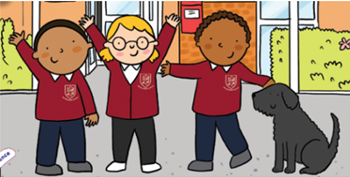

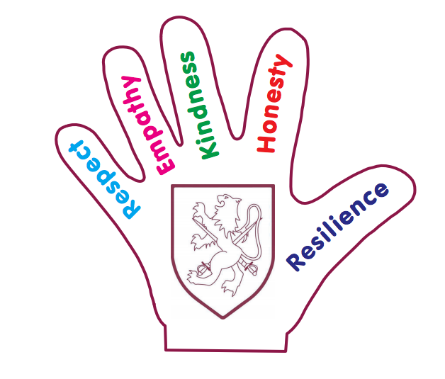

**Welcome to Walter Infant School and Nursery**

Thank you so much for visiting our website; my name is Judy Hargreaves and I am very proud to be the Headteacher of Walter Infant School and Nursery.

Walter Infant School and Nursery is unique; we call ourselves a BIG school for little people. The staff team at Walter Infant School and Nursery are committed to making our school a very happy place for our wonderful children to learn and play.

We are a Values-based School and our values of respect, kindness, honesty, empathy and resilience run through our school like a gentle, calming river, ensuring that our children feel safe, loved and cared for.

Our school motto is ***“To be the Best that I can Be!”*** We nurture our children to become the best version of themselves, celebrating all of their differences and learning alongside each other so that we can all do more, know more and remember more!

At Walter Infant School and Nursery, we understand how important choosing the right school is and so, on behalf of our pupils and staff, we warmly invite you to visit our school and experience for yourself the outstanding quality of education we provide.

Our school environment is perfect for young children; our buildings are very spacious and beautifully resourced and maintained, to ensure our children feel valued at all times. All our children make excellent progress from their starting points and leave us Junior School Ready.

Please have a really good look around our website to find out lots more about our brilliant school. If you would like to book a school tour, please follow this link, as it would be so lovely to show you around. <http://www.ticketsource.co.uk/walter-infant-school>



Judy Hargreaves and Walter our School Dog