Walter Infant School and Nursery
Murray Road Wokingham RG41 2TA
Tel: 0118 978 0825
www.walter.wokingham.sch.uk
admin@walter.wokingham.sch.uk
Headteacher: Mrs Judy Wheeler

Saturday 26th November 2022

Covid 19 changes from 21st February 2022

Dear Parents and Carers,

I hope you have all had a good half term break from school. As you will know, on February 21st, 2022, the Government made changes to their advice on how to manage the spread of infections of Covid 19 and I would like to share with you the most up to date guidance and the impact it will have on how we manage the virus in school until 1st April 2022.

Based on all the information you can access below (in this rather long, but necessary letter) these will be our expectations:

At Walter Infant School and Nursery, we will update our risk assessments and outbreak management plans to reflect the changes from the DfE. In addition to this, we will:
- Continue to send children with symptoms home and request that parents and carers follow the expectations listed above: What to do if you have Covid 19
- Provide PCR tests if required
- Manage our Covid 19 register and follow the due dates for return to school
- Maintain high cleanliness measures to reduce the spread of the virus

We will no longer expect face coverings to be worn outside whilst on our premises but will respect the wishes of those who continue to do so.

We will resume whole school assemblies (which I am particularly looking forward to) including whole school singing.

We would like the children to continue to wear PE kits on the days they have PE lessons. We will also continue to line up outside in Key Stage 1 as this has allowed the children to all enter school together which we believe works best.

A significant difference for our staff is:
From 21 February, the Government is removing the guidance for staff and students in most education and childcare settings to undertake twice weekly asymptomatic testing.
However, for as long as the tests are freely available, it is expected that a proportion of staff will continue to test regularly (it will be their own choice not a directive).
Below is the link I have received from the Department of Education:
https://www.gov.uk/government/publications/covid-19-people-with-covid-19-and-their-contacts/covid-19-people-with-covid-19-and-their-contacts

Updates to DfE guidance following the Prime Minister’s announcement
On Monday 21 February, the Prime Minister set out the next phase of the government’s COVID-19 response ‘Living with COVID-19’. COVID-19 continues to be a virus that we learn to live with and the imperative to reduce the disruption to children and young people’s education remains.

For the education and childcare sectors, the main changes announced include:
- changes to self-isolation and daily testing of close contacts
- changes to testing in education and childcare settings and children’s social care services
We (The DfE) have updated the following guidance to reflect these changes:
Our (The DfE) priority is to support you to deliver face-to-face, high-quality education to all pupils. The evidence is clear that being out of education causes significant harm to educational attainment, life chances and mental and physical health. We have worked closely with the Department of Health and Social Care (DHSC) and the United Kingdom Health Security Agency (UKHSA) to revise this guidance.

Changes to the previous version Changes to the guidance since its 21 February 2022 publication include:
• Update to Tracing close contacts and isolation section to reflect new public health guidance from 24 February
• Update to When an individual develops COVID-19 symptoms or has a positive test section to reflect new public health guidance from 24 February

Who this guidance is for?
There is no longer a legal requirement for people with coronavirus (COVID-19) infection to self-isolate, however if you have any of the main symptoms of COVID-19 or a positive test result, the public health advice is to stay at home and avoid contact with other people.
The following advice is for:
- people with any of the main symptoms of COVID-19
- people who have received a positive COVID-19 lateral flow device (LFD) or polymerase chain reaction (PCR) test result
- people who live in the same household as, or who have had close contact with, someone who has COVID-19
This also applies to children and young people who usually attend an education or childcare setting, with additional information available for these settings.
There is separate guidance for those working in health and social care settings.
This guidance applies in England.
Know the symptoms of COVID-19
The main symptoms of COVID-19 are a recent onset of any of the following:
- a new continuous cough
- a high temperature
- a loss of, or change in, your normal sense of taste or smell (anosmia)
If you have any of these symptoms you should order a PCR test. You are advised to stay at home and avoid contact with other people while you are waiting for the test result.
There is additional guidance for people who have been informed by the NHS that they are at highest risk of becoming severely unwell and who might be eligible for new COVID-19 treatments.
Other symptoms linked with COVID-19 include shortness of breath, fatigue, loss of appetite, muscle ache, sore throat, headache, stuffy or runny nose, diarrhoea, nausea and vomiting. Any of these symptoms may also have another cause.
If you are concerned about your symptoms, or they are worsening, contact 111 or speak to your GP. In an emergency dial 999.
Most children and young people with COVID-19 experience a mild illness or do not have any symptoms at all. Children who have symptoms of COVID-19 are more likely to pass the virus onto others than those who do not.
It is still possible to catch and spread COVID-19, even if you are fully vaccinated. For most people, especially if they have been vaccinated, COVID-19 will be a relatively mild illness. However, COVID-19 can still be a very serious infection and for some people the risk of becoming severely unwell is higher.
In some cases, COVID-19 can cause symptoms that last for weeks or months after the infection has gone. People who have had a mild illness can still have long-term problems.
What to do if you have COVID-19
The most effective way to avoid passing on COVID-19 infection is to stay at home and avoid contact with other people.
When someone with COVID-19 breathes, speaks, coughs or sneezes, they release small particles (droplets and aerosols) that contain the virus that causes COVID-19. These particles can come into contact with the eyes, nose or mouth or can be breathed in by another person. The particles can also land on surfaces and be passed from person to person via touch.
The risk of catching or passing on COVID-19 can be higher in certain places and when doing certain activities such as singing or vigorous exercise. In general, the risk of catching or passing on COVID-19 is highest when you are physically close to someone who is infected.
However, it is possible to be infected even by someone you do not have close contact with, especially if you are in a crowded, enclosed or poorly ventilated space. This is because the infectious particles can stay suspended in the air for some time.
If you have COVID-19, stay at home and avoid contact with other people
If you have COVID-19 you can infect other people from 2 days before your symptoms start, and for up to 10 days after. You can pass on the infection to others, even if you have mild symptoms or no symptoms at all. If you have COVID-19 you should stay at home and avoid contact with other people.
You should:
- not attend work. If you are unable to work from home, you should talk to your employer about options available to you. You may be eligible for Statutory Sick Pay
- ask friends, family, neighbours or volunteers to get food and other essentials for you
- not invite social visitors into your home, including friends and family
- postpone all non-essential services and repairs that require a home visit
- cancel routine medical and dental appointments. If you are concerned about your health or you have been asked to attend an appointment in person during this time, discuss this with your medical contact and let them know about your symptoms or your test result
- if you can, let people who you have been in close contact with know about your positive test result so that they can follow this guidance
Many people will no longer be infectious to others after 5 days. You may choose to take an LFD test from 5 days after your symptoms started (or the day your test was taken if you did not have symptoms) followed by another LFD test the next day. If both these test results are negative, and you do not have a high temperature, the risk that you are still infectious is much lower and you can safely return to your normal routine.

How to safely return to your normal routine before 10 days
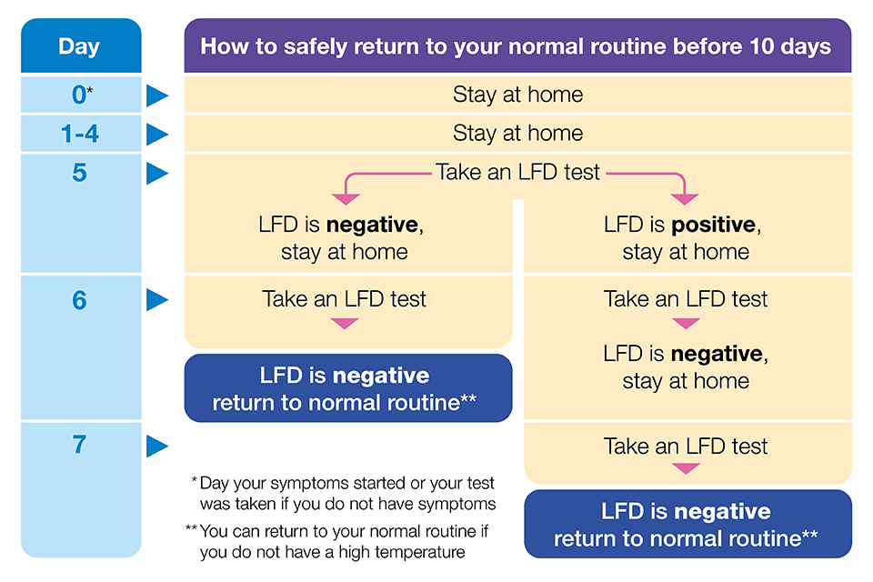
If your (your child’s) day 5 LFD test result is positive, you can continue taking LFD tests until you receive 2 consecutive negative test results.
Children and young people with COVID-19 should not attend their education setting while they are infectious. They should take an LFD test from 5 days after their symptoms started (or the day their test was taken if they did not have symptoms) followed by another one the next day. If both these test results are negative, they should return to their educational setting if they normally attend one, as long as they feel well enough to do so and do not have a temperature. They should follow the guidance for their educational setting.
Therefore, we would like to request that you continue to follow the guidance set out by the government, so on a day-to-day level, very little has changed for our families and our staff. We will continue to manage the risk in the same way as before until there are no longer free LFD and PCR tests available (see below):
The Government will implement further changes to the availability of testing in the coming months.
From 1 April, the Government will no longer provide free universal symptomatic and asymptomatic testing for the general public in England.
If you have any questions, please do not hesitate to contact me directly on head@walter.wokingham.sch.uk
Thank you for you continued support and co-operation.
Yours sincerely
Judy Wheeler ~ Headteacher

