

Walter Infant School and Nursery

‘To be the best I can be’

TEACHING AND LEARNING POLICY

Version | Action | By | Date
1 | Approved | Full Governing Body | 11/07/2017
2 | Approved | Full Governing Body | 8 May 2019
3 | Approved | Full Governing Body | November 2021
4 | Approved | Full Governing Body | November 2023

Next Review Date: November 2025

Walter Infant School and Nursery is an equitable, safe, secure and happy place to learn; our children grow as individuals in a stimulating and exciting environment which values respect, empathy, kindness, honesty and resilience.

Our Rationale
Our BIG Curriculum! At Walter Infant School and Nursery, we consider ourselves to be a “BIG School for LITTLE PEOPLE”. We have designed a ‘BIG’ curriculum to excite, inspire and foster a desire to learn; we want our children to know more about the world around them and to be happy, confident and successful. We will encourage our children to have very positive behaviours for learning and to ask BIG questions and for our staff team to support our children in finding authentic, age-appropriate answers to those questions and inspire them to want to know more. Our children will learn through real-life and practical experiences, as well as through wonderful, awe inspiring fiction texts in which they can ‘see themselves’ and exciting and purposeful non-fiction texts. Our children will learn inside and outside the classroom, fulfilling and exceeding the requirements of national age-appropriate curriculums in a stimulating, fun and memorable way.

At Walter Infant School and Nursery, we are committed to providing a meaningful and memorable education for all of our children; considering their personal needs and individual starting points. We want all of our school community to believe in the concept of ‘Lifelong Learning’ and to develop good behaviours for learning, so that everyone is able to tackle challenges positively, to build resilience and to learn from mistakes. We believe that appropriate learning experiences help children to lead happy and rewarding lives; through our teaching we equip our children with the skills, knowledge and understanding necessary to succeed, achieve and to make good choices.

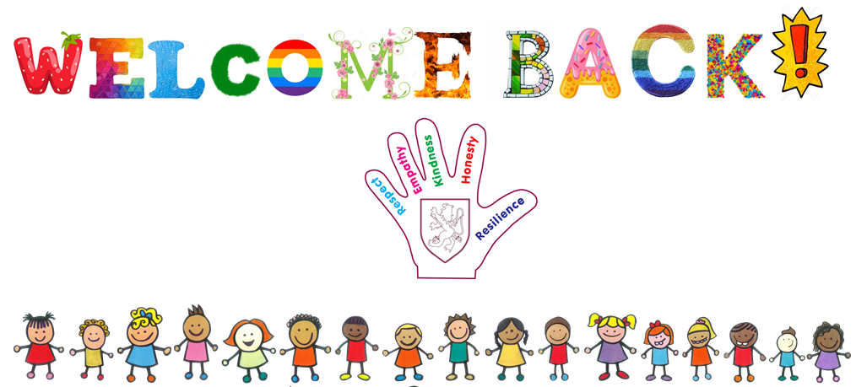

- Aims and objectives

At Walter Infant School and Nursery

- We aim to demonstrate that our children understand and behave in a way that reflects our core values: Respect, Honesty, Empathy, Kindness and Resilience.
- We aim to ensure that all our children will be tenacious, inquisitive, diligent and resourceful learners.
- We aim to provide ‘A BIG Curriculum for Little People’ that meets the needs of all our children, so that we can challenge, inspire and motivate our children to be ‘the best they can be’.
- We aim to provide opportunities for children to explore, test, question and consolidate their learning in a safe and secure environment which fosters a respect for each other and a desire to know more.
- We aim for our children to be resilient, never giving up and being brave enough to learn from their mistakes.
- We aim to meet the needs of every child, irrespective of their starting points, so that every child makes good or better progress.
- We aim to have a ‘Growth Mindset’ for all our children, to foster a desire to succeed and to provide opportunities for children to broaden their knowledge and skills.

- Through our Quality First Teaching we aim to:

- enable children to become confident, resourceful, enquiring and independent learners
- foster children’s self-esteem and help them build positive relationships with other people
- develop children’s self-respect and encourage children to respect the culture, ideas, attitudes, values and feelings of others
- encourage children to grow into kind, considerate and caring young people
- provide children with transferrable and adaptable skills to prepare them for life in a continually changing world

- Teaching and Learning

Through a variety of teaching and learning strategies and methodologies, teachers will seek to engage children in their learning, helping them to identify their areas for improvement, show them how to improve and help them to evaluate their success. Skills are taught in a progressive, coherent manner, each year building on the previous one. A variety of approaches are used to develop collaborative and independent learning and to extend pupils problem solving capabilities.

All teaching and learning opportunities will be intention or outcome led to ensure full coverage of the appropriate curriculum and the learning needs of the children; this is to allow accurate formative assessments against age related expectations. Once the learning need has been identified activities and resources, as well as levels of support will be planned for. The learning intentions and outcomes will be ‘child speak’ statements: for example, ‘I can write a sentence using a capital letter and a full stop’.

  - Assessment for Learning
Assessment for learning (AfL) is formative assessment and is used to help pupils learn; it plays an essential part in education and will focus heavily in all lessons; children will have opportunities to share their understanding in a variety of ways, including self-assessment using the ‘I can’ statement from the learning objective and the ‘Steps to Success’ which will be carefully planned for when appropriate, but always in Mathematics and English lessons.

Assessment for Learning is constructive because it focuses mainly on improvement and is used to support progress.

Assessment for Learning:
- Helps learners to know how well they have learned and provides feedback on how they can do better
- Encourages learners to support and help each other while they are learning
- Builds self-motivation, self-confidence and self-reliance

Learning Intentions will:
- Make clear the nature of the learning in child speak; ‘I can statements’
- Emphasise the learning rather than the doing
- Enable children to demonstrate knowledge and understanding
- Separate the intention from the context
- Be manageable, accessible and visible

Marking and feedback

All marking and feedback will be delivered using the guidance from the Marking Policy for Walter Infant School and Nursery. Marking will relate to the Learning Intention and the Steps to Success (Success criteria).

Assessment for Learning, marking and feedback will inform the next steps in learning. Lessons in Mathematics and English will be planned in response to the learning that has taken place each day to ensure that all children learn and make progress from their starting points and have the necessary learning experiences and opportunities to reach their innate potential.

- Personalised Learning
Every child is different; some children will be able to learn successfully within an age-appropriate curriculum reaching age-appropriate levels of attainment. Some children will be working at greater depth and some children will be working towards age-appropriate levels of attainment. At Walter Infant School and Nursery, we will adapt our teaching and learning in a variety of ways to ensure that all children have the opportunities, support and resources they need to succeed. This will be part of a personalised learning approach; sometimes supported by a Learning Plan if necessary, with specific targets that are agreed with the child, the parents or carers, staff and sometimes outside agencies.

- Diminish the Difference/No child left behind
We are committed to ‘Diminishing the Difference’ for our vulnerable children, whatever their needs or gaps may be. We will ‘tilt’ our practice to ensure that there are no missed opportunities for our children.

Any children in receipt of the Pupil Premium Grant will have a Personalised Provision Plan; detailing what is in place to identify barriers and close gaps. We have a Pupil Premium Strategy to ensure that we get best value for money. Teachers are able to request additional resources to support the personal or learning needs of any Pupil Premium child.

- Catch-Up and Recovery (Post Covid)
Catch Up: All children have the opportunity to access catch up resources and funding opportunities where identified
We will identify the children in every year group who meet one or more of the following criteria:
- Children who are our lowest 20% for attainment
- Children who have moved backwards from the previous terms’ assessments (reading, writing, mathematics) for example, Greater Depth (GD) to Working At (WA) or from Working At (WA) to Working Towards (WT) or from Working Towards (WT) to Emerging (E)
- Children who have not met social and/or emotional milestones (including in some cases self-care)
- Children who have not met expectations for physical development
- Children who have joined our school and are Working Towards the Expected Standard or below without an identified Special Educational Need or Disability
- Children with English as an Additional Language as a new beginner may meet the requirements for Catch Up provision

- Character Education
How do our curriculum and teaching develop resilience and confidence?
- Resilience is one of our five core values and our children are encouraged to learn from their mistakes and to keep on trying (Don’t give up). Our staff use authentic praise freely and enthusiastically and we actively celebrate achievement in many ways including positive feedback and achievable next steps (either verbal or written), stickers, Headteacher awards, values badges and ‘Star of the Week’ certificates. Throughout Lockdown, we offered a variety of home learning awards and celebrated home learning success in our weekly newsletter. We have WOW boards, sharing pieces of work that show resilience, for example how much improvement (progress) they have made and the perseverance they have invested to ‘be the best they can be!’
- Our curriculum is always adapted to meet the needs of every child in the school; these adaptations make learning accessible to everyone. The children who need support to learn will receive it through Quality First Teaching and our teachers and support staff never stop learning either!
- Our children are encouraged to share their successes from home with school too; this could be in sport, music, dance, art or any of the core subjects. The children’s work is displayed everywhere in our school, including our website. We have celebrated the BEST joke ever as well as the best handwashing hero posters, which were displayed in all the local shops and supermarkets. We have introduced strategies from Voice 21 to help children to share their own voice confidently; this has been affected by the pandemic BUT we will be using the lessons learned to develop the children’s confidence to share their thoughts and ideas. We have a Kindness Tree which celebrates impromptu (random) acts of kindness and a celebration shelf in the library for all our joint achievements. We have a school council, which becomes bigger over the year as more children are invited to produce their personal manifesto and present their ideas to the class. We have live performances including nativities, Christmas Concerts and a Year 2 Production.
- As part of our curriculum offer, the children learn about resilient people who didn’t give up and changed the world; Nelson Mandela, Rosa Parks and Robert Falcon Scott (of the Antarctic).
- We rejoice in the diversity of our community asking the children to share their personal experiences so that we can learn from them and celebrate empathically.

- Starting points
The children will enter Walter Infant School and Nursery at their own unique starting point; we will commit to working with the children from that starting point to ensure that they have no gaps in their learning and to maximise opportunities to enable them to reach their innate potential. We will adapt the learning to meet the needs of every individual and maintain high expectations for the children to succeed. We will conduct rigorous, but informal, assessments and observations and work in partnership with parents to develop a very clear understanding of each child.

- ‘Non-Negotiables’
Every member of the teaching team at Walter Infant School and Nursery will be committed to meeting the requirements of the Walter Infant School and Nursery list of ‘Non-Negotiables’ (see Appendix 2) to ensure equality of opportunity for every child. Each lesson will be planned using the expected format for the subject and the Learning Intention will be clearly shared in every lesson.

- Questioning
Teacher’s questioning plays a critical role in the classroom; it is an area of teaching that is characterised by instinctive good practice and an innate skill in which a teacher can assess understanding but also develop thinking skills and the cultivation of curiosity, scepticism and intellectual behaviours.

Our teachers will plan the questions they will use in their teaching in order to:
- Summarise and review previously learned material
- Focus on key issues and concepts
- Help pupils see connections and relationships
- Help pupils reflect on information and commit it to memory
- Arouse curiosity and to stimulate new ideas
- Develop from concrete and factual information to analytical and evaluative interpretations

- The 5Ws (and H) Who? What? Where? When? Why? and How?
Our teachers will use key questions in their teaching; these could be closed questions, which require a single correct answer, or open questions, which can stimulate discussion, opinion or personal interpretation.

Sometimes factual information needs to be established before higher order thinking can begin. The 5Ws and H can provide a good checklist to establish that the lower order foundations are laid firmly (checking knowledge and understanding) and then to invite children to explain their thoughts and ideas further.

A mixture of closed and open questions is the most effective way for young children to learn; we can extend our questioning by adding ‘why?’ or ‘how do you know?’ These questions will stimulate higher order thinking and can be used in all subjects within the Early Years Foundation Stage (EYFS) Framework and the National Curriculum.

- Bloom’s Taxonomy
Bloom’s Taxonomy enables us to decide on the type of questions we need to ask the children; it can help us to ensure that we ask enough higher order questions and that we choose the right question for the purpose (see Appendix 1).

It provides a logical way of categorising questions to identify the type of thinking required; knowing which type of thinking each question will provoke enables our teachers to keep a balance between higher and lower order thinking and between the different higher order categories.

There are six levels of thinking in Bloom’s Taxonomy:
- Remember: recognising and recalling
- Understand: interpreting, exemplifying, classifying, summarising, inferring, comparing, explaining
- Apply: executing and implementing
- Analyse: differentiating, organising, attributing
- Evaluate: checking and critiquing
- Create: generating, planning and producing

Our teachers will use Bloom’s Taxonomy to support assessment for learning strategies as an integral part of every lesson and as part of on-going formative assessment.

- Adaptation
Every lesson will be adapted for at least three levels of ability, as well as for children with SEN (Special Educational Needs), EAL (English as an Additional Language) or with a physical disability (see the Accessibility Plan). The learning will be adapted in many ways and will not always be through support or outcome. The children will have access to all the resources they need to succeed in each lesson, this could be practical equipment for mathematics lessons or word banks for writing lessons. Every teacher will have access to Communicate in Print to support vocabulary and spelling and an interactive whiteboard. Children will be taught in mixed ability classes and will usually be organised into ability matched groups of up to six. The children will have access to guided lessons from the teacher and the Learning Support Assistants for the class; they will also have opportunities to work independently, with support or with a partner.

Teachers will adapt the questions they plan using Bloom’s Taxonomy to enable all children to articulate or demonstrate their understanding and to ensure that the children make progress over time.

Learning intentions may sometimes be specifically adapted for a minority of children and will ensure that all children have appropriate access to the intended learning; the children will have a good understanding of what it is they need to be able to do in order to be successful either independently or with support.

Adapted success criteria as ‘Steps to Success’ will be shared with the children so that they understand what the need to be able to do to achieve the learning intention.

- Risk taking
Our children need daily opportunities to take reasonable risks and challenges in order to develop into strong, capable children. Thinking about what to do differently next time leads to more thoughtful and strategic learning; it promotes independent thinking and self-reflection.

Taking risks through play and in Physical Education will enable our children to develop age-appropriate strength, co-ordination and good body awareness. It can lead to good sensory and motor development.

Our children are taught to learn from their mistakes and that making mistakes is a good thing sometimes. A good balance of reasonable risk taking results in a willingness to make mistakes and to learn from failure.

- Challenge

Each lesson, in every subject, will be planned to include levels of challenge for every child; suitable challenges enable children to have high personal expectations so that they can aspire to be the best they can be. Children working at age-related expectations will be provided with learning opportunities to enable them to work at greater depth where appropriate.

- Resilience
We will promote and recognise resilience; through our teaching and as part of our values education at Walter Infant School and Nursery. Our curriculum will enable a ‘Growth Mindset’ and ensure that children have opportunities’ to revisit key learning objectives regularly in carefully planned interesting lessons or as spontaneous activities that spill out of good assessment for learning. By building our children’s resilience in this way we will help them realise that when they engage confidently with a challenge, anything is possible and failure is not something to fear. This is vitally important. After all, it’s not what children know, but what they can do with what they know, that is the goal of education.

- Safe and Secure
At Walter Infant School and Nursery, we are committed to safeguarding; please read our Safeguarding and Child Protection policies.

Our children can expect to be kept safe at all times; each classroom and learning area is subject to rigorous risk assessment controls and all risk assessments for each area are kept on display at all times. They are revisited annually.

All offsite visits are managed by the Educational Visits Lead in school using EVOLVE procedures.

- National curriculum for Key Stage One
English, including reading, writing and phonics, and Mathematics are taught as discrete and cross curricular subjects.
Computing, Science, History, Geography, Design and Technology, Personal, Social, Relationships and Health Education (PSHE) and Art are taught in a variety of ways – sometimes through thematic topics and sometimes as discrete units of work.
The children have two Physical Education lessons each week in KS1, one is taught by a coach and one by the class teacher.
The Religious Education curriculum follows the outline set by Wokingham Borough Council’s SACRE. Should parents wish to withdraw their children from this part of the curriculum they may do so by contacting the Headteacher. The School has no affiliation to any specific religious denomination.

- Early Years Foundation Stage Framework
In the Foundation 1 classes (Robin) and the Foundation 2 classes (Dove, Magpie and Woodpecker) the teachers follow the Department for Education’s Early Years Foundation Stage Curriculum; this sets out the knowledge, skills and understanding which young children should have acquired by the end of the academic year in which they reach the age of five. The curriculum is organised into 7 areas of learning:

Prime Areas
- Communication and language
- Physical development
- Personal, social and emotional development

And four Specific Areas through which the three prime areas are strengthened and applied:

- Literacy
- Mathematics
- Understanding the world
- Expressive arts and design

The Foundation Stage classes provide an environment of rich and meaningful experiences and play. Learning is developed through a balance of teacher led activities and opportunities for independent exploration.

- Our governors determine, support, monitor and review the school policies on teaching and learning. In particular they:
- support the use of appropriate teaching strategies by allocating resources effectively;
- ensure that the school buildings and premises are best used to support successful teaching and learning;
- monitor teaching strategies in the light of health and safety regulations;
- monitor how effective teaching and learning strategies are in terms of raising pupil progress and attainment;
- ensure that staff development and performance management policies promote good quality teaching;
- monitor the effectiveness of the school’s teaching and learning policies through the school self-review processes, including reports from subject leaders and the Headteacher’s report to governors as well as a review of the in-service training sessions attended by our staff.

- Parent Partnership
At Walter Infant School and Nursery, we are committed to working in partnership with our parents and carers; we believe in an ‘Open Door’ policy and teachers and senior leaders are available every day to talk to parents and carers, either face to face, by email or on the telephone. In order to ensure a strong partnership with parents and carers we:
- Provide a written progress report annually
- Hold parent consultation meetings twice a year to share progress, attainment and general information either face to face or remotely
- Provide curriculum information on the Learning Platform and website as well as access to activities and resources to support learning at home
- Schedule information meetings at different times of the day for parents and carers on a variety of topics, such as phonics and reading
- Have a home school agreement detailing our expectations for parents
- Provide translation facilities on our website for families that to not have English as a first language.
- Hold open mornings and evenings for Foundation Stage parents to come into school, including regular ‘Stay and Play’ opportunities.
- Share our expectations for homework (see Homework Policy)
- Have weekly newsletters (Friday Flyer) sharing information with parents about the learning that has taken place in school.
- Use social media sites to share information, including photographs, with parents
- Hold a class assembly once a year for parents to attend

- Monitoring and review
We have light touch monitoring procedures at Walter Infant School and Nursery. Teaching and Learning at Walter Infant School and Nursery will be reviewed regularly through a triangulated process which will involve observing teaching and learning walks, staff appraisal, pupil progress meetings, assessment data, ‘planning scanning’ and ‘book looks’ to ensure that the children are accessing the best possible learning opportunities each day.

This policy should be read in conjunction with:
- The Safeguarding and Child Protection Policy
- The Accessibility Plan
- The National Curriculum
- The Early Years Foundation Stage Framework
- The Assessment Policy
- The Marking and Feedback Policy
- The Behaviour Policy
- The English Policy
- The Mathematics Policy
- The Foundation Stage Policy
- The Curriculum Policy
- The Computing Policy

Appendix 1

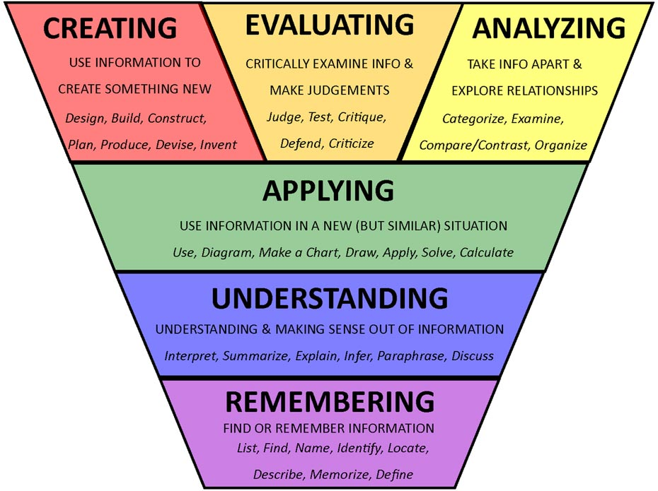

Appendix 2

Walter Infant School and Nursery
‘NON-NEGOTIABLES’

Teaching and Learning
- All learning will be explicit in Key Stage 1
- Learning Intentions must be displayed in every lesson and clearly shared with children and clearly displayed
- ‘Steps to Success’ will be included for Mathematics and English lessons and displayed with the Learning Intentions for English and Mathematics
- Children will be expected to be able to talk about their learning.
- Assessment for Learning strategies should be an integral part of every lesson, moving the learning on rapidly or enabling learning to be revisited.
- The experiences for PE will be the same for all children in the cohort. Every class will have a PE lesson with a Sports Coach and an additional PE lesson planned from the expectations of the National Curriculum with a learning intention which can be shared orally with the children.

Planning
- Lesson plans must be produced, using the agreed formats for English and Mathematics. These should be done on a daily basis, in response to the learning that has happened in the lesson that day.
- There is no expectation for the amount of detail in the lesson plan; but they must include at least 3 levels of differentiation, questions, key vocabulary, context, a brief teaching outline and a planned and purposeful plenary.
- All plans must include reference to: PPG children, SEN children and EAL children to ensure that practice is tilted to meet their needs.
- As part of ‘Diminishing the Difference’ consider the needs of the most vulnerable children first.
- Guided reading will be planned for using the agreed format.
- Foundation subjects, Science and Computing will be planned for (in teams) as part of a weekly overview.
- Phonics will be planned from Letters and Sounds with support from Phonics Play – there is no expectation to change the planning format from Phonics Play but plans should be annotated if changes need to be made.
- Planning will form part of the ‘Tri-angulated Monitoring’ of Teaching and Learning and as part of Performance Management.

Marking
All teachers should follow the expectations from the marking and feedback policy:
- Work should be annotated to show the level of support e.g. I independent W/S with support G guided etc.
- Learning support assistants should mark the work of the children they have supported or guided
- Guided group work can simply be annotated with G and the initials of the teacher working with them.
- Next steps or modelled comments should be clearly shown (at an age appropriate level) on approximately every third piece of work. This means that only one third of books need any deeper marking at the end of each lesson.
- Include next steps and success criteria when making writing frames, work sheets or labels to be stuck in for Learning Intentions – these can then be ticked or high-lighted as met (pink) or not met (green)
- Use the punctuation icons on Learning Intentions to clearly share expectations, for self-assessment and for speedy marking. These can be found in on the Resources drive in English.
- Verbal Feedback can be indicated by using VF bit it is good practice to sometimes give examples of the child’s voice when appropriate.
- Marking must be up to date.
- Marking will also form part of the ‘Triangulated Monitoring’ and Performance Management at Walter Infant School and Nursery.

Expectations for teaching English:
Every class will have:
- 5 English lessons, with a writing element, each week
- 5 phonics or spelling lessons each week
- An English working wall
- Published work on display
- WOW boards to celebrate success
- At least 3 guided reading sessions a week
- 1:1 reading for children working below ARE
- A book corner
- A language rich environment

Every child will have:
- At least one guided reading session a week (alternating between the teacher and the learning support assistant on a two-week rota)
- An up to date reading diary
- Differentiated spellings
- The opportunity to change their reading book daily (with support if necessary)
- A library book

Expectations for teaching mathematics:
Every class will have:
- 5 mathematics lessons each week one of which will be in the computing suite
- Every mathematics lessons will begin with counting patterns
- Every mathematics lesson will have a mental/oral starter revisiting prior learning
- Every classroom will have a maths working wall
- Numbers, shapes and key vocabulary must be displayed at all times
- Children must have independent access to resources that will support their learning in the lesson
- Practical mathematics lessons must take place each week
- Problem solving and reasoning must be a focus for planning
- Times tables and counting facts will form part of the homework for year 2
- Mathematics will have cross curricular links with science, history, geography and DT

Additional duties:
Every teacher will:
- Meet all the expectations from the Teachers Standards (see Appendix 3)
- Adhere to the Code of Conduct at Walter Infant School and Nursery
- Be aware of their personal responsibilities for safeguarding and child protection
- Read and adhere to all school policies
- Teach within the Fundamental British Values of the United Kingdom
- Follow the Walter Infant School and Nursery Respect Agenda
- Present school assemblies as part of an agreed rota
- Be available for supervision at playtimes and the beginning and end of the school day as required
- Attend parent consultation meetings at given times within the school year
- Produce written reports for parents throughout the school year
- Complete Pupil Premium Plans, Learning Plans, Cause for Concern documents and Case Studies as required
- Meet the expectations for assessment, tracking and pupil progress for Walter Infant School and Nursery; using Point in Time Assessments (PITAS) and SIMS
- Check their school email account each day – please note there is no expectation to read or respond to emails at the weekend or in school holidays
- Contribute to the day to day running of the school diary
- Attend one staff meeting and one team meeting and one morning briefing meeting each week
- Take part in all INSET activities and CPD (up to 5 days per year depending on teaching commitment)
- Support and manage the behaviour of the children in line with the school’s behaviour policy
- Treat minor first aid injuries and be aware of how to escalate first aid incidents rapidly, following school procedures
- Respect and take care of resources within the school

Appendix 3

Teachers’ Standards

Preamble
Teachers make the education of their pupils their first concern, and are accountable for achieving the highest possible standards in work and conduct. Teachers act with honesty and integrity; have strong subject knowledge, keep their knowledge and skills as teachers up-to-date and are self-critical; forge positive professional relationships; and work with parents in the best interests of their pupils.

PART ONE: TEACHING

A teacher must:

1. Set high expectations which inspire, motivate and challenge pupils
- establish a safe and stimulating environment for pupils, rooted in mutual respect
- set goals that stretch and challenge pupils of all backgrounds, abilities and dispositions
- demonstrate consistently the positive attitudes, values and behaviour which are expected of pupils.

2. Promote good progress and outcomes for pupils and…
- be accountable for pupils’ attainment, progress and outcomes
- be aware of pupils’ capabilities and their prior knowledge, and plan teaching to build on these
- guide pupils to reflect on the progress they have made and their emerging needs
- demonstrate knowledge and understanding of how pupils learn and the impact this has on teaching
- encourage pupils to take a responsible and conscientious attitude to their own work and study.

3. Demonstrate good subject and curriculum knowledge
- have a secure knowledge of the relevant subject(s) and curriculum areas, foster and maintain pupils’ interest in the subject, and address misunderstandings
- demonstrate a critical understanding of developments in the subject and curriculum areas, and promote the value of scholarship
- demonstrate an understanding of and take responsibility for promoting high standards of literacy, articulacy and the correct use of standard English, whatever the teacher’s specialist subject
- if teaching early reading, demonstrate a clear understanding of systematic synthetic phonics
- if teaching early mathematics, demonstrate a clear understanding of appropriate teaching strategies.

4. Plan and teach well structured lessons
- impart knowledge and develop understanding through effective use of lesson time
- promote a love of learning and children’s intellectual curiosity
- set homework and plan other out-of-class activities to consolidate and extend the knowledge and understanding pupils have acquired
- reflect systematically on the effectiveness of lessons and approaches to teaching
- contribute to the design and provision of an engaging curriculum within the relevant subject area(s).

5. Adapt teaching to respond to the strengths and needs of all pupils
- know when and how to adapt learning appropriately, using approaches which enable pupils to be taught effectively
- have a secure understanding of how a range of factors can inhibit pupils’ ability to learn, and how best to overcome these
- demonstrate an awareness of the physical, social and intellectual development of children, and know how to adapt teaching to support pupils’ education at different stages of development
- have a clear understanding of the needs of all pupils, including those with special educational needs; those of high ability; those with English as an additional language; those with disabilities; and be able to use and evaluate distinctive teaching approaches to engage and support them.

6. Make accurate and productive use of assessment
- know and understand how to assess the relevant subject and curriculum areas, including statutory assessment requirements
- make use of formative and summative assessment to secure pupils’ progress
- use relevant data to monitor progress, set targets, and plan subsequent lessons
- give pupils regular feedback, both orally and through accurate marking, and encourage pupils to respond to the feedback.

7. Manage behaviour effectively to ensure a good and safe learning environment
- have clear rules and routines for behaviour in classrooms, and take responsibility for promoting good and courteous behaviour both in classrooms and around the school, in accordance with the school’s behaviour policy
- have high expectations of behaviour, and establish a framework for discipline with a range of strategies, using praise, sanctions and rewards consistently and fairly
- manage classes effectively, using approaches which are appropriate to pupils’ needs in order to involve and motivate them
- maintain good relationships with pupils, exercise appropriate authority, and act decisively when necessary.

8. Fulfil wider professional responsibilities
- make a positive contribution to the wider life and ethos of the school
- develop effective professional relationships with colleagues, knowing how and when to draw on advice and specialist support
- deploy support staff effectively
- take responsibility for improving teaching through appropriate professional development, responding to advice and feedback from colleagues
- communicate effectively with parents with regard to pupils’ achievements and well-being.

PART TWO: PERSONAL AND PROFESSIONAL CONDUCT
A teacher is expected to demonstrate consistently high standards of personal and professional conduct. The following statements define the behaviour and attitudes which set the required standard for conduct throughout a teacher’s career.
- Teachers uphold public trust in the profession and maintain high standards of ethics and behaviour, within and outside school, by:
  - treating pupils with dignity, building relationships rooted in mutual respect, and at all times observing proper boundaries appropriate to a teacher’s professional position
  - having regard for the need to safeguard pupils’ well-being, in accordance with statutory provisions
  - showing tolerance of and respect for the rights of others
  - not undermining fundamental British values, including democracy, the rule of law, individual liberty and mutual respect, and tolerance of those with different faiths and beliefs
  - ensuring that personal beliefs are not expressed in ways which exploit pupils’ vulnerability or might lead them to break the law.
- Teachers must have proper and professional regard for the ethos, policies and practices of the school in which they teach, and maintain high standards in their own attendance and punctuality.
- Teachers must have an understanding of, and always act within, the statutory frameworks which set out their professional duties and responsibilities.

