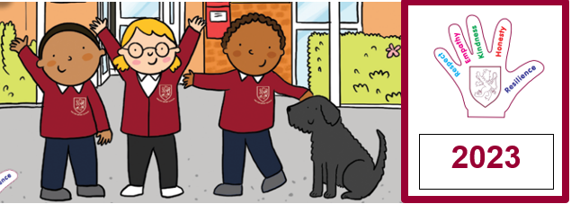
2024
Walter Infant School and Nursery
Monday Mail
Dear Walter Families,

As I type this, it is snowing! It is not supposed to snow again this week, but please make sure your children are suitably dressed for colder weather, including a coat, hat, gloves and a scarf. We will be going out to play each day!

Welcome to the Spring term; we have had lots of exciting changes over the holidays. You will have noticed the new gymnasium equipment! The children are really enjoying using it and we are happy for them to do so at the start and end of the day too, but please ensure that if your child is using the equipment that you are supervising their safety.

We also have our new scooter rack; thank you to all of you who are walking, cycling or scootering to school. This dramatically reduces the amount of traffic to the school; however, we have experienced some really bad traffic and congestion, which seems destined to continue for some time after the installation of temporary traffic lights on the Reading and Oxford Roads. The junction where Murray Road joins the Oxford Road can be extremely busy. We recommend parking your cars further from school and walking the rest of the way to avoid getting trapped in the traffic jams!

You may also have noticed our new Learning Pod; this is nearly ready for use. We are delighted to have this installation to support some of our children with high needs. It is not quite finished!

Junior School Admissions
Please make sure that you have completed your Junior Place paper work, the deadline is 15th January 2024. If you need help, please speak with Mrs Janes or Mrs Hemmings in the school office. Thank you.

PE Kits and School Uniform
I have noticed that some of the children are not wearing navy blue track suits on PE days; this is part of our requested school uniform. We would like the children to wear a plain white or navy t-shirt, navy joggers or leggings and a navy hoodie or sweat shirt. We are happy for them to have any colour of trainer on PE days (or in Foundation Stage) but we would like them to wear black shoes or trainers with their school uniforms. If you will struggle to provide these items, please get in touch. Please do not send your children to school in branded clothes, football kits or highly patterned sweatshirts and jackets, these are not appropriate and could get lost or damaged.

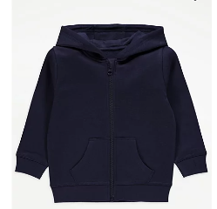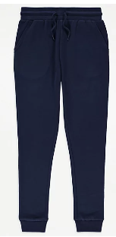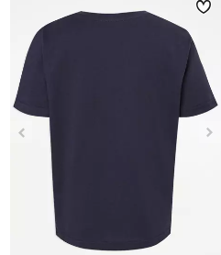

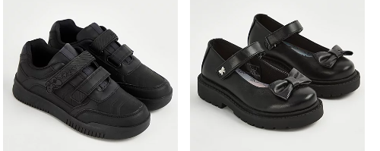
These items are all available from Asda.

We also have cosy and warm fleeces available through Goodies on our website; these are available in navy or burgundy.

Packed Lunches and School Dinners
Some children find it so hard to eat at lunchtime as it is so different from how it is at home and hot dinners that they enjoy at home may taste a little different at school. However, the standard of food produced by Natalia and her team is excellent; many of the staff choose to have a school lunch as it is so tasty and always cooked freshly from scratch. AND the lunch is free of charge for all our children. Some children are bringing packed lunches that they don’t want to eat either! Please do not send anything with nuts or that could contain nuts, such as chocolate spread. Please also consider the quantity and storage of food that you prepare for your child, we are happy to help with opening packets or boxes so that items can be kept separately. Today I noticed a child whose food had all got muddled so his raisins were mixed in with his crisps and biscuits! We would also encourage you to send in healthy lunches as we are a healthy school, although we do recognise how difficult it is when some children have very limited preference for food! If you send grapes in, please ensure they have been cut in half. Thank you.
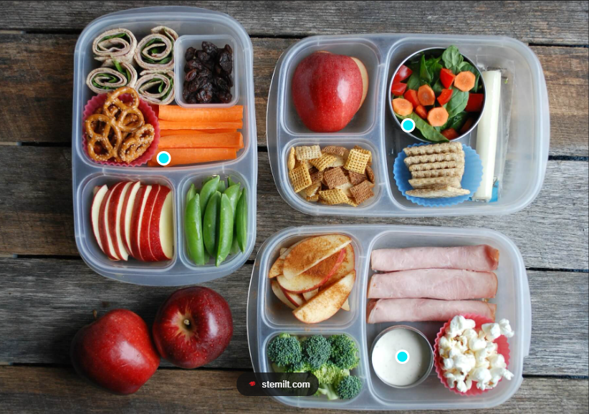

Bulbs
We would like to plant lots more bulbs for the children to enjoy and to support our learning in Science; if you would like to donate some spring bulbs, we would be delighted to receive them and plant them in our borders, planters and pots. The children will be able to take care of them and watch them grow.

Star of the Week
Here are our first Stars of 2024; this week we have been finding out how much the children have learned since the start of the school year in September and we have been so impressed by their progress. It was a very tough decision for the teachers this week to decide on just one star! Well done all of you for striving to be the BEST that you can be!

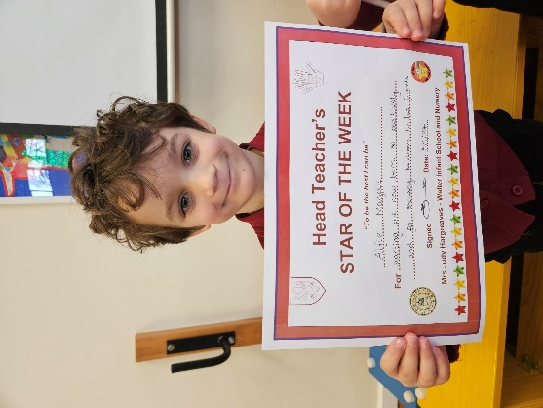 | 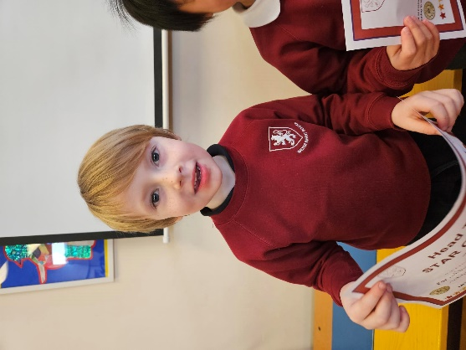 | 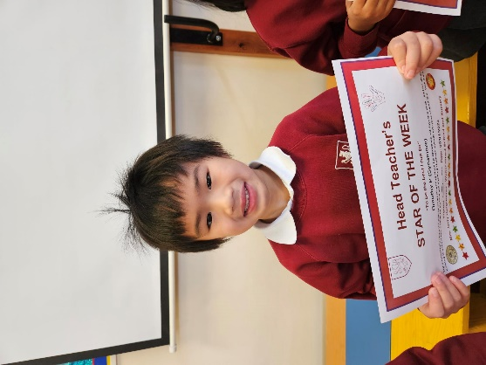
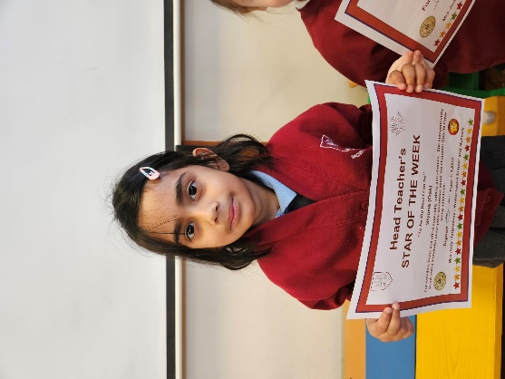 | 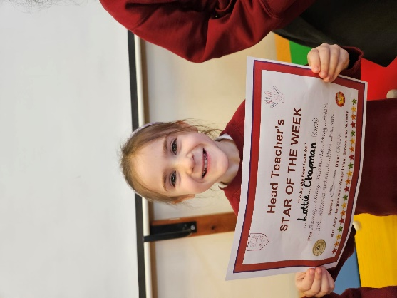 | 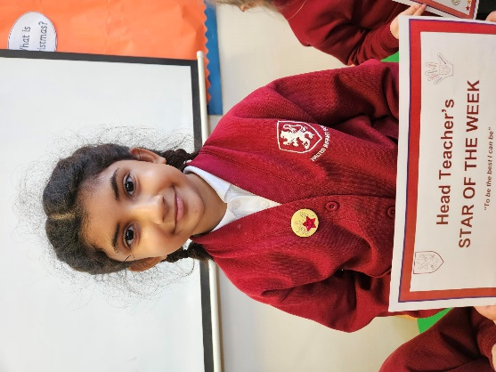
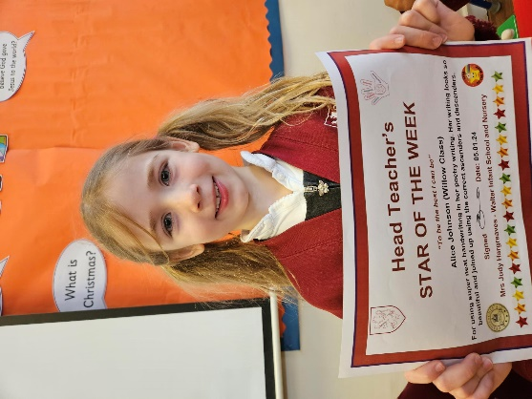 | 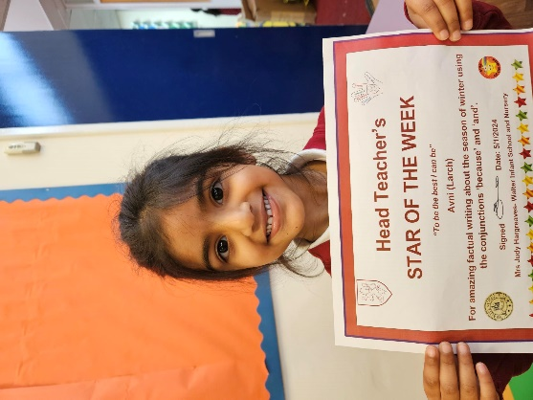 | 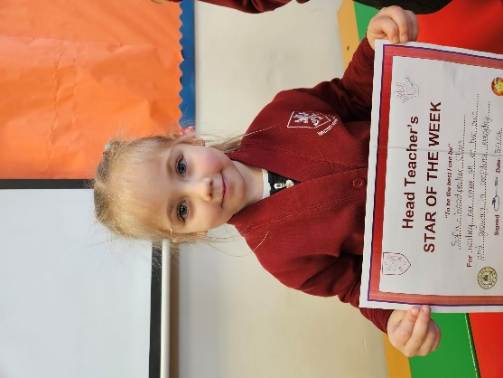
 | 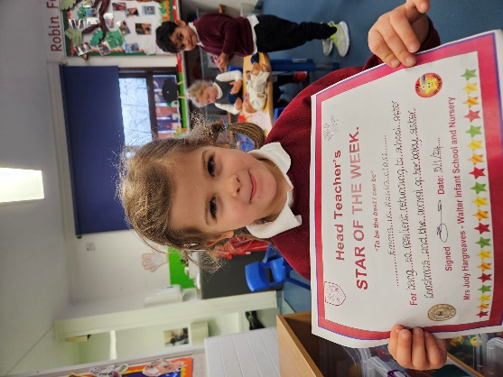
If you are struggling to provide all you need to at the moment; we can provide Food Vouchers for the Foodbank and fuel vouchers.

We can help!
If you are struggling to provide anything essential for your child’s well-being, such as pyjamas, coats, shoes, socks, underwear, school uniform, bedding etc please ask us as we are here to help. We do not want any of our children to miss out on the basic fundamentals that they are all entitled to. As before, please just ask.

Walter’s Pantry
Don’t forget about Walter’s Pantry; you can collect food to cook a hot stove top meal each day, collect breakfast for the following morning, or pick up necessary sanitary products, such as toothpaste, nappies, toothbrushes etc. We would be very grateful to receive boxes of cereal, if you would like to donate to the pantry.

Pupil Premium Funding
Some of our families are entitled to Pupil Premium Funding for their children; this is a wonderful addition to our school’s budget and helps us to provided curriculum enrichment and support for our Pupil Premium children and all other children too!

Your child may be entitled to this funding which can be used to pay for clubs, uniform, additional support, one to one nurture, Canine Assisted learning etc.

If you are in receipt of one the following benefits you may be eligible for free school meals or the pupil premium:
1) Income Support.
2) Income based Job Seeker's Allowance.
3) Income related Employment and Support Allowance.
4) Child Tax Credit - Where the family's annual income is not more than £16,190 and Working Tax Credit is not in payment.
5) Guarantee Pension Credit.
6) Support under part six of the Immigration and Asylum Act 1999.
7) Universal Credit.

Please contact Mrs Janes in the office to find out more or follow this link https://www.wokingham.gov.uk/schools-and-education/school-information-and-services/free-school-meals-and-the-pupil-premium/

Have a great weekend!
Judy Hargreaves: Headteacher

