Walter Infant School and Nursery
School Development Targets for 2025 2026
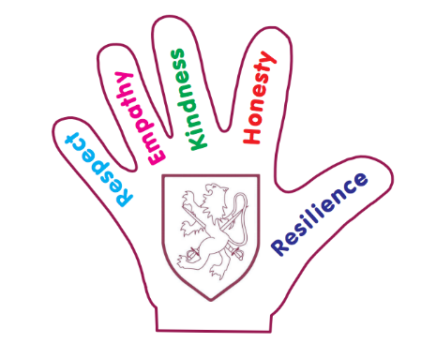
Quality of Education
- To focus on the progress of the lowest 20% in each cohort to ensure all children can make progress and the gaps between the lowest ability children and all children diminish.
- To further develop the teaching of writing using the new Writing Framework so that reading and writing attainment are more easily matched (writing improves in all cohorts).
- Leaders must be ambitious for learners with additional needs and provision is well-led and managed

Behaviours and Attitudes
- Walter Infant School and Nursery will provide an environment that promotes wellbeing and recognises and responds to learner’s social and emotional needs

Personal Development
- Our curriculum and ‘Hidden Curriculum’ will support our learners to develop their character; including their resilience, confidence and independence. We will help them know how to keep physically and mentally healthy.

Leadership and Management
- The Writing Framework Section 7: Leadership and management of writing. Headteachers are responsible for creating a positive writing culture in their schools, as well as for developing an effective, well-sequenced writing curriculum and ensuring that all classroom teachers, not just subject leads, are trained to teach writing effectively. All staff play a role in fostering a supportive writing environment, but leaders establish the culture and set the standards.
- Senior Leaders and Managers have a clear and ambitious vision for providing high-quality, inclusive education and training to all. This is realised through strong, shared values, policies and practice


