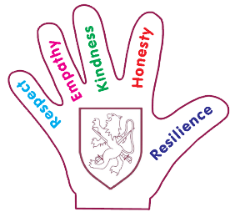
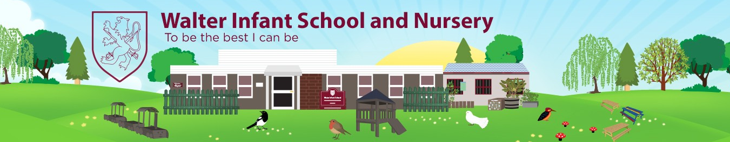

Year One – Autumn 1 Curriculum Intent
2026-27
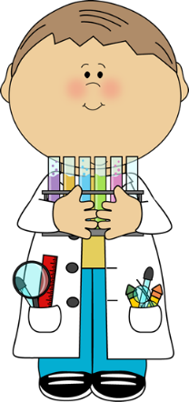
Materials
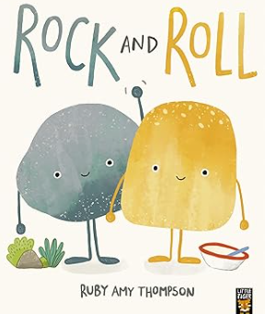
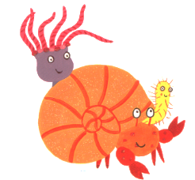

Walter Values
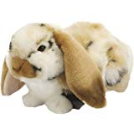  Respect | To show respect for my new classroom and the outdoor environment.
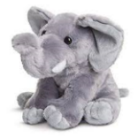  Empathy | To show empathy towards other people’s feelings.
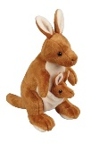  Kindness | Be kind to my friends and helping new friends settle in.
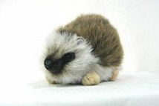  Honesty | To be honest talking about my feelings.
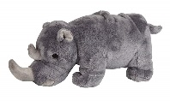  Resilience | To show resilience in my new year group and the new work.

Intended Additional English Coverage

Sharing a Shell/A home for stone/ Rock and Roll
Using phonics to encode and spell words.
Practising letter formations and include finger spaces
Writing a simple sentence

The Three Little Pigs
Sequence a story using pictures and verbally re-tell the story
Character descriptions
Write a sentence using a capital letter, finger space and full stop

Autumn Non-fiction/ Leaf Thief
To write a statement sentence
Spell some common exception words correctly
Write a sentence using a capital letter, finger space and full stop

Intended Additional Mathematics Coverage

Place Value
More than less than
Count, read and write numbers to 20 and beyond
Identify and represent numbers using objects, pictorials and a number line
2D Shapes
Name 2D shapes and their properties
Addition and Subtraction
Add and subtract one and two digit numbers
Read and interpret mathematical statements involving addition, subtraction and equals

PSHRE and RE
Jigsaw PSHRE   | Discovery RE  
Being Me in My World  Help others to feel welcome  To make our school community a better place  Think about everyone’s right to learn  Care about other people’s feelings  Work well with others  Choose to follow the Learning Charter | What do Christians believe about God?  The Creation, God the Father as an introduction to the Trinity.

Subject Key
English   | Maths   | Science   | PE   | PSHRE   | Computing  
RE | History   | Geography   | Art   | Music   | DT  

Subject Connectors
Subject | Connector
 | As athletes we are learning ball skills  As athletes we are competing in small teams.
 | As members of the Walter community, we understand change happens and that we need to foster our value of resilience.
 | As enquirers, we are finding out how Christians
 | As scientists, we are learning about materials and their properties.  As scientist, we are learning about the season of Autumn.
 | As geographers, we are learning about the seasons and daily weather patterns in the UK.
 | As technologists, we are learning how to turn on a computer and how to use a mouse to draw.
 | As artist, we are learning to develop a wide range of art and design techniques.
 | As musicians, we are learning to sings songs tunefully.
 | As historians and citizens, we will be learning about influential people during Black History Month.

Skills and Knowledge
Subject | Skills and Knowledge | Curriculum Coverage
PE | Multi skills  - To learn how to work as part of a team.  - To practise throwing and aiming.  - To Jump with balance and control.
Science | Materials  - To Identify and name a variety of everyday materials.  - To distinguish between an object and the material it is made from.  - To describe the properties of everyday materials.  - To test and compare the properties of two items (Rolls and Stones)  - To Investigate which material is best to keep Mr Pig dry.
Science/  Geography   | Weather/seasons  - To observe changes across the seasons (autumn).  - To Make physical observations made within the school grounds  - To Identify seasonal weather patterns in the UK  - To Investigate how length of the day varies depending on which season
Art | Collage  - To decorate a shell using pattern and collage.  - To learn about Andy Goldsworthy and to create an autumn picture/sculpture inspired by his work  Painting  - To draw a Little Pig thinking about shape and paint in their picture carefully.  - To design and paint my own stone.
Music | Singing  - To learn new songs and sing them tunefully (3 Little Pig)
Computing | Computer skills  - To learn how to turn on a computer  - To practise clicking and using a mouse.  - To create picture using the program 2Publish
History | Black History Month  - To learn about black history heroes.
DT | Bread Rolls  - To learn how bread is made and where the ingredients come from.  - To help create, knead and make bread rolls

Subject Concepts

