
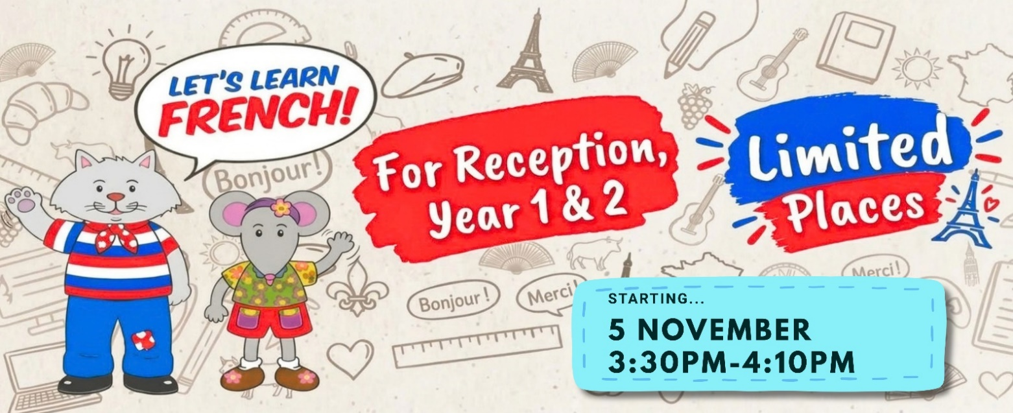
Dear Parents,
FOR RECEPTION, YEARS 1 & 2 | STARTING THURSDAY 5 NOVEMBER | 3:30PM – 4:10PM
Now is the perfect time to introduce your child to the fun of learning a new language. Young children are naturally curious and receptive to new languages, so the earlier learning starts the better.

I would like to invite your child to discover why children at Walter Infant School love my French Club.

My French Club has been a firm favourite with pupils for years, and I am delighted to have a few spaces available for children in Reception, Year 1 and 2, starting 5 November 2026 – straight after school.
It’s a wonderful opportunity for your child to have fun, make new friends and discover the excitement of learning French in a relaxed and supportive environment.
What makes our French Club different?
⭐️ We give your child a head start with languages – helping them build confidence and familiarity before they begin learning a language more formally at school
⭐️ We inspire & make learning French fun – with games, songs, stories, role-play & interactive activities
⭐️ We create a relaxed and supportive environment – where children feel comfortable joining in, making friends and growing in confidence
⭐️ We give children a valuable life skill – one that can broaden their horizons and open up future opportunities
⭐️ We make children feel part of something special – learning, having fun and growing in confidence alongside other children
What do children enjoy at French Club?

✅ Fun songs, games and interactive activities with stories, role-play and simple conversations!
✅ Discovering French culture and traditions
✅ Small, friendly classes with plenty of opportunity to join in
✅ A structured programme that develops confidence & skills step by step and no pressure just tons of fun!
✅Their own Activity Book which pupils love, plus you get access to our Media Player App, so learning can continue at home. A great way for you to follow their progress and get involved too!

We follow the award-winning La Jolie Ronde programme, which has been inspiring children to enjoy and learn languages for over 40 years. Programmes are designed for young learners, to help them to develop pronunciation, communication skills & cultural awareness while having lots of fun. Recognised by the French Government too!!!
Cost: £6.00 per class plus a one-off fee of £23.00 for the Pupil Activity Book, CD & Media Player App access which lasts at least one academic year.
Places are limited, to reserve your child’s place or find out more email: laurencethonon@yahoo.com
Best wishes, Laurence Thonon

