

Walter Infant School and Nursery

Procedures: Lockdown to a Safe Place

DOCUMENT HISTORY

Version | Action | By | Date
1.0 | Draft | Trevor Sleet | November 2012
1.1 | Draft | Fiona Cross | February 2013
1.1 | Approved | Environment Committee | 5 March 2013
1.1 | Approved | Full Governing Body | 25 March 2013
2.0 | Approved | Judy Wheeler - Headteacher | 21st September 2016
3.0 | Approved | Full Governing Body | 18th September 2018
4. | Approved | Full Governing Body | 14th November 2019
5 | Approved | Full Governing Body | November 2022
5 | Approved | Full Governing Body | 16th November 2023
6 | Approved | Full Governing Body | Autumn Term 2024

Next Review Date: Autumn Term 2026

LOCKDOWN PROCEDURE

I Purpose & Scope

This procedure defines the responsibilities, processes and actions to be taken in the event of a person(s), who may present a serious threat to the children, staff or visitors. This person(s) may be on the school premises or in the local vicinity.
Note:
A School Lockdown may be invoked if there is an escape from Broadmoor Hospital and the person is in the local vicinity.

II Related Documents

School – Rainbow Plan
School - Broadmoor Escape Procedure
School - Physical Security Policy
School - Banning Individuals from School Procedure
School - Health & Safety Policy
School - Health & Safety Manual

III Abbreviations

WBC - Wokingham Borough Council.

1 Definitions
Safe Area: The area which offers the children, staff and visitors to the School the maximum safety. This maybe classrooms or St. Paul’s C of E Junior School and will be dependent on the circumstances / situation.

2 Roles and Responsiblities
In the event of a School Lockdown to a Safe Place all School staff who are on the premises will be considered to be on duty.

3 Introduction

This procedure is for guidance purposes as every situation may be different and therefore the actions which are taken will vary depending on the circumstances. These actions have one driving purpose and that is to ensure, as far as possible, the safety of the children, staff and visitors to the School. This is best achieved by maintaining, where ever possible, a quiet and calm atmosphere.

4 Lockdown Signal & Contact Details

Whistles will be used to signal lockdown for Walter Infant School and Nursery and are stored in the school office and in the Head’s and Deputy Head’s Offices. The school Administration Assistant from Walter Infant School and will telephone St. Paul’s (01189 785219) to alert them by saying ‘Lockdown’.

The list of primary contact details is also held securely by the School Offices.

5 School Lockdown Practice

The School Lockdown should be regularly practised, just as the School’s emergency evacuation procedure is regularly practised at least on an annual basis in the autumn term.

6 School Emergency Response Team

In the event of a real lockdown the Head Teacher or whoever is deputising and the office and any non-teaching staff who can safely be assembled, should form a ‘School Emergency Response Team’. This team should quickly appoint a single person to be the focal point and be the co-ordinator. The following actions should be taken:
- Invoke the School Lockdown, signal accordingly, using a whistle, and notify the Police and WBC.
- Any staff, children or visitors who are outside should move to the nearest safest location e.g. the hall or an appropriate classroom.
- Check all classrooms, corridors, toilets and any other school buildings and ensure that the children are in the allocated safe areas.
- In some circumstances, consideration should be given to moving all of the children through the Link corridor to St. Paul’s.
- Oversee the checking of all registers and the Signing in Ipad to ensure that all persons are present.
- All external doors should be locked, to prevent anybody getting into the school buildings, though consideration must be given to the need to evacuate the buildings in case of fire etc.
- All classroom doors should be shut and locked. Windows should be shut along with blinds down/closed. Lights should be turned off.
- Children will sit in the cloakrooms or on the floor and away from doors and windows unless circumstances indicate that it is best to sit under desks.
- Wait for the all clear (the sound of the playground bells) or further instruction from official sources e.g. Police, or WBC who will declare the all clear.
- Once the ‘All Clear’ is received the end of the Lockdown can be announced and the staff and visitors notified accordingly.

7 Parents / Carers

Parents / carers must not be allowed to pick up their children during a School Lockdown. Children will only be released after an all clear is given.

8 Teaching Staff
- Should remain with their children at all times.
- Should NOT allow anyone to leave the safe area where ever that may be. This must be maintained until the all clear is given.
- Try and maintain a calm atmosphere at all times, this may best be achieved by engaging in a quiet game or activity.
- Be alert to the emotional needs of any children.
- If a member of the teaching staff is out of the class at the time of the incident, they should attempt to go back to the safe place, but only if it is safe to do so. If this is too risky or dangerous, they must try and make contact with the children as soon as possible.

Lockdown Logistics:

- Teachers in charge of Oak, Pine, Sycamore and Willow will secure the classroom doors and windows. The children will sit where they are not visible from the door in the classroom cloakroom. All blinds must be closed.
- The teacher in charge of Beech will secure doors and windows and close blinds. The children will sit on the floor in the classroom
- The teacher in charge of Larch will take the children into the Computing room, locking the door. Secure all doors and windows and close blinds.
- The teachers working in Foundation Stage will take all the children into Robin as there are toilets and a telephone, along with keypad security on all doors. Close all blinds and cover all windows.
- If a class is working in the Computing Room, they will stay there and wait for Larch to join them.
- If children are outside for PE, they will return quickly to their classroom.
- If we have to evacuate to St Paul’s, this will be done via the link corridor to their hall.
- In the event of lockdown, teachers will maintain in contact via email or telephone when the use of personal mobile phones will be permitted in the presence of children.
- Children and adults working in the Learning Hub or Thrive Room will lock down in the Thrive Room, securing the door, windows and closing the blinds.
- Finance Staff and Site Controller in Finance Office; lock doors, close windows and blinds
- Office Staff: Office, lock doors, close windows and blinds
- Head and Deputy, Head’s Office once everywhere has been checked.

Willow  Year 2 |  | Sycamore  Year 2 | Robin  FS1 | Nest  
 |  | Pine  Year 2 | Dove  FS2 | Magpie
 |  | Oak  Year 1 |  | Woodpecker  FS2
 |  | Oak  Year 1 | Steph | Woodpecker  FS2
Beech  Year 1 |  | Learning Hub   | Thrive Room | Woodpecker  FS2
Beech  Year 1 |  |  | Hall   | Kitchen  
Larch  Year 1 |  | Library   |  | Staff Room  
Larch  Year 1 |  |  | First Aid | HT Office
IT Suite
IT Suite |  |  | Office | Toilets

Appendix 1
Schools in the vicinity of the Broadmoor Hospital

(See flowchart for those WBC schools to which this procedure applies)

- Warning Systems

There is no longer a warning signal!

Telephone numbers for the cascade system should be prominently displayed for easy access.

Schools will stay open and operate as normally as possible.

- Action in the event of an escape

In the event of an escape children will be required to:
- Remain in their classrooms working normally with an adult
- Not be allowed out during breaks or outside PE/games

Schools will need to:
- Minimize and supervise movement between different buildings on the site
- Ensure that all external doors and windows closed and gates locked.
- That visitors calling without prior arrangements at the school will be asked to call on another occasion. Visitors will only be admitted to school once identification has been produced or with the approval of the Head Teacher.

All staff on the premises should consider themselves on duty during the alert.

If during the alert there is an immediate and actual intruder threat, (eg the person(s) are known to be on-site or the immediate vicinity of the site) action may need to escalate beyond these precautionary procedures.

FORESTCARE
(01344) 786500 FAX (01344) 786520

BROADMOOR HOSPITAL ESCAPE WARNING SCHEME
WARNING

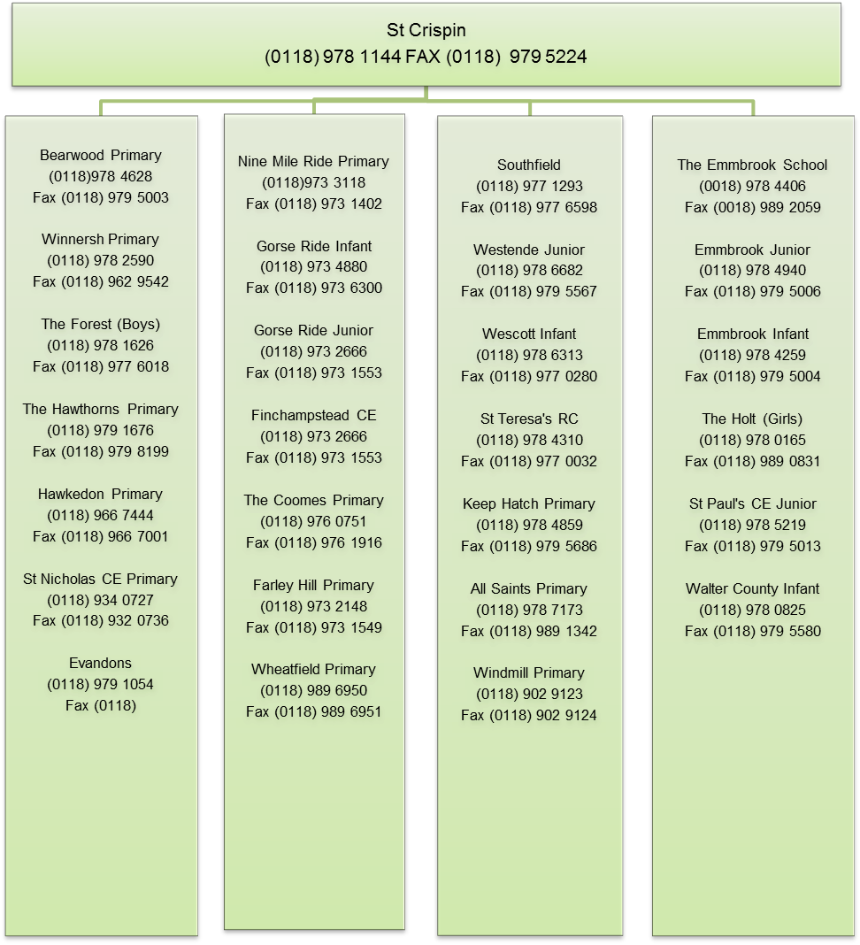
Walter Infant School and Nursery
01189780825

Walter Admin Staff will telephone Forest Care (see number above) to let them know that the cascade is complete.

