

Walter Infant School and Nursery -Spelling Homework

This homework is provided so your child can practise their spellings.
The words are linked to our phonics work in school. This sheet does not need to be returned to school. The words in bold are common exception words and you will need to take extra care with these.

rude | June | flute | oh
used | cute | tune | their

Look at the spellings above. Write the words in the table below, in a different colour. We expect the children to learn these words but we will not be formally testing them.

rude | June | flute | oh
used | cute | tune | their

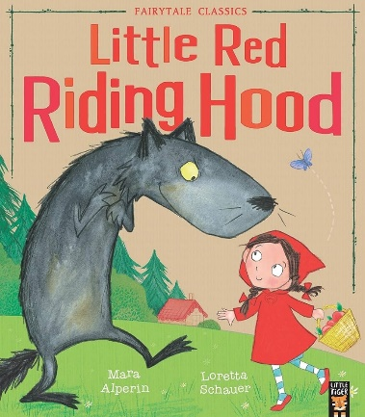
In English this week, we have been learning about Little Red Riding Hood. The children have been using ‘and’ to describe the charaters in the story. Here are some pictures of the characters, can you describe them to your grown up?
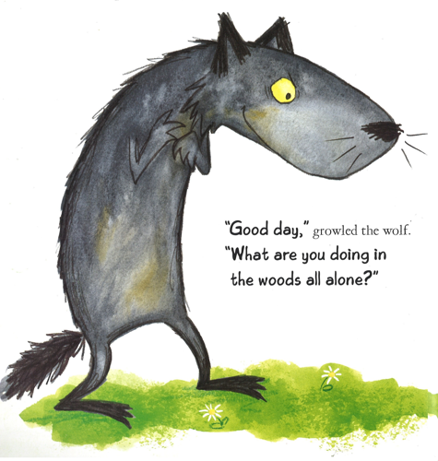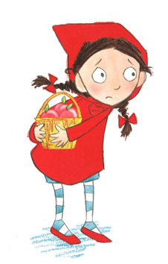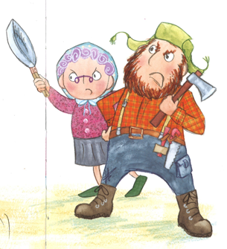
I wonder what the characters are saying? Can you act out the story with your grown ups?

