LB Gymnastics
I am a fully qualified British Gymnastics Level 2 Woman's Artistic Coach and Level I Pre-School Gymnastics Coach. After competing for Great Britain myself in gymnastics. I now have many years of coaching experience. Gymnastics is a foundation sport that develops key physical competencies such as postural control. coordination, the ability to jump and land safely, as well as strength. flexibilty and balance. The sport also enables participants to gain key social experiences such as


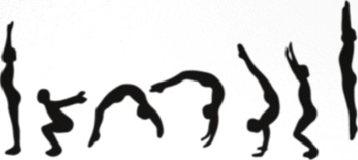

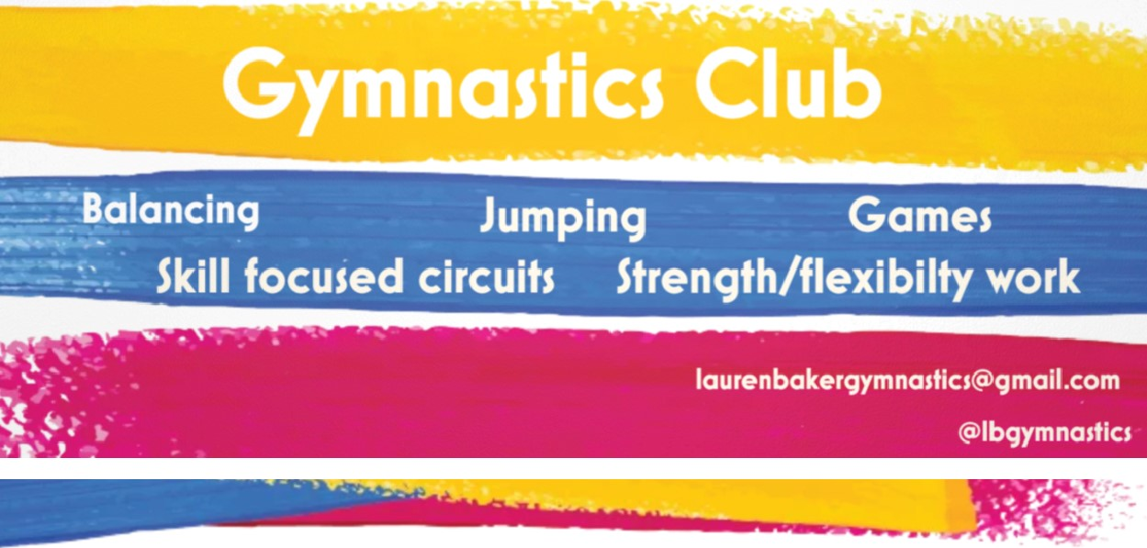
exploring their creativity amongst their peers.
Available for:
-Before School, Lunch Time & After School Clubs
-SEN Gymnastics Sessions
-PE Gymnastics
-Birthday Parties
Enquiries - laurenbakergymnastics@gmail.com

British
Gymnastics
More than a sport

