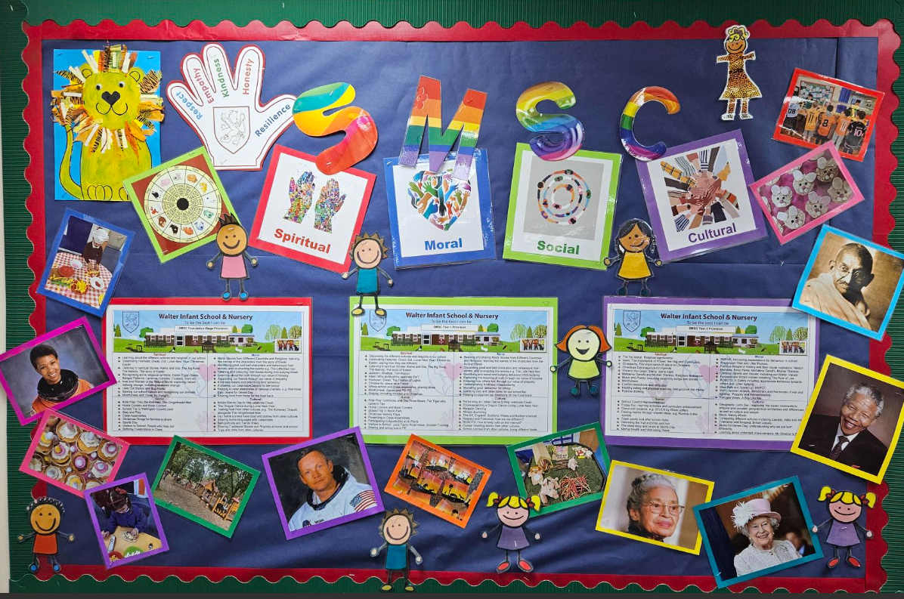

**SMSC @ Walter Infant School and Nursery**