Walter Infant School and Nursery
“To be the best I can be”
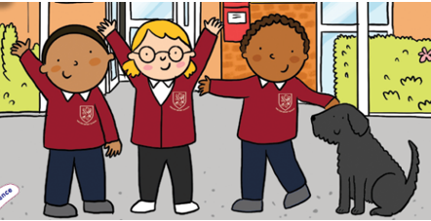
Walter Infant School and Nursery is an equitable, safe, secure and happy place to learn; our children grow as individuals in a stimulating and exciting environment which values respect, empathy, kindness, honesty and resilience
Cultural Capital @ Walter
Our aim is for all our children to leave us ‘Junior School Ready’; this means we have prepared them for the next stage in their learning journey.
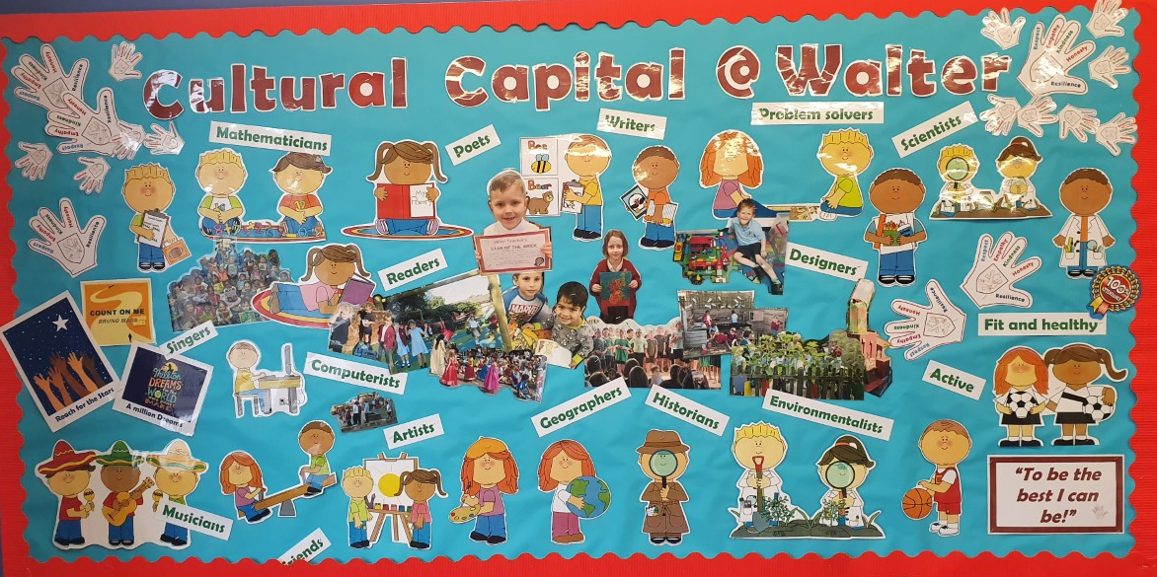

What is Cultural Capital?
Ofsted define Cultural Capital as:

“the essential knowledge that pupils need to be educated citizens, introducing them to the best that has been thought and said, and helping to engender an appreciation of human creativity and achievement”

For some of our children our focus will be to ensure they are working at Age Related Expectations, for others we will support them to develop their self-confidence, their independence or their ability to manage their emotions. Some children need help to find a ‘voice’; our greatest SEND need is for Speech and language Support. Some of our children will need help with physical resources, such as uniform or PE kit, or an extra-curricular club.

All our children are known well by the teachers and support staff as well as the leadership team; we know what their needs are and what we have to do to plug gaps and raise attainment and self-confidence. We are proud of each and every one of our children because we know they are trying their best. We want every child that leaves us, to do so with, a desire to know more, an ability to talk about themselves and ambitions to be successful in their future. We want them to know that they can be whatever they hope to be, even if they have to keep on trying!

Our children care for and respect each other; we celebrate our differences and learn from others. We support local and national charities and the children learn why it is important to take responsibility for our actions and to try to instigate change.

We never place a glass ceiling on any of our children; we teach them to ‘Reach for the Stars’ and to have a ‘Million Dreams’.

What experiences, knowledge and skills do we want our children to have at the end of each school year so that they are ready for the next step?

At the End of Foundation Stage 1 we hope that all our children will be able to do or have the experience of the following:

- To be able to listen carefully to stories, joining in with refrains and talking about what they have heard and understood
- To enjoy singing and dancing as part of a class group
- To recite our core rhymes as part of a group
- To perform in a seasonal production for an audience of parents, carers and staff
- To talk to a range of other people including staff and visitors to school (for example speech therapists)
- To use the toilet with increasing independence
- To recognise their own name
- To enjoy mark making, using a functional tripod grip
- Select and use resources independently
- To separate from a parent or carer independently
- To meet and communicate with performers visitors to the school
- To talk about an experience of an off-site trip (e.g. post box Summer term)
- To manage transition times with increasing independence
- To be able to appreciate different cultures, particularly those relating to their own class
At the End of Foundation Stage 2 we hope that all our children will be able to do or have the experience of the following:

- To be able to manage their personal self-care; such as using the toilet independently
- To be able to use a knife and fork when eating a school lunch (this may be very different from how they eat at home).
- To hold a pencil effectively (tripod grip) to write their name
- To be able to use scissors correctly/safely
- To separate from a parent or carer independently and with confidence
- To manage their own belongings and transition times independently, e.g. at the beginning and end of the day
- To put on and take off their own coat (including using the zip) and their own jumper or cardigan
- To be able to select and use resources independently; talking about their choices and reviewing (plan, do review)
- To be able to use their words to express their feelings
- To experience visitors to the school and comment on what they have found out or observed, for example, The Louis Taylor Road Safety Show or the Reindeer
- To have attended an offsite visit, for example a Coach Trip to the Look Out or Wellington Country Park

At the End of Year 1 we hope that all our children will be able to do or have the experience of the following:

- To be able to come into school independently at the start of the day
- To be able to organise themselves and look after their own belongings
- To regulate their emotions, when things may not be going their way
- To have opportunities to explore their creative side including music, dance and art
- To have experienced a wide range of quality texts, which have been read to them and discussed
- To be confident speakers and able to ask questions when in class and with their peers.
- To have been on an offsite school trip using a specific mode of transport and to be part of other whole school experiences or activities, such as the end of Year 2 Production
- To be able to demonstrate the 5 school values at an age-appropriate level
- To be confident using the phase 2 and 3 sounds to read and spell words.
- To be able to construct and write a sentence using capital letters, full stops and finger spaces
- To know my numbers to 100
- To be able to add and takeaway using concrete resources
- To be able to write the majority of my numbers and lowercase letters correctly.
- To be able to answer questions or make suggestions as part of a large group, for example, in assembly
- To understand that they can contribute to a charity to improve another person’s circumstances
- To be able to talk about and compare seasons and weather

At the End of Year 2 we hope that all our children will be able to do or have the experience of the following:

- To have experience of a school trip, including travelling by coach, bus or train, for example visiting Legoland
- To have experience of different cultures and make comparisons with their own and others in their class, such as Islam
- To be ready to start at junior school; to be Junior School Ready
- To be equipped with basic IT skills e.g. logging on and off a computer, using a mouse
- To be able to read at an age appropriate level and to have the skills to decode unfamiliar words with increasing stamina
- To have a good understanding of the 4 operations in maths
- To have the confidence to write sentences independently and able to sequence these to form short narratives
- To easily separate from their parents or carers when they go into school every day
- To have life-long happy memories of their time at infant school
- To continue to demonstrate the Walter Values for life
- To have good behaviours for learning
- To have learned a variety of sports, including competitive sports and to have a good understanding of fair play
- To have laughed and cried, but never at the expense of other people’s feelings
- To support a charity and make a selfless act to raise or donate money, for example, the Maths Day Challenge for the NSPCC
- To have at least one experience of an extra-curricular activity, whether a sport or a language
- To have strong, friendships that last a life time
- To have learned about animals, including having a real-life experience close to them or touching them
- To know how to cross the road safely
- To know how to keep themselves safe, including Stranger Danger
- To have earned several values badge

