

**Walter Infant School and Nursery**

**“*To be the best I can be”***

**PREVENTING RADICALISATION POLICY**

#### DOCUMENT HISTORY

|  |  |  |  |
| --- | --- | --- | --- |
| **Version** | **Action** | **By** | **Date** |
| 1.1 | Approved | Full Governing Body | November 2017 |
| 1.2 | Approved | Full Governing Body | February 27th 2020 |
| 1.3 | Approved | Full Governing Body | February 17th 2022 |
| 2 | Approved | Full Governing Body | Autumn 2024 |

#### Next Review Date: Autumn 2026

1. **Background**

This ‘Preventing Radicalisation Policy’ is part of our commitment to keeping children safe. Since the ‘Education and Inspections Act 2006’ schools have a duty to promote community cohesion. Over the last few years, global events have led to a growth of extremist viewpoints, including advocacy of violent extremism.

All schools have an important part to play in both educating children and young people about extremism and recognising when pupils start to become radicalised. In March 2015, new statutory duties were placed on schools by the Counter Terrorism and Security Act (2015) which means they must work to prevent children being drawn into extremism.

Safeguarding children from all risks of harm is an important part of a school’s work and protecting them from extremism is one aspect of that.

1. **Ethos**

At Walter Infant School and Nursery, we ensure that through our vision, values, relationships and teaching we promote tolerance and respect for all cultures, faiths and lifestyles, as well as instilling confidence and developing self-esteem in all pupils. The Governors and Senior Leadership Team also ensure that this ethos is reflected and implemented effectively through all school policies and practice and that there is an effective suite of safeguarding policies in place to safeguard and promote pupils’ welfare.

We have a duty to prepare our children for life in modern Britain and to keep them safe.

Everyone at Walter Infant School and Nursery has the right to learn and work in safety. We do not tolerate bullying of any kind and will challenge derogatory language and behaviour towards others.

1. **Statutory Duties**

The duty to prevent children and young people being radicalised is set out in the following documents.

• Counter Terrorism and Security Act (2015)

• Keeping Children Safe in Education (2016)

• Prevent Duty Guidance (2015)

• Working Together to Safeguard Children (2015)

* 1. **Prevent Objectives**

The objectives of Prevent are to:

* tackle the ideological causes of terrorism
* intervene early to support people susceptible to radicalisation
* enable people who have already engaged in terrorism to disengage and rehabilitate

1. **Non-statutory Guidance**

• Promoting fundamental British values as part of SMSC in schools: Departmental advice for maintained schools (DfE 2014)

1. **Related Policies**

• E- Safety All in One Policy

• Child Protection and Safeguarding Policies

• Code of Conduct and Personal Behaviour Policy

• Whistle-blowing Policy

• Anti-bullying and Equality Policy

1. **Definitions**

**Extremism** is defined in the 2011 Prevent strategy as vocal or active opposition to fundamental British values, including democracy, the rule of law, individual liberty and mutual respect and tolerance of different faiths and beliefs. We also include in our definition of extremism calls for the death of members of our armed forces, whether in this country or overseas.

**Radicalisation** refers to the process by which a person comes to support terrorism and extremist ideologies associated with terrorist groups.

**British Values** are democracy, the rule of law, individual liberty and mutual respect and tolerance of those with different faiths and beliefs.

Prevent deals with all kinds of terrorist threats to the UK. Prevent’s **first objective** is to tackle the ideological causes of terrorism. The ideological component of terrorism is what sets it apart from other acts of serious violence. Islamist ideology is resilient and enduring. Extreme Right-Wing ideology is resurgent. Other ideologies are less present, but still have the potential to motivate, inspire and be used to justify terrorism.

In the UK, the primary domestic terrorist threat comes from Islamist terrorism. Islamist terrorism is the threat or use of violence as a means to establish a strict interpretation of an Islamic society. For some this is a political ideology which envisions, for example, the creation of a global Islamic caliphate based on strict implementation of shari’ah law, drawing on political and religious ideas developed in the 20th century by Sayyid Qutb and Abdallah Azzam. Many adherents believe that violence (or ‘jihad’ as they conceive it) is not only a necessary strategic tool to achieve their aims, but an individual’s religious duty.

Extreme Right-Wing Terrorism describes those involved in Extreme Right-Wing activity who use terrorist violence to further their ideology. These ideologies can be broadly characterised as Cultural Nationalism, White Nationalism and White Supremacism. Individuals and groups may subscribe to ideological trends and ideas from more than one category. Unlike Islamist terrorist groups, Extreme Right-Wing terrorists are not typically organised into formal groups with leadership hierarchies and territorial ambitions, but informal online communities which facilitate international links.

Prevent also tackles other ideologies and concerns that may pose a terrorist threat. Established terrorist narratives exhibit common themes such as antisemitism, misogyny, anti-establishment, anti-LGBT grievances and religious or ethnic superiority. Left-Wing, Anarchist and Single-Issue Terrorism currently represents a significantly smaller terrorist threat to the UK than Islamist terrorism or Extreme Right-Wing Terrorism and is not currently present in the UK at any significant scale (although there has been some activity that has met a terrorism threshold in recent years). The majority of related activity in the UK has consisted of lawful protest, and where these have involved violence, it has resulted in offences relating to public order.

Conspiracy theories can act as gateways to radicalised thinking and sometimes violence. In some cases, a blurring of ideologies with personal narratives makes it harder to assess the risk that people may pose. The need to understand motivation and intent is why in some cases it can take time for an incident to be declared terrorism or not, and why sometimes it remains unclear

**Early intervention: referral to Prevent**

Prevent’s **second objective** is to intervene early to stop people from becoming terrorists or supporting terrorism. This means providing bespoke interventions for people who are susceptible to radicalisation.

Prevent referrals are likely to be made in the first instance by people who come into contact with those who appear to be at risk of being radicalised. There is no single model of a person’s radicalisation journey or single profile of a radicalised person. Frontline professionals, when deciding whether to make a referral, should consider whether they believe the person they are concerned about may be on a pathway that could lead to terrorism.

Signs that extremist views are being adopted, including changes in behaviour that might signal a concern, can be used to consider whether a referral should be made to seek support under Prevent. In determining whether a concern meets the threshold for referral to Prevent, it is important to consider the harm posed to the person, as well as whether accessing support through Prevent might stop potential wider societal harm committed by the person.

The process will vary, but when a concern is identified, the [notice, check, share procedure](https://www.gov.uk/guidance/get-help-if-youre-worried-about-someone-being-radicalised) should be applied as outlined in the Prevent duty GOV.UK awareness course[[footnote 9]](https://www.gov.uk/government/publications/prevent-duty-guidance/prevent-duty-guidance-for-england-and-wales-accessible#fn:9) [[footnote 10]](https://www.gov.uk/government/publications/prevent-duty-guidance/prevent-duty-guidance-for-england-and-wales-accessible#fn:10). Specified authorities should use the Prevent [national referral form](https://www.gov.uk/guidance/get-help-if-youre-worried-about-someone-being-radicalised)[[footnote 11]](https://www.gov.uk/government/publications/prevent-duty-guidance/prevent-duty-guidance-for-england-and-wales-accessible#fn:11).

Often, the concern will be escalated to the organisation or institution’s Designated Safeguarding Lead (DSL) or **Prevent Lead** to check. If there is a concern about potential radicalisation or a reason to believe that someone is at risk of becoming involved in terrorism or supporting it, a referral should be made to police, who will assess whether the person is suitable to be considered by a Channel panel for support.

Anyone making a referral should ensure there is concern that someone may be susceptible to becoming involved in terrorism or supporting it. There may be times when the precise ideological driver is not clear. Yet, like any safeguarding mechanism, it is far better to receive referrals which turn out not to be of concern than for someone who genuinely needs support to be missed.

Providing feedback on referrals is not always possible to protect the confidentiality of the person referred once received by police.

If you are unsure whether a concern constitutes a Prevent referral, we encourage seeking advice from your DSL (or equivalent), local authority Prevent lead or police, in the first instance. Consideration should also be given to whether the person may be susceptible to radicalisation or may instead be more suitable for a different type of support or safeguarding referral.

Further guidance on making a referral and how to apply the notice, check, share procedure can be found by completing the [GOV.UK Prevent duty training](http://www.gov.uk/prevent-duty-training)[[footnote 12]](https://www.gov.uk/government/publications/prevent-duty-guidance/prevent-duty-guidance-for-england-and-wales-accessible#fn:12).

48. For members of the public who have concerns about someone being radicalised into terrorism or supporting terrorism, the [ACT Early](https://actearly.uk/) website offers advice and guidance, including signs of radicalisation to look out for, case studies and information on how to share those concerns[[footnote 13]](https://www.gov.uk/government/publications/prevent-duty-guidance/prevent-duty-guidance-for-england-and-wales-accessible#fn:13).

**Roles and Responsibilities**

1. **Role of the Headteacher (Prevent Lead in School)**

It is the role of the Headteacher to:

• ensure that the school and its staff respond to preventing radicalisation on a day-to-day basis,

• ensure that the school’s curriculum addresses the issues involved in radicalisation where appropriate

• ensure that staff conduct is consistent with preventing radicalisation

1. **Role of Designated Safeguarding Leads**

It is the role of the Designated Safeguarding Lead to:

• ensure that staff understand the issues of radicalisation, are able to recognise the signs of vulnerability or radicalisation and know how to refer their concerns

• receive safeguarding concerns about children and young people who may be vulnerable to the risk of radicalisation or are showing signs of radicalisation

• make referrals to appropriate agencies with regard to concerns about radicalisation

• liaise with partners, including the local authority and the police

1. **Role of staff**

It is the role of staff to understand the issues of radicalisation, are able to recognise the signs of vulnerability or radicalisation and know how to refer their concerns.

1. **The Role of the Governors**

The Governing Body of our Walter Infant School and Nursery will undertake appropriate training to ensure that they are clear about their role and the parameters of their responsibilities as Governors, including their statutory safeguarding duties. The Governing Body will support the ethos and values of our school and will support the school in tackling extremism and radicalisation. In line with the provisions set out in the DfE guidance ‘Keeping Children Safe in Education’ (most recent publication) the governing body will challenge the school’s senior management team (SMT) on the delivery of this policy and monitor its effectiveness.

1. **Curriculum**

We are committed to ensuring that our pupils are offered a broad and balanced curriculum that aims to prepare them for life in Modern Britain. We encourage our pupils to be inquisitive learners who are open to new experiences and are tolerant of others.

Our values; Empathy, Respect, Honesty, Kindness and Resilience support the development of the whole child as a reflective learner within a safe respectful learning environment. Teaching the school’s Core Values alongside the fundamental British Values supports quality teaching and learning, whilst making a positive contribution to the development of a fair, just and civil society.

1. **Internet Safety**

The internet provides children and young people with access to a wide-range of content, some of which is harmful. Extremists use the internet, including social media, to share their messages. The filtering systems used in our school blocks inappropriate content, including extremist content.

Where staff, students or visitors find unblocked extremist content they must report it to a senior member of staff.

We are aware that children and young people may have access to unfiltered internet when using their own devices at home and staff are alert to the need for vigilance around this.

Pupils and staff know how to report internet content that is inappropriate or of concern.

1. **Staff Training**

Staff will be given training **annually** to help them understand the issues of radicalisation, are able to recognise the signs of vulnerability or radicalisation and know how to refer their concerns. This information also forms part of annual safeguarding training.

1. **Safer Recruitment**

We ensure that the staff we appoint to Walter Infant School and Nursery are suitable, our recruitment procedures are rigorous and we follow the statutory guidance published in part 3 of *Keeping Children Safe in Education (2016).* Vetting and barring checks are undertaken on relevant people, including governors and volunteers.

1. **Visitors**

Visitors to Walter Infant School and Nursery are made aware of our safeguarding and child protection policies on arrival at the school and are given information about what to do if they are concerned about any aspect of child welfare.

We undertake due diligence to ensure that visiting speakers are appropriate.

Speakers will be supervised at all times and will not be allowed to speak to children without a member of staff being present.

Staff must not invite speakers into school without first obtaining permission from the headteacher.

1. **Signs of Vulnerability**

There are no known definitive indicators that a young person is vulnerable to radicalisation, but there are number of signs that together increase the risk. Signs of vulnerability include:

• Underachievement

• Being in possession of extremist literature

• Poverty

• Social exclusion

• Traumatic events

• Global or national events

• Religious conversion

• Change in behaviour

• Extremist influences

• Conflict with family over lifestyle

• Confused identify

• Victim or witness to race or hate crimes

• Rejection by peers, family, social groups or faith

1. **Recognising Extremism**

Early indicators of radicalisation or extremism may include:

• Showing sympathy for extremist causes

• Glorifying violence, especially to other faiths or cultures

• Making remarks or comments about being at extremist events or rallies outside school

• Evidence of possessing illegal or extremist literature

• Advocating messages similar to illegal organisations or other extremist groups

• Out of character changes in dress, behaviour and peer relationships (but there are also very powerful narratives, programmes and networks that young people can come across online so involvement with particular groups may not be apparent.)

• Secretive behaviour

• Online searches or sharing extremist messages or social profiles

• Intolerance of difference, including faith, culture, gender, race or sexuality

• Graffiti, art work or writing that displays extremist themes

• Attempts to impose extremist views or practices on others

• Verbalising anti-Western or anti-British views

• Advocating violence towards others

1. **Referral Process**

Staff and visitors to the school **must** refer all concerns about children and young people who show signs of vulnerability or radicalisation to the **Designated Safeguarding Lead** using the usual methods for reporting other safeguarding concerns.

When there are significant concerns about a pupil, the Designated Safeguarding Lead (the Headteacher) will make a referral to the appropriate body. This referral would be made to the School Police Officer for Wokingham Borough (Thames Valley Prevent Officer), on 07800702074.

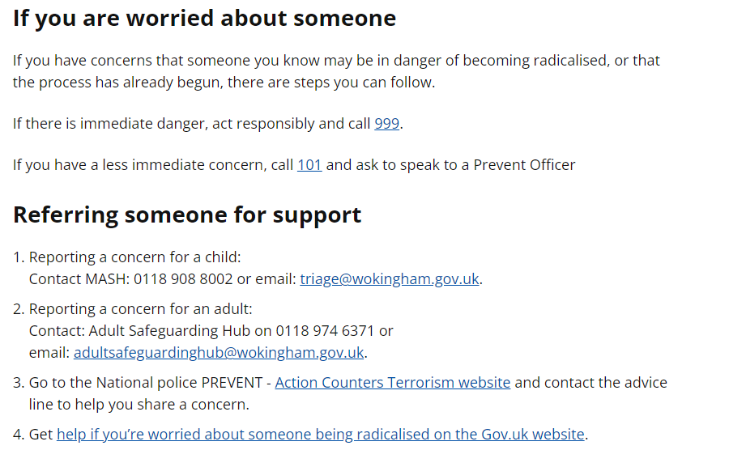

1. **Monitoring and Review**

This policy will be monitored and reviewed by the Full Governing Body annually by receiving a report from the Designated Safeguarding Lead.

Further information relating to this policy can be found at https://www.gov.uk/government/publications/2010-to-2015-government-policy-counter-terrorism/2010-to-2015-government-policy-counter-terrorism

**Appendix 1:**

**Dos and Don’ts**

