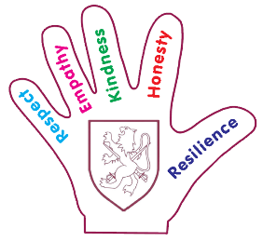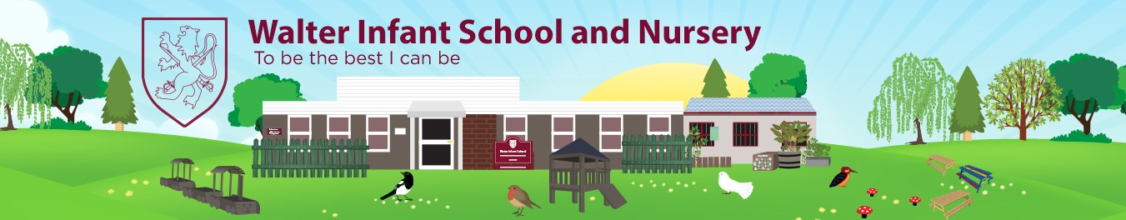

**Year One – Autumn 1 Curriculum Intent**

**2023**

**Materials**

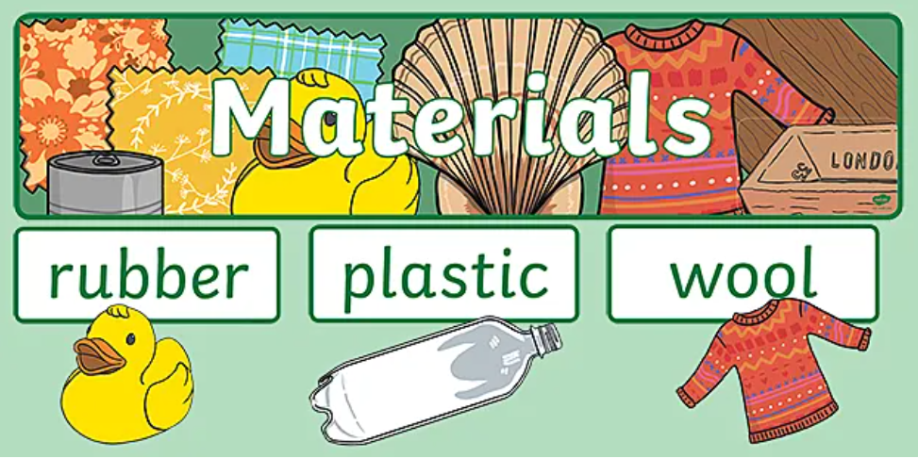

**Walter Values**

|  |  |
| --- | --- |
| **Respect Rabbit photo**  **Respect** | To show respect for my new classroom and the outdoor environment. |
| **Empathy Elephant photo**  **Empathy** | To show empathy towards other people’s feelings. |
| **Kindness Kangaroo photo**  **Kindness** | Be kind to my friends and helping new friends settle in. |
| **Honesty Hedgehog photo**  **Honesty** | To be honest talking about my feelings. |
| **Resilience Rhino photo**  **Resilience** | To show resilience in my new year group and the new work. |

**Intended Additional English Coverage**



|  |
| --- |
| **Sharing a Shell**  Using phonics to encode and spell words.  Practising letter formations and include finger spaces  **The Three Little Pigs**  Sequence a story using pictures and verbally re-tell the story  Character descriptions  Use phonics to help spell words  Write a sentence using a capital letter, finger space and full stop  **Wolf Won’t Bite**  Using phonics to encode and spell words.  Practising letter formations and include finger spaces  Plan and write an alternative version  **Autumn Non-fiction/ Leaf Thief**  To write a statement sentence on the season autumn  Spell some common exception words correctly  Write a simple sentence using the Conjunction ‘and’ |

**Intended Additional Mathematics Coverage**



|  |
| --- |
| **Place Value**  More than less than  Count, read and write numbers to 20 and beyond  Identify and represent numbers using objects, pictorials and a number line |
| **2D Shapes**  Name 2D shapes and their properties |
| **Addition and Subtraction**  Add and subtract one and two digit numbers  Read and interpret mathematical statements involving addition, subtraction and equals |

**PSHRE and RE**

|  |  |
| --- | --- |
| **Jigsaw PSHRE**  **Puzzle** | **Discovery RE** |
| **Being Me in My World**  Special and Safe  My class  Rights and Responsibilities  Rewards and Feeling Proud  Consequences  Owning our Learning Charter | **Christianity – Creation Story**  Does God want Christians to look after the world? |

**Subject Key**

|  |  |  |  |  |  |
| --- | --- | --- | --- | --- | --- |
| **English**  **Books** | **Maths**  **Mathematics** | **Science**  **Plant** | **PE**  **Soccer** | **PSHRE**  **Puzzle** | **Computing**  **Internet** |
| **RE** | **History**  **Hourglass** | **Geography**  **Earth globe Africa and Europe** | **Art**  **Palette** | **Music**  **Music notes** | **DT**  **Scissors** |

**Subject Connectors**

|  |  |
| --- | --- |
| **Subject** | **Connector** |
| **Soccer** | As athletes we are learning ball skills  As athletes we are competing in small teams. |
| **Puzzle** | As members of the Walter community, we understand change happens and that we need to foster our value of resilience. |
|  | As enquirers, we are finding out how Christians believe the world was created. |
|  | As scientists, we are learning about materials and their properties. |
| **Earth globe Africa and Europe** | As geographers, we are learning about daily weather patterns in the UK. |
|  | As technologists, we are learning how to create work using a computer program. |
| **Palette** | As artist, we are learning to develop a wide range of art and design techniques. |
| **Music notes** | As musicians, we are learning to sings songs tunefully. |

**Skills and Knowledge**

|  |  |  |  |
| --- | --- | --- | --- |
| **Subject** | **Skills and Knowledge** | **Curriculum Coverage** | |
| **PE**  **Soccer** | **Athletics**   * Learning to cooperate and work as a team. * Practise throwing objects at distance and at a target. * Jumping with balance and control. * Competing to win as a team. | | **Soccer** |
| **Science**  **Plant** | **Materials**   * Identify and name a variety of everyday materials. * Distinguish between an object and the material it is made from. * Describe the properties of everyday materials. * Investigate which material is best to keep Mr Pig dry. * Investigate which material is best to create a parachute for Mr Pig | | **PlantBooks**  **ScissorsPalette** |
| **Science/Geography**  **Plant** | **Weather**   * Observe changes across the seasons (autumn). Make physical observations made within the school grounds * Identify seasonal weather patterns in the UK * Investigate how length of the day varies depending on which season | | **PlantEarth globe Africa and Europe**  **PaletteBooks** |
| **Art**  **Palette** | **Collage**   * Decorate their own shell using pattern and collage to create their own crab * Create mixed medium brick out of a range of different art materials * Create Autumn picture/sculptures out of autumn objects e.g. leaves acorns   Painting   * Draw a Little Pig thinking about shape and paint in their picture carefully. | | **PaletteBooksPlant** |

**Subject Concepts**