

**Walter Infant School and Nursery**

**School Development Targets 2024 2025**

*“To be the Best I can Be!”*

***Walter Infant School and Nursery is an equitable, safe, secure and happy place to learn; our children grow as individuals in a stimulating and exciting environment which values respect, empathy, kindness, honesty and resilience.***

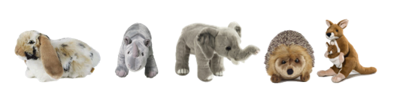

**Quality of Education**

**Year 1 focus: To close the gaps between PPG/FSM children and all children. To close the gaps between SEN children and all children.**

**Year 2 focus: to close the gaps between PPG/FSM children and all children. To close the gaps between SEN and all children**

**To increase the number of girls at Greater Depth in Mathematics**

**Behaviours and Attitudes:**

**To embed our Behaviour Curriculum in line with our Therapeutic Thinking approach**

**To establish calm and productive working environments for all children, where the children are able to know more, do more and remember more because of their positive behaviours for learning.**

**Personal Development:**

**To develop curriculum Enhancement opportunities and Character Education experiences for all our children focussing on our most disadvantaged children from lower socio-economic groups and vulnerable groups**

**To introduce hot lunches (via Caterlink) for Nursery Children**

**Leadership and Management:**

**To ensure that Safeguarding is a priority for all members of our school community.**

**To ensure that our attendance is above 95% for all children**

**Early Years Provision:**

**To close the Gender Gap and increase word reading skills and support increased mark-making and writing opportunities**