

**Year 1 at Walter Infant School and Nursery**

**Information for Parents and Carers**

Walter Infant School and Nursery is an equitable, safe, secure and happy place to learn; our children grow as individuals in a stimulating and exciting environment which values respect, empathy, kindness, honesty and resilience.

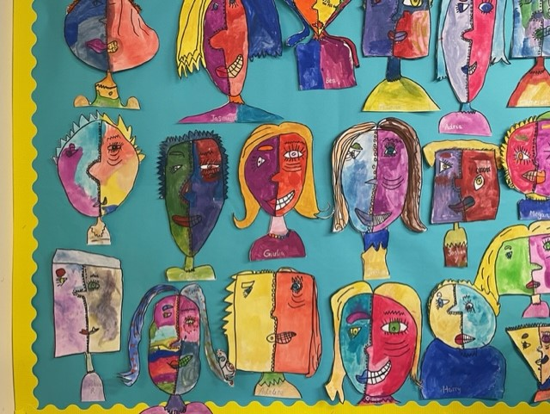

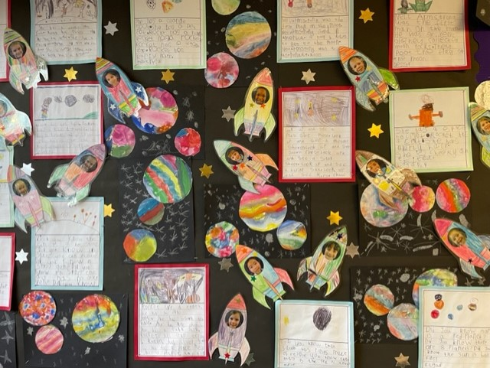



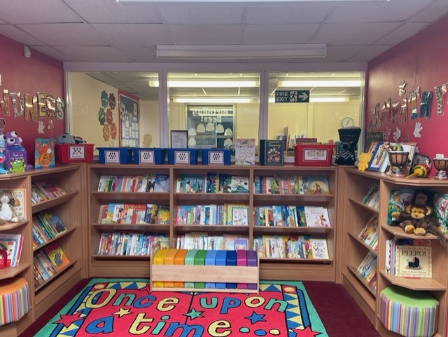



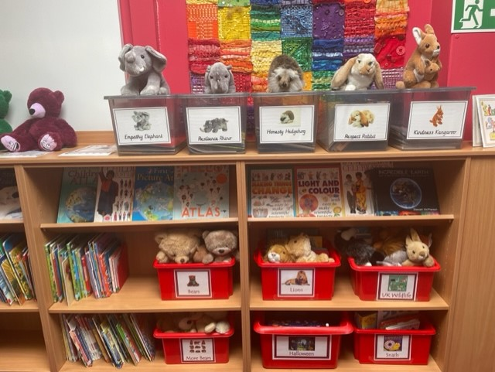

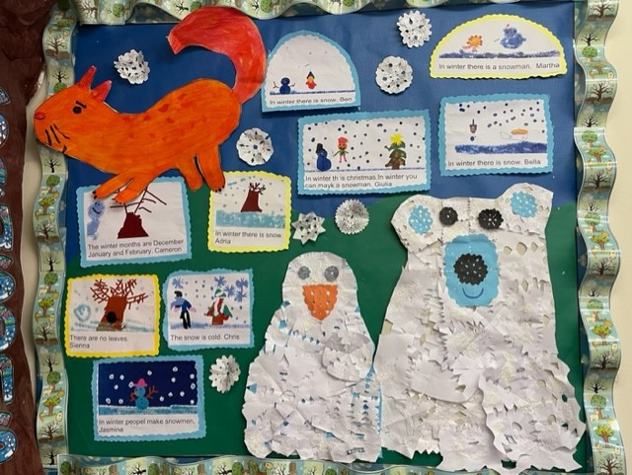



**Walter Infant School and Nursery**

**Murray Road, Wokingham, RG41 2TA.**

**Tel: 0118 978 0825**

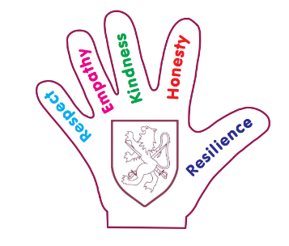

[**www.walter.wokingham.sch.uk**](http://www.walter.wokingham.sch.uk)

[**admin@walter.wokingham.sch.uk**](mailto:admin@walter.wokingham.sch.uk)

**Headteacher: Mrs Judy Wheeler**

***‘To Be the Best I Can Be’***

**Welcome to our new children and their families**

Welcome to Walter Infant School and Nursery; I hope that this booklet will answer many of your questions. If you require any further information, please do not hesitate to contact Mrs Janes or Mrs Hemmings in the school office on [admin@walter.wokingham.sch.uk](mailto:admin@walter.wokingham.sch.uk) at any time.

**Miss Lisa Palmer**

**Year One Leader**

**Our Staff Team and Classes**

|  |  |  |  |
| --- | --- | --- | --- |
| **Beech** | **Class Teacher**  **Miss Veale** | **Class LSA**  **Mrs Ullah** |  |
| **Larch** | **Class Teacher**  **Miss Palmer** | **Class LSA**  **Mrs Wynne** |  |
| **Oak** | **Class Teacher**  **Mrs Seale** | **Class Teacher**  **Mrs Starbuck** | **Class LSA**  **Mrs Adams-Price** |

Miss Palmer leads our dedicated and talented team, who have exceptional experience of working with young children at the beginning of their school lives. They are all ready to welcome your children with open arms. They will ensure your child enjoys their time in school; they will enable all children to develop socially, physically and academically in a fun, exciting and stimulating environment following our **‘Big Curriculum for Little People’**.



**Day to Day Organisation**

Year One’s day begins at 8:40 am; the children come into the playground in the morning and wait with their parents or carers until the door opens. At 8:40am, your child’s teacher will come out. The children line up in front of the classroom adults, ready to go in. If you arrive after 8:50am, you will need to enter school through our reception area.

The children change their home reading books, hang up their coats on their own pegs and organise their belongings into their own drawer, all will be carefully labelled. They will place their water bottles in the trays provided for easy access throughout the day. The children then choose their lunches and the teacher will take the register.

The children will have their lunch at 12:15 pm until 1:15 pm. The children eat their lunches in the school hall, supervised by our wonderful team of Lunch Time Controllers.

The children will go home at 3:20 pm. We ask all parents to wait in the playground:

**Beech** class will leave via the external door to their classroom. The Year One teachers’ will wait by the door with their class and dismiss the children one at a time. Please wave at the teacher to make the handover that little bit quicker.

**Larch** class will leave via the external door to their classroom. The Year One teachers’ will wait by the door with their class and dismiss the children one at a time. Please wave at the teacher to make the handover that little bit quicker.

**Oak** class will leave via the side door by the garden The Year One teachers’ will wait by the climbing frame with their class and will dismiss the children one at a time. Please wave at the teacher to make the handover that little bit quicker.

Each child will be released one at a time to an expected adult known to the school. We will only release the children into the care of responsible adults that routinely collect the children. We will not release the children to older siblings, unless they are an adult. If there are changes to the usual adult please contact the office before the end of the school day and the class teacher will be informed. You will need to share a password so that we know we can release the child. Please do not try to collect other people’s children for them if their parent or carer is running late. Please do not be offended if we refuse to hand over a child that does not belong to you.

**Absence from School**

If your child is unwell please email the school on [absences@walter.wokingham.sch.uk](mailto:absences@walter.wokingham.sch.uk) as soon as possible and tell us why your child is absent.

Please let the office know if your child needs to attend a medical appointment. Forms are available from the reception foyer.

**School Uniform**

The children are expected to come to school in their school uniform. This is to help them feel part of our community and to keep the children looking smart and ready to learn. Our school uniform is as follows:

* Grey trousers or shorts, grey skirt or tunic dress
* White, navy or sky blue polo shirts
* School sweatshirt or cardigan
* Black smart shoes which should be sturdy and practical for school life (we politely request Velcro fastening shoes rather than laces).
* In summer, the girls can wear light blue and white checked dresses.
* Trainers are to only be worn during PE lessons (we polity request Velcro fastening shoes rather than laces).

If you would like to order any of the school uniform, please visit the following website. The website contains an up-to-date price list and is sorted by year groups for easy ordering:

<http://walter.gooddies.co.uk/>

Please ensure that **ALL** clothing is named to minimise a risk of loss, including PE kit and shoes. On PE days, the children are expected to come into school in their full PE kit. Their PE kit should consist of:

* Blue shorts
* Blue tracksuit bottoms or leggings
* Long sleeve jumper/hoodie
* Socks
* Trainers (any colour)
* White t-shirt.

**Year One’s PE Days**

|  |  |  |
| --- | --- | --- |
| **Beech** | **Larch** | **Oak** |
| Wednesday | Monday | Monday |
| Thursday | Tuesday | Wednesday |

**Food and Drink**

**Water**

The children need to bring in a **named** water bottle that they can use themselves, which will stay in their classroom. They can access their water throughout the day. **Filled with water only and no squash please.**

**Snacks**

We provide a piece of fruit or a vegetable for every child daily. Please do not send in other snacks.

**Milk**

If you would like your child to receive milk daily please register with

Cool Milk:  
[registration@coolmilk.com](mailto:registration@coolmilk.com) www.coolmilk.com or call 0844 854 2913

Alternatively, please contact the school office for a ‘Cool Milk’ form.

**Packed Lunches**

Please ensure that if you are providing a packed lunch that you include food your child enjoys eating. If your child is bringing their own packed lunch, it will need food that they can manage to eat easily by themselves but we will help if necessary.

Please do not include any sweets or nuts. We recommend food that should be eaten cold; we do not have facilities to warm food up. We would usually expect to see a salad or pasta dish, a sandwich, roll or wrap with a filling that your child enjoys. A piece of fruit or vegetable, yoghurts or cheese and maybe a sweet or savoury snack such as a cake, biscuit, crisps or crackers.

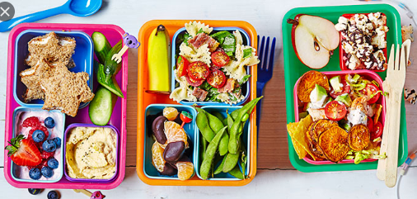

**School Lunches**

Each term we will send home a menu card for you to decide with your child what they would like to eat. The children will be asked in the morning to order their lunch, choosing from the main meal or the vegetarian option. All the children are entitled to a free school lunch every day.

**Allergies/Dietary Requirements**

It is very important for us to know about any allergies or food intolerances when your child starts school. We are a **no nuts** school; please do not bring anything to school containing nuts. If you have any concerns please speak with your class teacher.

**Parent Partnerships**

We have an ‘Open Door Policy’ at Walter Infant School and Nursery and staff members are available at the beginning or end of the day. Please leave any important messages with a member of staff at the gate. Your child’s class teacher is contactable directly by email.

We would like to work in partnership with you to make sure that we give your child the best start to their National Curriculum education. Please come and talk to us about your child, let us know if there is anything, we should know or if anything changes. Throughout the year there will be times to meet more formally at parent consultations.

**Homework**

In Year One, we set the following homework:

* Reading at home. A little and often approach at home is best. Ideally, we would like you to read with your child on a daily basis for about 10-15 minutes. We ask that you would record this into their reading records that they take home. This is to ensure that we can keep track of their reading at home.
* We may also ask the children to complete research projects at home. This would be linked to an area of learning and the curriculum within school
* Weekly spelling to practise at home.

**Helping Your Child with Reading**

* Listening to your child read on a daily basis, at least 10-15 minutes every day. A little and often approach is best.
* Enjoy stories and sharing books together.
* Choose from a wide range of texts, which includes fiction, non-fiction and poetry.
* Talk about the text before, during and after reading. Discuss the character’s feelings and actions, the plot, try to predict events and discuss new vocabulary.
* All reading is valuable. This could be books, magazines, newspapers, poetry, comic books and the Internet.
* Encourage free choice. Do not just read books taken home from school; visit the local library or bookshop.
* The children also have access to Rocket Phonics e-readers online.

**Helping Your Child with Writing**

* Encourage opportunities for writing. Write letters, shopping lists, notes, stories, diaries or poems.
* Write together. This will help the children see writing for a purpose and allow them to have a role model for writing.
* Read through the writing with the children. Discuss how they can edit mistakes.
* Always show praise and encouragement for their writing. Mistakes are okay to make, as writing can always be edited.
* Practise letter formation.

**Helping Your Child with Mathematics**

* Count and Play games involving the multiples of 2, 5 and 10.
* Play mental games, including counting different amounts forwards and backwards.
* Encourage children to read and tell the time O’clock and half past
* Counting, including money.
* Taking children and involving them in shopping. This can involve many aspects of mathematics.
* Look for and identify 2D and 3D shapes at home or when out and about.
* Cooking involves the application of many areas of mathematics.
* Play board games.

**[](https://www.google.co.uk/url?sa=i&rct=j&q=&esrc=s&source=images&cd=&cad=rja&uact=8&ved=&url=http://hsd.qmul.ac.uk/A-Z/First%20Aid/index.html&psig=AFQjCNEbUhGIn0GuzcBAWPho8tNz7rGBHw&ust=1498552844220939)Health and Well-being**

We have qualified paediatric first aiders on site at all times; we will administer first aid if your child needs it during the school day. You will be informed if your child has an accident such as a cut or a graze via our first aid reporting system.

If your child receives a bump to the head, you will be contacted by telephone, as it is our policy to inform parents because of the risk of concussion or compression. We will also ask you to sign a medical slip to confirm we have informed you of the incident.

It is imperative that your contact details are kept up to date. This includes a work place telephone number in case of an emergency throughout the day. If anything changes, please contact the office immediately. If a child has an accident that we suspect could be a broken limb, the parent is informed immediately. If necessary we will call an ambulance and inform you of its destination.

**Illness**

Childhood illnesses are common; if your child has sickness or diarrhoea please keep them away from school for 48 hours after their last episode. If you have a concern about whether your child should be in school, please telephone the office and we will be able to advise you.

**Our Big Curriculum for Little People: The Year One Curriculum**

We have designed a ‘BIG’ curriculum to excite, inspire and foster a desire to learn; we want our children to know more about the world around them and to be happy, confident and successful.

We want our children to have very positive behaviours for learning and to ask BIG questions and we want our staff team to support our children in finding authentic, age-appropriate answers to questions which stimulate them to want to learn more.

The children will learn through real-life and practical experiences, as well as through wonderful, awe inspiring fiction texts and exciting non-fiction texts.

**How is Year One taught?**

At Walter Infant School and Nursery Year One are taught following the objectives from the National Curriculum. This made up of various subjects that are taught following themes or various contexts. In Year One we plan thematically, which means that all our work or learning, that term will centre around a singular theme to help generate ideas. Each term we will publish our Curriculum Intent on the school’s website. This will outline what we are teaching and learning in Year One.

The National Curriculum subjects are; English, Mathematics and Science are core subjects. The other subjects, Geography, History, PSRHE, RE, Art, DT, Computing and Music are referred to as Foundation Subjects or Our Walter Cultural Education. That means that the core subjects of English, Mathematics and Science would be taught discretely and will be taught in other subjects.

|  |  |
| --- | --- |
| English - Writing | Taught daily |
| Guided Reading | The children have one guided reading session in a group weekly, with follow up activities. |
| Phonics | Taught daily |
| Maths | Taught daily |
| PE | Taught twice weekly |
| Science, Geography, History, PSRHE, RE, Art, DT, Computing and Music | Forms part of our big curriculum and taught weekly or regularly. |

**Teacher Assessment in Year One**

The children are thoroughly assessed in English (Reading and Writing), Mathematics and Science; this includes how the skills that are taught in these subjects are used throughout the curriculum. Based on the children’s learning, work in their books, the teacher’s make an assessment or judgement on their work. We will decide if the children are: working towards age related expectations, working at age related expectations, or working at greater depth. Below are the objectives that the children have to meet by the end of year One to be at age related expectations for Reading, Writing, Mathematics and Science;

**Reading**

**The children have to:**

* Respond speedily to the correct sound to grapheme for all 40+ phonemes
* Read many familiar and unfamiliar words accurately by blending sounds
* Read many common exception words, noting unusual correspondences between spelling and sound
* Read some words containing taught GPCs with ‘ing’, ‘ed’ and ‘er’ endings
* Read many words of more than one syllable that contains taught GPCs
* Read some words with contractions and understand the apostrophe represents the omitted letter(s)
* Reading age appropriate books – book band Orange or above
* Check the text makes sense to them as they read and correcting inaccurate reading
* Discuss the significance of the title and events
* Make inferences on the basis of what is being said or done in a familiar book being read to them

**Writing**

**The children have to:**

* Spell words (phonetically plausible) containing each of the 40+ phonemes already taught
* Spell some common exception words correctly
* Name the letters of the alphabet in order
* Use letter names when spelling alternative graphemes
* Use ‘ing’/’ed’ where no change is needed in the spelling of the route words
* Begin to form lower-case letters in the correct direction, starting and finishing in the right place
* Begin to form capital letters accurately
* Form digits 0-9
* Leave spaces between words
* Join words and join clauses using ‘and’
* Begin to punctuate sentences using a capital letter and a full stop, question mark or exclamation mark
* Use a capital letter for their name and the personal pronoun ‘I’ and know they should be used for the names of others, places and the days of the week as well
* Compose a sentence orally before writing it
* Sequence sentences to form short narratives
* Re-read what they have written to check that it makes sense

**Mathematics**

**The children have to:**

* Read, write and interpret mathematical statements involving addition (+), subtraction (-) and equals (=) signs
* Know and use number bond facts for 10
* Add and subtract one-digit and two-digit numbers to 20, including zero
* Count, read and write numbers to 100 in numerals; count in multiples of twos, fives and tens
* Given a number, identify one more and one less
* Recognise, find and name a half as one of two equal parts of an object, shape or quantity
* Recognise 2-D shapes [for example, rectangles (including squares), circles and triangles]
* Recognise 3-D shapes [for example, cuboids (including cubes), pyramids and spheres]
* Compare, describe and solve practical problems for: length and heights [for example, long/short, longer/shorter, tall/short, double/half]
* Compare, describe and solve practical problems for: mass/weight [for example, heavy/light, heavier than/lighter than]
* 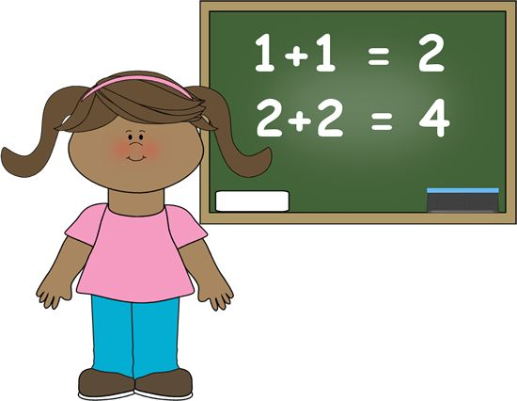Measure and begin to record lengths and heights
* Recognise and know the value of different denominations of coins
* Tell the time to the hour and half past the hour

**Science**

**The children have to:**

* Ask their own questions about what they notice
* Observe changes over time
* Notice similarities, differences and patterns
* Group and classify things
* Carry out simple comparative tests
* Use appropriate scientific language to communicate their ideas in a variety of ways, what they do and what they find out
* Name and locate parts of the human body, including those related to the senses
* Describe and compare the observable features of animals from a range of groups
* Group animals according to what they eat
* Describe seasonal changes
* Name different plants and animals
* Use their knowledge and understanding of the properties of materials to distinguish objects from materials and identify and group everyday material

**Phonics and Spelling**

At Walter Infant School and Nursery, we use phonics for the prime method for teaching reading and spellings. The children have access to the following phonics card to help them to encode or spell a word. Some words cannot be spelt using phonics and these are known as Common Exception Words. A list of the year one common exception words are attached.

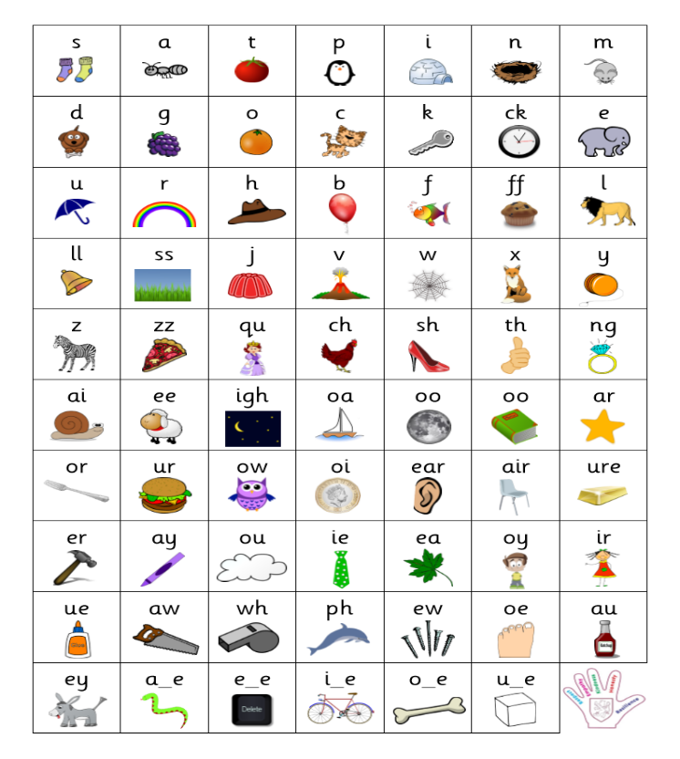

**Year One Common Exception Words**

|  |  |  |  |
| --- | --- | --- | --- |
| **do** | **the** | **is** | **today** |
| **to** | **a** | **his** | **says** |
| **no** | **they** | **has** | **our** |
| **go** | **said** | **I** | **ask** |
| **so** | **love** | **put** | **you** |
| **he** | **come** | **full** | **your** |
| **be** | **some** | **pull** | **house** |
| **me** | **of** | **push** | **school** |
| **we** | **are** | **our** | **friend** |
| **she** | **here** | **once** | **by** |
| **there** | **one** | **my** | **where** |
| **was** |

**Phonic Screening Check**

Every child in year 1 will be required to sit the phonics screening check in the summer term. The phonics screening check is a short, light-touch assessment to confirm whether individual children have learnt phonic decoding to an appropriate standard. It consists of a list of 40 words, half-real words and half pseudo words (fake words). Pseudo words (fake words) are used to check the decoding skills.

Below is an example of a page from a Phonic Screening Check. You will be able to see the real words and the pseudo words.

[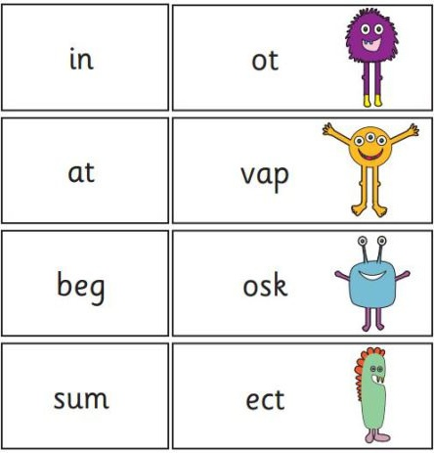](https://www.google.co.uk/url?sa=i&url=https://www.readwithphonics.com/blog/how-important-phonics-screening-check&psig=AOvVaw0F_XluodH3mNOAYHLFgZMF&ust=1593695683568000&source=images&cd=vfe&ved=0CAIQjRxqFwoTCIikpZGRrOoCFQAAAAAdAAAAABAE)

Real words

Pseudo words (fake words) to check decoding skills.

**Handwriting**

As part of the Year 2 National Curriculum, the children have to form letters that are joined using a continuous cursive script that is clear and legible. For this reason, we have adopted a handwriting style with leads in. At the start of Year One, children will continue to form their letters using print learnt in Foundation Stage Two. They will start the formation of all letters at the top (excluding d and e).

Once the children have mastered forming their letters correctly, we will then start introducing lead in lines in preparation for year 2. For the majority of children, this will be introduced during the summer term.

The final intention is that children should be able to form letters that are joined using a continuous cursive script that is clear and legible.

Please see examples of our handwriting below; we have also sorted the letters in families or groups.

The lower case letters should join in a whole word; however, capital letters should not join and may take more than one stroke to form. Please see the examples below.

Example of end of Year Two handwriting



**Pupil Premium Funding**

**Does your child qualify for Pupil Premium Funding?**

Pupil Premium funding is an additional amount of funding allocated to schools by the government to support the learning and progress of children in receipt of free school meals or those looked after by the local authority.  It is for schools to decide how the Pupil Premium Funding is spent and we are held accountable for the impact the funding has on those for whom the money is allocated.

All children in FS2, Year 1 and Year 2 are entitled to a Universal Free School meal; however, we may be able to access additional funding to support your child and other children access the curriculum or indeed extra-curricular activities.

Children who are or have been in care, and children who have a parent who is or was in the armed forces, are also entitled to pupil premium.

If you are in receipt of:

* Universal credit (provided you have a net income of £7400 or less)
* Income support
* Income-based jobseekers’ allowance
* Income-related employment and support allowance
* Support under Part IV of the Immigration and Asylum Act 1999
* The guaranteed element of state pension credit
* Child tax credit, provided that you are not also entitled to working tax credit and have an annual gross income of £16,190 or less. The Pupil Premium for 2021 to 2022 will include pupils recorded in the January 2021 school census who are known to have been eligible for FSM since May 2020, as well as those first known to be eligible at January 2021.

If you think you may be eligible; the funding will benefit your child and other children in our school, please contact the school office in the strictest of confidence

We use the funding to support our children in a wide variety of ways:

* Access to extra-curricular activities in school such as a sports club
* Help with school uniform
* Canine Assisted Learning from our therapy dog
* Help towards the cost of school trips
* Daily milk
* Additional resources for differentiated learning

|  |  |
| --- | --- |
| **Walter Infant School and Nursery**  **Safeguarding Policy & Procedures** | |
| We are committed to safeguarding children and have a duty to refer any  suspected cases of neglect or harm to the appropriate agencies. | |
| The Role of the Designated Person for Safeguarding   * Listen and act when adults report concerns * To make referrals to Social Care if necessary * Ensure confidential records are kept * Attend case conferences and provide reports * Ensure all staff are aware of school’s Safeguarding Policy and procedures * Ensure unexplained absences are referred to the Education Welfare Officer * Keep themselves up to date with knowledge to enable them to fulfil their role and attend training every two years * Provide an anonymised report to the Governors once a term * Notify Social Care when a child is privately fostered * Ensure that any concerns about a pupil who leaves the school are forwarded to the next school. | The Safeguarding Children Team at Walter Infant School  Designated Person for Safeguarding is the Head Teacher, **Judy Wheeler** 0118 978 0825. Deputy Designated Person for Safeguarding is the Deputy Head Teacher, **Stephanie Bell.** The Inclusion Manager is **Louise Walker**.  Your Safeguarding Children Team also links with the Nominated Governor for Safeguarding: Gordon Waterson |
| The welfare of the child is our paramount concern. If you are concerned, report your concerns to the Designated Person for Safeguarding — **Judy Wheeler**  or Chair of Governors – **Ghislene Lokuciewski**  0118 978 0825 |
| For a copy of our full Safeguarding Policy please go to [www.walter.wokingham.sch.uk](http://www.walter.wokingham.sch.uk) or ask at the School Office |

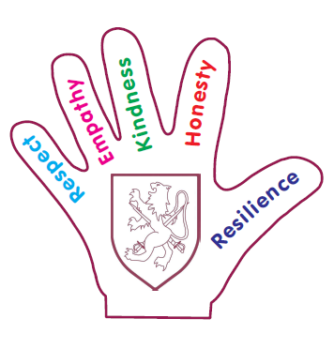**Term Dates 2023-2024**

